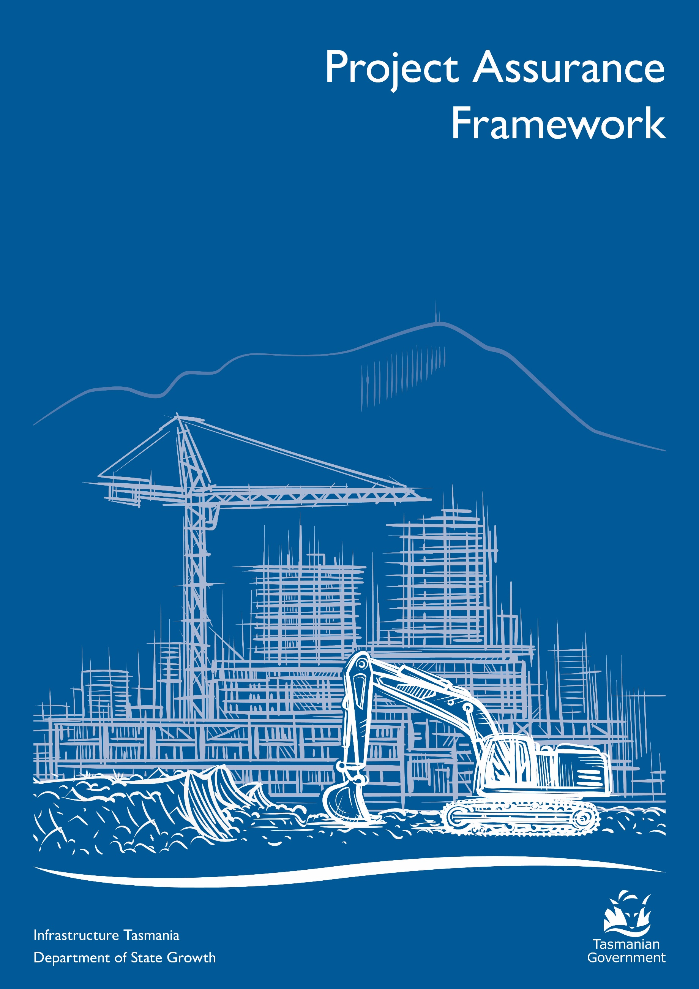

Document control and approval
No | Version | Date | Approval | Role | Variations
1 | 1.0 | 07/05/2021 | Martin Blake | CEO Infrastructure Tasmania
2 | 1.1 | 13/06/2024 | Ben Goodsir | CEO Infrastructure Tasmania | The document clarifies roles and responsibilities, strengthens information and confidentiality, clarifies payment and provides for incidental amendments

Contact(s) for enquiries and proposed changes
Contact | Email
Infrastructure Tasmania | itas@stategrowth.tas.gov.au

Contents
Contents 1
Glossary 2
Background and purpose 3
Purpose of the Framework 3
Considerations in developing this Framework 3
Assessment of existing processes and resources 3
Framework implementation 3
Framework objectives 4
Benefits 4
Framework application 5
Infrastructure Tasmania's role 5
Assurance reviews 6
Treatment of projects and programs 7
Project registration and risk profile assessment 7
Gateway reviews, health checks and deep dives 8
Recommended Assurance Reviews across project tiers 8
Overview of gateway review focus across project and program delivery 9
Improving infrastructure outcomes 9
Framework operations 10
Assurance review process 10
Assurance roles and responsibilities 11
Assurance review ownership and confidentiality 11
Assurance review distribution protocols for review reports 13
Recommendation action plan 13
Appendix A - Assurance review reporting and rating 15
Red Amber Green (RAG) definition 15
Overall rating key 15
Individual recommendations (criticality) 15
Key focus areas 15
Appendix B – Role of the SRO 16
Appendix C - Overview of risk profile criteria 17
Project-tier weighted risk score matrix 17

Glossary
Term | Definition
Assurance reviews | Refers to gateway, health check and deep dive reviews.
Deep dive reviews | Deep dive reviews are similar to health check reviews but focus on a specific and often specialised or technical issue. These reviews are usually undertaken in response to an issue raised by stakeholders.
Delivery agency | The Government agency tasked with developing and/or delivering a project applicable under this framework.
Gate | Key decision point(s) in a project/program’s lifecycle when a gateway review may be undertaken.
Gateway review | A review of a project/program by an independent team of experienced practitioners at a specific key decision point (gate) in the project/program lifecycle.  A gateway review is a short, focused, independent expert appraisal of the project/program that highlights risks and issues, which if not addressed may threaten successful delivery. It provides a view of the current progress of a project/program and assurance that it can proceed successfully to the next stage if any critical recommendations are addressed.
Health check | A health check is an independent review carried out by a team of experienced practitioners seeking to identify issues in a project/program which may arise between gateway reviews.
Program | Programs provide an umbrella under which related projects and activities can be coordinated. A program is likely to be longer term and have a life that spans several years.  Projects that form part of a program may be grouped together for a variety of reasons including co-location, similar nature (for example, agency capital program or road upgrades) or shared outcome.  The component parts of a program are usually individual projects or smaller groups of projects (sub-programs). In some cases, these individual projects or sub-programs may have a different project tier to the overall program.
Project | A project is a group of interrelated activities that are planned and then executed in a particular sequence to achieve planned and agreed outcomes, within a predetermined timeframe. A project has the following characteristics:  • defined scope and finite resources  • has a definable start and end dates  • introduces a change  • creates a unique result, product or service  • has its own governance structure  A particular project may or may not be part of a program.
Project assurance | The governance, reporting and expert project review process that assesses the health and viability of a project. Project assurance can provide investors and other stakeholders with the confidence that the project can deliver to time, budget and quality.
Project Assurance Services Panel | Established and managed by Infrastructure Tasmania, the panel includes experts with skills, experience and capability across infrastructure sectors and project delivery. The project assurances service panel ensures quick mobilisation and coordination of review teams and the consistent application of the project assurance framework.
Project tier | The project tier classification is comprised of three project tiers, where Tier 1 encompasses projects deemed as being the highest risk profile (Tier 1 – high value, high risk projects), and Tier 3 with the lowest risk profile. Tier classification considers a project's overall risk profile and the project’s estimated total budget.
Regular infrastructure project reporting | Routine reporting of projects prepared by the Department of Treasury and Finance and provided to Government.
Assurance Review Team | A team of expert independent reviewers, sourced from the project assurance services panel engaged by Infrastructure Tasmania to undertake a gateway review, health check or deep dive review.
Senior Responsible Officer (SRO) | The delivery agency secretary or deputy secretary with strategic responsibility and the single point of overall accountability for a project/program. The Senior Responsible Officer (SRO) is the owner of the business case, accountable for all aspects of governance and delivery of benefits. Some project management methodologies refer to this role as the Project Executive, Sponsor or Client.

Background and purpose
Over the past two decades jurisdictions across Australia have adopted the gateway process to project assurance to inform investment decisions and obtain increased oversight throughout project development and delivery.
The Tasmanian Government expanded Infrastructure Tasmania’s (ITas) role in November 2020 to include a project assurance function to monitor infrastructure delivery and delivery capacity.
Key objectives of this function include:
- the establishment of a framework for undertaking project assurance activities across the Government’s infrastructure investment projects
- regular monitoring and reporting of infrastructure project/program delivery
- coordination and commissioning of assurance activities in line with a newly defined framework.
This document outlines the ITas Project Assurance Framework (the Framework), ITas’ role in coordinating project assurance activities and its responsibilities for the management and delivery of the Framework.

Purpose of the Framework
Project assurance is a critical part of identifying and managing project and program risk to ensure objectives and outcomes are being delivered.
For the purposes of the Framework, project assurance is defined as the governance, reporting and independent expert project review process that assesses the health and viability of a project. Project assurance helps manage risk and improves delivery confidence.
This Framework provides a structured approach for the independent assessment of the health and viability of projects/programs and focuses on the following assurance activities:
- gateway assurance reviews
- health checks and deep dives
- infrastructure project reporting.
Project assurance is not an audit, approval or endorsement process. It is a process that supports project development and delivery to minimise the risk of project failure and improve project management skills and systems.

Considerations in developing this Framework
- Building on and leveraging from existing processes where possible.
- Considering constraints in terms of agencies’ capacity to implement and participate in new processes.
- Ensuring proposed activities and structures are discussed with key stakeholders and reviewed on a regular basis.

Assessment of existing processes and resources
Throughout the development of this Framework existing processes and guidance material was leveraged where possible. Infrastructure bodies such as iNSW, the Victorian Government and Infrastructure South Australia have published extensive guidance material and have well established processes in place. In addition to material published through interstate agencies, this Framework was informed by documentation from the Infrastructure and Projects Authority of the United Kingdom Government.

Framework implementation
Acknowledging the constraints in capacity and resource availability, this Framework will be implemented through a staged approach. This allows stakeholders to provide feedback early and enables ITas to consider improvements throughout the implementation.

Framework objectives
This Framework has been developed to achieve the following objectives:
- A single source of independent assurance across all infrastructure projects/programs – providing strong advice to Government.
- Informed decision making – supporting Government as an investor through improved data collection and analytics.
- A flexible risk-based approach – to focus on what matters considering project/program specific needs.
- Continuous improvement – monitoring and reporting allows the review and improvement of existing processes and policies.
- Collaboration and support for agencies – sharing resources, processes and insights across agencies to improve delivery and to learn from experience.
- Value to agencies – identifying issues early and providing practical advice.
The Framework does not take away from delivery agencies’ requirements to comply with Government governance and procurement requirements.

Infrastructure Tasmania Project Assurance Framework in the context of existing guidelines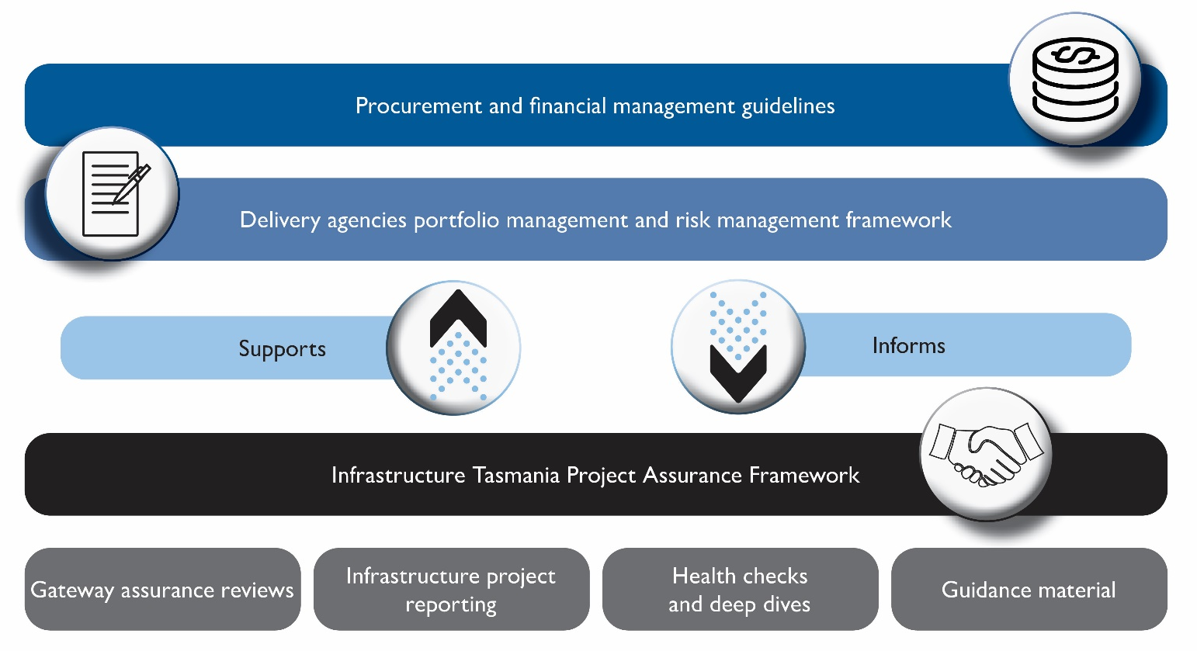

Benefits
Implementing a consistent approach to project assurance across all major government infrastructure projects will achieve the following benefits for the Tasmanian Government and the public.
- Transparency in project/program planning and delivery risks and progress, which allows for informed decision making.
- Consistent application of good practice methodologies and principles in delivery, which improves project and program management capability within the public sector.
- Early identification of risks and issues that may impact project/program outcomes or viability.
- A focus on delivering outcomes from infrastructure investments, rather than just outputs.
- Experience and lessons learned can be shared across Government.
- Increased confidence in the timely provision of value for money infrastructure that meets community needs.

Framework application
The Framework application is not mandatory, however it provides guidance in line with good practice and reflects assurance practices that are already in place across other states. Over the years assurance requirements have evolved in other states and have highlighted the benefits from implementing overarching assurance functions specifically for infrastructure projects/programs.
The Framework was developed to focus on infrastructure projects with a total estimated cost above $5 million. Agencies can elect to participate in the assurance activities outlined in this Framework at their discretion throughout the life of their project.
The Framework does not operate in isolation and is intended to complement existing risk controls that are already in place at an agency level. It has been developed with the objective to support better outcomes when delivering infrastructure projects and programs.

Infrastructure Tasmania’s role
ITas reports to the ITas Steering Committee which advises Government on the current and emerging Tasmanian Government Infrastructure Investment Program. This will include common trends and insights identified through the implementation of the Framework.
The following aspects of the Framework will be phased in, depending upon the resources available to ITas and the support of delivery agencies:
- risk profile assessment tool
- assurance reviews (gateway reviews and deep dives) across all stages of the project lifecycle
- project health checks
- regular infrastructure project reporting.

Assurance reviews
The Framework includes four key components:
- gateway reviews (Gate 0-6)
- health checks
- deep dives
- regular infrastructure Project Progress Reporting.
Reviews are linked to specific stages of the project lifecycle to inform key decisions before progressing to the next stage. Similarly, health checks can have a specific focus in common delivery issues or risks to inform the readiness for the next project stage.
Assurance activities across the project lifecycle
Project phase | Initiate | Plan and development |  | Procurement |  |  | Execute | Close
Lifecycle phase | Establish mandate | Strategic analysis | Investment decision | Prepare for Market | Competitive procurement |  | Award contract and deliver project | Benefits realisation
Gateway reviews | Gate 0 Project registration | Gate 1  Project justification | Gate 2  Business case | Gate 3  Readiness for market/ Delivery strategy |  | Gate 4  Tender evaluation | Gate 5  Readiness for market/delivery strategy | Gate 6  Benefits realisation
Health checks | Preferred options |  |  | Market engagement  Procurement strategy | Preferred options |  | Delivery | Lessons learned
Deep Dives | Technical and specific scope as required
Reporting | Infrastructure projects progress reporting

Treatment of projects and programs
The Framework applies to programs as it applies to projects. An initial risk profile assessment provides an indication of the overarching assurance needs.
However once programs are more progressed and have an approved business case in place (Gate 2) the program can be separated into individual projects with each having individual timing, funding and staging requirements. The individual projects will be assessed using the risk profiling tool to assess their assurance requirements. The separated projects will then be consolidated back into a program at Gate 6 to assess the benefits of the program in its entirety.

Project registration and risk profile assessment
Assurance activities can be tailored to the specific projects using a risk-based approach. To do this, a risk profile assessment is conducted as part of projects registering for assurance reviews with ITas. The assessment considers the following criteria:
- government priority
- agency capability and capacity
- funding and procurement complexity
- project interface complexity
- stakeholders and approvals complexity
- environmental and sustainability complexity.
Based on the weighted risk score across these criteria and the total estimated budget, projects can be grouped into risk-based tier.
The risk-based tiers are as follows:
Increased level of assurance required.
- Tier 1 – High value and high risk
- Tier 2 – Medium risk
- Tier 3 – Low risk
Based on the tier, an assurance plan is developed to outline which gateway reviews, number of health checks and deep dives are relevant to the individual project or program. Following this structure, a higher level of scrutiny is recommended for Tier 1 – High value and high risk projects.
See Appendix C for the project tier weighted risk score matrix and detailed risk criteria.

Example: This means a ‘community centre upgrade’ project with a budget of $30 million, delivered by an agency with significant experience successfully delivering similar projects, and minimal project risks may be classed as a Tier 3 project. At the same time, a new ‘stadium upgrade’ project with a $30 million budget could be classed as a Tier 1 project based on multiple external stakeholder partners involved in delivery and uncertain approval and procurement complexities adding to the project risk profile.

Gateway reviews, health checks and deep dives
Gateway reviews are intended to provide a series of short, focused, independent expert reviews at key decision points of the project lifecycle. The reviews will highlight risks and issues which are likely to threaten successful delivery. The reviews are supported by guidance material to ensure a standardised and robust approach is applied consistently.
Health checks may be conducted at any stage of the project lifecycle but are most likely to be of value when there are long durations between gateways. Health checks are relevant to identify any emerging issues between key decision points and are undertaken by an independent Assurance Review Team.
Deep dives focus on more project specific issues at a certain point in the project lifecycle and can provide a more technical assessment of issues faced by a project.

Recommended Assurance Reviews across project tiers
There is currently no mandatory requirement for projects to complete gateway reviews. This framework identifies key gates that are recommended to be completed (in line with the assessed project tier). However, the standard practice is to assess the need for further gateway reviews at each gateway review. In this context, it is unlikely that all Tier 1 projects would be required to undertake all 6 gateway review.

Gateway reviews | Tier 1 |  | Tier 2 |  | Tier 3
Gate 0 – Project registration | R |  | R |  | R
Gate 1 – Project justification | R |  | R |  | O
Gate 2 – Business case | R |  | R |  | O
Gate 3 – Readiness for market/ Delivery strategy | R |  | O |  | O
Gate 4 – Tender evaluation | R |  | O |  | O
Gate 5 – Readiness for market/delivery strategy | R |  | O |  | O
Gate 6 –Benefits realisation | R |  | R |  | R
Health checks
Delivery | R | R |  | O
Deep dives
Any phase | O | O |  | O
Other assurance activities
Regular progress reporting | R | R |  | R
R= Recommended; O= Optional

Overview of gateway review focus across project and program delivery
Initiate | Activities |  | Gate 0 – Project registration
 | Establish mandate  - Decision to initiate project |  | - evidence that the problem and service needs exist  - registration with ITas  completion of Gate 0 template including risk profile assessment and preliminary project assurance plan
Plan and development | Activities |  | Gate 1 – Project justification
 | Strategic analysis  - develop strategic case  - consider options  - conduct investment logic mapping |  | - well defined service need  - evidence of how the project scope meets the service need  - appropriate level of options and cost/benefit analysis
 | Activities |  | Gate 2 –Business case
 | Develop Business Case  - identify and appraise options  - establish affordability, deliverability and  value for money  - develop program or project brief  - develop procurement strategy |  | - completed final business case including detailed risk plan, cost plan and cost benefit analysis
Procurement | Activities |  | Gate 3 – Readiness for market/ Delivery strategy
 | Prepare for Market  - specify requirements finalise procurement documentation |  | - scope definition  - procurement documentation and commercial approach  - evaluation strategy/plan  - probity plan
 | Activities |  | Gate 4 – Tender evaluation
 | Competitive Procurement  - release tender  - evaluate bids and select or confirm supplier  - confirm final costing include contingencies and update business case |  | - evaluation report  - probity report  - summary of variations  - evidence of delivery readiness and handover approach
Execute | Activities |  | Gate 5 – Readiness for market/delivery strategy
 | Award Contract and deliver project  - award contract and commence contract management  - construct or deliver asset  - establish handover plans  - obtain independent verifier report confirms scope delivery |  | - independent verifier reports confirming scope delivery  - testing and commissioning documentation  - operational readiness documentation  - handover strategy
Close | Activities |  | Gate 6 – Benefits realisation
 | Benefits realisation  - evidence of operational performance  - records of lessons learnt  - report against benefits realisation plan |  | - evidence of operational performance  - records of lessons learnt  - benefits realisation plan and reporting against benefits  - completed Gate 6 template

Improving infrastructure outcomes
ITas will use trends and insights from assurance reviews to work with agencies, industry and review teams to identify how to best address challenges at a whole of government level. ITas will explore opportunities to share lessons and insights across government agencies and the project management community.

Framework operations

Assurance review process
The process flow below provides a high-level overview of the key steps involved from project registration to finalising an assurance review.

Assurance roles and responsibilities
The framework applies the following roles and associated responsibilities.
 | Role | Responsibility
ITas Steering Committee | To advise on current and emerging risks and issues to the Tasmanian Government Infrastructure Investment Program, identified through assurance reviews. | - Receive updates on the assurance reviews conducted, common issues, common themes, data trends and analytics identified through assurance reviews.
Interdepartmental Infrastructure Delivery Committee (IDC) | To collaborate and address mutual challenges and delivery of the Tasmanian Government’s Infrastructure Investment Program, and to provide advisory advice to ITas and ITas steering committee. | - Receive updates with analytics constructed from aggregated assurance reviews.  - Define potential solutions to infrastructure project delivery challenges.  - Provide advice on common themes, data trends and analytics identified through assurance reviews.
ITas  (Infrastructure Tasmania) | To administer and review the framework. | - Work with delivery agencies to ensure that a project is risk profiled and assigned a risk-based tier rating.  - Establish and administer project assurance panels which include experts with skills, experience and capability across relevant infrastructure sectors and project delivery.  - Appoints assurance review teams with specific expertise.  - Guide and coordinate the gateway review, health check or deep dive.  - Monitor quality, scope and consistency of assurance reviews.  - Provide data for the annual report.  - Provide regular high-level performance reports to the ITas Steering Committee, IDC and to government, including commentary on recommendations.  - Collect and analyse data and insights to identify common issues, common themes, data trends and analytics.  - Work with agencies, industry and assurance review teams on how to best address challenges at a whole of government level.  - Explore opportunities to share lessons and insights across government agencies and project management communities.  - Maintain and continuously review policy, process and provide advice.
Assurance Review Team | To undertake a gateway review, health check or deep dive in line with the agreed terms of reference. | - Undertake a confidential, independent assurance review in line with the terms of reference.  - Write a draft and final report setting out the findings and reasoning for the assurance review and share with ITas and the SRO.
Senior Responsible Officer (SRO) | The delivery agency executive (secretary or deputy secretary) with strategic responsibility, who is the single point of overall accountability for project, including responsibility for governance and of benefits. The SRO is normally the secretary or deputy secretary. | - Delegate (in writing) appropriate work activities to the project team.  - Endorse the project risk profiling assessment, and agree the terms of reference, names of interviewees and documents which are shared with ITas.  - Actively engage with ITas and the assurance review team, including fact checking queries.  - Provide responses to the draft report recommendations.  - Owns and is responsible for addressing or remedying any recommendations in the final report.
Delivery agency | To develop and/or deliver a project that will undergo a gateway review, health check or deep dive. | - Nominate an SRO.  - Make resources available to support successful delivery of the project.

Assurance review distribution protocols for review reports
For consistency and quality purposes the following three protocols will apply across all types of assurance reviews:

Recommendation action plan
The Final draft review report (Protocol 2) will include a set of recommendations supported by a report outlining key findings. A recommendation action plan is prepared by agencies to address these recommendations. The objective of the recommendation action plan is to provide detail of how the project/agency will close-out recommendations.
Over time, ITas will monitor progress towards the closing out of actions and recommendations. Common themes across recommendation action plans will also inform regular reporting to Government.

Information and confidentiality

Ownership
All project information is owned by the delivery agency, even when the information has been supplied to ITas.
The delivery agency owns the assurance review reports prepared by the assurance review team.

Confidentiality
The assurance review process and associated documentation, including the report, is confidential between the SRO and ITas.
Confidentiality is essential to ensure the review outcomes are reliable and credible, and so government as the investor can make appropriate decisions. Confidentiality allows interviewees to openly raise issues, and allows the government and investor to have confidence that issues and identities will not be disclosed. Confidentiality assists the project to build internal capability based on the non-release of reports. It also creates an environment where appropriate mitigations can be developed and actioned immediately.

Disclosure
The effectiveness of assurance reviews is reliant on the contents of the report not being disclosed. If participants assume their comments will be disclosed, it may reduce their candour. Disclosure of a report would create a future risk that undermines the integrity and validity of the assurance review and its purpose, which is to provide clear and honest advice.
ITas treats the report as protected information, and not to be disclosed, as it was communicated in confidence within the realm of undertaking Government business. ITas retains a copy of the reports for reporting purposes. ITas does not distribute the reports without the written consent of the SRO.
The assurance review team destroys all documentation following the assurance review.

Use
ITas is committed to the confidential nature of the assurance review report. It uses information collected from reports in two ways.
- ITas keeps a copy of the report for the purpose of reporting on metrics and analytics from aggregated project assurance reviews. ITas also identifies trends affecting the performance of infrastructure projects, key drivers of risk, challenges and opportunities associated with the infrastructure investment program.
- ITas may keep a copy of the report to monitor the recommendations and follow up with delivery agencies and SROs the status of addressing those recommendations. The report may also be used as background for a subsequent assurance for the same project.

Security
ITas limits staff with access to project assurance records as an added confidence that the assurance review process and the report is confidential. Only staff with a direct role to manage or coordinate assurance reviews can access records. The records that are kept relate to administrative process associated with the assurance review and the report. ITas does not keep information collected from interviews or source documents which informed the drafting of the report.

Payment
The costs of an assurance review are borne by the delivery agency. ITas invoices the delivery agency following receipt of the final report. Payment is to be made within 14 days of receipt of the invoice.

Appendix A - Assurance review reporting
and rating
Every Review Report will provide an overall confidence rating and include recommendations with a criticality rating using a Red, Amber, Green status.

Red Amber Green (RAG) definition
There are two levels of RAG Status for a project that must be given, using the colour-coded indicators Red, Amber or Green described below.
- Red (Low), Amber (Medium) or Green (high) delivery confidence assessment for the overall project.
- Red (critical), Amber (essential) and Green (good practice) for individual recommendations.

Overall rating key
Low | Successful delivery of the project is in doubt, with major risks or issues apparent in a number of key areas. Urgent additional action is needed. | The project may need re-baselining and/or the overall viability reassessed.
Medium | Successful delivery is feasible but significant issues exist which require timely management attention. | These issues appear resolvable at this stage and, if addressed promptly, should not impact on cost, time or quality
High | Successful delivery of the project to time, cost and quality appears highly likely. | There are no major outstanding issues that at this stage appear to threaten successful delivery.

Individual recommendations (criticality)
Individual recommendations are now classified as either critical (red) or essential (amber) as per the diagram below. Green is used for recommendations strengthening good practice.
Critical | Action required. This item is critical and urgent. The project team should take action immediately.
Essential | The recommendation is important but not urgent. The project team should take action before further key decisions are taken.
Good practice | The recommendation is not considered critical or urgent but the project development may benefit from implementing this recommendation.
This ensures recommendations are focussed on criticality for project success while still capturing opportunities to embed good practice across project delivery and leadership.

Key focus areas
Each report will provide an assessment of the following key focus areas:
- service need, value for money and affordability
- governance
- risk management
- stakeholder management
- asset owner's needs and change management
- social, economic and environmental sustainability
- review of current phase and readiness for next phase

Appendix B – Role of the SRO
Infrastructure projects generally include three key parties with a governance and oversight function. These include a sponsor, a deliverer and an asset owner/manager or operator. The SRO may come from either the sponsoring agency, delivering agency or the asset manager/owner agency depending on the stage of the project lifecycle. At any point in time it should be easy to identify who holds the role of SRO.
The SRO is a key stakeholder for the successful delivery of gateway reviews. They are expected to be available to meet with the review team as well as support the review of all necessary information requested.
Typical holder of the SRO role across the project lifecycle
Project stage | Initiate | Plan & Development |  | Procurement |  | Execute |  |  | Close
Gate 0
Project Registration (alternative start Gate)
Gateway Reviews | Gate 0 Project registration | Gate 1  Project justification | Gate 2  Final business case | Gate 3  Readiness for market/ Delivery strategy | Gate 4  Tender evaluation | Gate 5  Readiness for service |  |  | Gate 6  Benefits realisation
SRO | Sponsor agency |  |  | Delivery agency
 |  |  |  |  |  |  | Asset manager / owner operator

Appendix C - Overview of risk profile criteria

Project-tier weighted risk score matrix
ITas has developed a Risk Profiling Assessment Tool which is completed by delivery agencies when registering a project for assurance reviews. The process involves giving each project a score against a set of risk assessment criteria and providing key information such as total estimated cost.
The assessment considers the following criteria:
- government priority (20%)
- agency capability and capacity (20%)
- funding and procurement complexity (15%)
- project interface complexity (20%)
- stakeholders and approvals complexity (15%)
- environmental and sustainability complexity (10%).
The six risk assessment criteria are scored (ranging from 5 (very high) to extremely low (0)) using the Risk Profiling Assessment Tool. To assist agencies, indicators are provided to consider when defining a score. The Risk Profiling Assessment Tool calculates the weighted risk score and determines the risk based project tier in line with the matrix below.
Weighted risk  score | Estimated total cost range
 | $5M – $10M | $10M-$50M | $50M-$100M | $100M-$500M | >$500M
0.0 - 2.0 | Tier 3 | Tier 3 | Tier 2 | Tier 2 | Tier 2
2.1 - 2.2 | Tier 3 | Tier 3 | Tier 2 | Tier 2 | Tier 1
2.3 - 2.4 | Tier 3 | Tier 2 | Tier 2 | Tier 1 | Tier 1
2.5 - 2.9 | Tier 2 | Tier 2 | Tier 1 | Tier 1 | Tier 1
3.0 – 3.9 | Tier 2 | Tier 1 | Tier 1 | Tier 1 | Tier 1
4.0 – 5.0 | Tier 1 | Tier 1 | Tier 1 | Tier 1 | Tier 1
Table 1 weighted risk score matrix

