Department of Infrastructure, Energy and Resources

Riverline – Hobart Light Rail

Preliminary Plan

25 March 2014

Contents

Executive summary 1

1 Introduction 3

2 HLR summary and assumptions 4

2.1 Project scope 4

2.2 Assumptions 5

3 Requirements and issues 7

3.1 Legislative requirements and issues 7

3.2 Contractual requirements and issues 9

3.3 Tenure requirements and issues 10

3.4 Procurement and Financing Options 12

4 Preliminary risk assessment 13

4.1 Workshop process 13

4.2 Outcomes 14

5 Draft statutory approvals plan 16

5.1 Project Impact Area 16

5.2 Assessments likely to be required 22

5.3 Approvals likely to be required 23

6 Public transport service requirements 26

6.1 Service requirements 26

6.2 Technical requirements 29

7 Supportive policy 30

7.1 Policy areas 30

8 Conclusions 34

8.1 Next steps 34

9 References 35

Appendix A Level crossing example 39

Appendix B Risk register 40

Executive summary

1. PwC has been engaged by the Department of Infrastructure, Energy and Resources to prepare this preliminary planning report regarding a potential light rail line to improve transport options in Hobart's northern suburbs.
2. Hobart is a capital city experiencing moderate population growth. The city has a diversifying economic base and is centralising services and activity in the CBD core (health and education in particular). Greater Hobart has a larger geographic footprint than Manhattan but only 13 per cent of the population. The spread out (sub-urban) nature of the city at very low density makes providing quality mass transit expensive and uncompetitive in terms of travel time. It also means that the population is highly dependent on cars for meeting their daily travel needs.
3. The intensification of key corridors and nodes is the most efficient way to make public transport competitive in terms of meeting everyday transport needs. It will also provide greater choice for the Hobart population in terms of housing stock and transport options. For example people who do not want a large back yard, or do not want to drive (particularly younger and older people) in many cities prefer to live in more dense urban environments with a wide range of services within walking distance of home.
4. However, intensification will generate increased travel demand to these locations, which given the car dependent nature of Hobart has the potential to generate increased traffic congestion (particularly in the short to medium term). This potential traffic congestion would reduce the attractiveness of the nodes and corridors and stifle potential development.
5. Improving public transport services along corridors and between nodes is possible using the existing bus network. Topographic constraints mean that buses will continue to be the main form of public transport in Hobart for the foreseeable future. This is particularly relevant in the east and south where the Derwent River and hilly terrain make buses the most cost effective and efficient mode of transport. However as bus use increases and Hobart CBD intensifies, bus congestion will reduce the efficiency of the system.
6. Hobart’s northern corridor has an existing railway line which is currently used for freight services which will cease in mid-2014. This presents an opportunity to use the existing rail corridor for passenger transport which could improve both perceived and actual travel time for some travellers in the corridor (dependant on station locations and operating configuration).

Project objective

1. The main objective of this project is to improve transport options in metropolitan Hobart which in turn is expected to increase public transport mode share, reduce congestion in Hobart CBD, enabling an intensification of activity within the CBD and making the Hobart economy more productive. There are secondary objectives related to social inclusion and meeting the transport needs of an ageing population.
2. The problem that Hobart currently faces is one of a small and dispersed population that is very difficult to serve effectively with public transport (of any form). Only in corridors where there is significant density of journey origins and destinations (such as Hobart CBD to Glenorchy or University of Tasmania) can public transport routes be cost effective and efficient (as they need a critical mass of demand).

Options

1. There are a range of potential options (including provision of light rail) which would help solve these problems. The options can be categorised as being policy, governance, operational and infrastructure based. The greatest impact is likely to come from a holistic approach that implements improvements in all categories. For example, ensuring that land use policy is aligned with governance changes and operational changes related to existing public transport services, is essential to gaining the outcomes predicted to arise from the light rail option.
2. Constructing a new piece of public transport infrastructure (such as a light rail line) will attract attention and generate some interest in the options for intensifying activity in the corridor. The subject of this preliminary plan is to investigate the issues and next steps regarding the option to develop a light rail line between Hobart and the northern suburbs, specifically between Franklin Square and MONA via Macquarie Point, Moonah and Glenorchy.

This Report

1. This document reports on the preliminary planning work necessary (legislative, regulatory, policy and operational considerations) and identifies risks and issues that should be further addressed in the Development Phase of the Hobart Light Rail (HLR) Project. This Preliminary Plan includes a:

* Statutory Approvals Plan to assist the Development Phase of the HLR Project; and
* Risk assessment.

Through the course of preparing the HLR Draft Strategic Assessment it was identified that further work is needed in order to build the most compelling case for investment in light rail. This report identifies a range of issues to be further addressed in the Development Phase of the HLR Project. The timeframe for consideration and resolution of these issues varies according to when in the future a light rail solution becomes viable.

## Introduction

1. PwC have been commissioned by the Department of Infrastructure, Energy and Resources (DIER) to assist with the development of preliminary planning tasks ahead of the Development Phase of the Hobart Light Rail (HLR) Project. The purpose of this report is to highlight the preliminary planning work needed and identify the issues and risks to be further addressed in the Development Phase of the project.
2. Providing light rail services on the northern suburbs rail corridor has the potential to reduce car dependency by:

* Providing a high quality, frequent, reliable, fast public transport option; and
* Supporting better value land use through high density and mixed use development along the northern suburbs corridor.

1. Light rail would also stimulate denser mixed use development along the corridor in the activity centres of Glenorchy and Moonah and provide stimulus for development in the Hobart CBD to increase its scale and diversity, thereby improving Hobart’s and Tasmania’s economy.
2. The **Stage 1 Light Rail Business Case - Hobart to Glenorchy 2013** indicates that providing light rail services between Hobart and Glenorchy (with a stop at Moonah) augmented by feeder bus services is capable of delivering a Benefit Cost Ratio of 1.12.
3. An extension of the service to the iconic Museum of Old and New Art (MONA) would be likely to provide additional patronage, and the service could be later extended along the rail corridor as far north as Brighton.
4. There is a risk that the Hobart Light Rail project will not address the identified problems if:

* Hobart’s economic disadvantages such as lack of scale cannot be overcome by the initiative;
* Extant conditions favouring car use (such as availability of free/cheap parking, lack of reliable, fast public transport options, low density urban form) persist.
* Land use policies are not adjusted to encourage denser urban and mixed use development along the northern suburbs corridor.

1. This report explores those risks, approvals required and policy changes that will support light rail development. The remainder of this document is structured as follows:

* Chapter 1 - Discusses the HLR project and assumptions
* Chapter 2 - Discusses requirements and issues
* Chapter 3 - Discusses the preliminary risk assessment
* Chapter 4 – Provides a draft Statutory Approvals Plan
* Chapter 5 - Discusses public transport service requirements
* Chapter 6 - Discusses supportive policy changes

## HLR summary and assumptions

This chapter of the report summarises the HLR project and outlines key assumptions that are relevant to the preliminary plan.

###### Project scope

1. The Hobart Light Rail (HLR) project proposes the development of a light rail system along the existing freight rail corridor in Hobart. The HLR involves the development of a:

* 12 km light rail service from the Hobart CBD to MONA in Stage 1. This is dependent on a highly frequent, reliable and comprehensive feeder bus service to improve access to the light rail for people living in the further northern suburbs.
* 16 km light rail service from MONA to Brighton in Stage 2
* 1.5 km extension to North Hobart in Stage 2

This geographic scope of the project is shown in Figure 1 below.

Figure : HLR Scope (all stages)

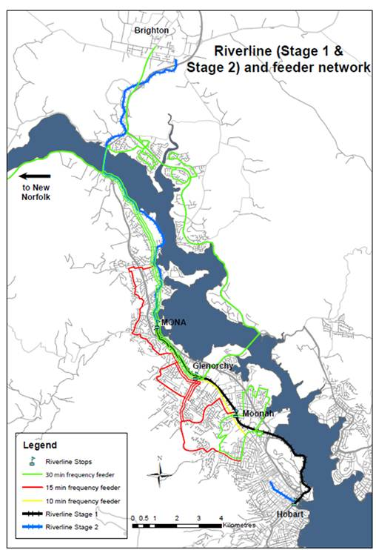

This report is focussed on stage 1 (Hobart – MONA) as the other stages are unlikely to be funded before stage 1 due to a range of factors such as cost, benefits and physical feasibility.

###### Assumptions

1. The HLR project consists of a range of operating assumptions. These have been tested over the past three years, to land on a final set of operating assumptions that inform future project development. The previous Business Case (Hobart to Glenorchy) analysis developed a number of Optimal Operating Service Models (OOSM). The preferred OSSM included the following key assumptions.
2. Utilisation of long (~40 metre) light rail vehicles, accommodating up to 300 passengers each, operating on a 15 minute timetables with limited stops Glenorchy, Moonah and Hobart. The system operated with two passing loops with alignment and approach of the service to the final terminus adjacent to Franklin Square on the southern or Sullivans Cove side of Davey Street.
3. While the above OOSM ultimately generated at benefit cost ratio of 1.12 the HLR is now proposed to extend to MONA and the original OOSM requires review to reflect not only the longer route but to make allowance for inherent variability which may be associated with the operation of HLR.

A review of assumptions associated with the previous OOSM suggests there may be alternative assumptions. These are outlined in Table 1 below.

Table : HLR Operating Assumptions

|  |  |  |
| --- | --- | --- |
| Topic | Assumption | Discussion |
| Track Configuration | Single (standard gauge) track with three passing loops and stub terminus at each end. | This allows for minimum 15 minute headway between vehicles. |
| Number of stops | Including the terminals HLR is expected to have 4 to 7 stops depending on longer term demand:   * Franklin Square (Hobart CBD) * Macquarie Point (dependent on position of rail route and future demand) * New Town (dependant on future catchment) * Moonah * Derwent Park (dependent on future demand) * Glenorchy * MONA | These stops cater for major activity centres and attractors in the corridor.  The stops are expected to look like light rail stops (stations) in Adelaide, Melbourne and Sydney with level boarding, at-grade pedestrian crossings and basic facilities.  The potential location of stops has been previously considered as has the impact on service frequency and travel time. |
| CBD Terminus | In Elizabeth Street between Davey and Macquarie Streets (Franklin Square) | As close to the centre of the CBD as possible. Adjacent to the Hobart City Interchange. Close enough to tourism attractors in Sullivan’s Cove. |
| Signalling | Electronic Interlocking Signalling System. | This should meet the safety requirements of a single track system. |
| Bus Interchanges | Glenorchy, Moonah & Hobart CBD. Adjacent bus stops and transfer between bus and rail services also possible at Derwent Park and New Town stops. | If possible interchanges between light rail and bus would be cross-platform interchanges. |
| Vehicle Specifications | Maximum capacity: 300 passengers  Floor height: ultra-low floor  Traction: Electric (600DC or 750DC power).  Double-ended control  Size: 2.65m wide, 45m long | Alternative costing options should consider lower capacity vehicles, with higher floor heights (and platforms to match). This could significantly reduce fleet costs as other systems retire high-floor vehicles. To accommodate peak passenger demand service frequency may be greater than 15 minutes as proposed in the original OOSM.  Single-end vehicle control could reduce fleet and operational costs but would require a full turning loop at each terminus. |
| Service Frequency | 4 services per hour base frequency, potential for more frequent peak services (subject to passing loop and fleet capacities).  Scope to have 2 services per hour in quiet times. | Service frequency is constrained by the location and number of passing loops. The (short) length of the passing loops and on street running in the CBD result in significant potential for reliability issues. It is recommended that consideration be given to increasing the number of passing loops to increase reliability and allow for higher peak frequency and or smaller vehicles. |

## Requirements and issues

1. This section of the report outlines the key requirements of HLR and the issues to be addressed in the next development phase of the project. This is not a legal review and is not exhaustive in identifying every legal requirement for HLR. If the project proceeds, specific legal advice (relevant to each stage of the planning process) should be sought.

A future full legislative amendment due diligence process will be required to develop detailed recommendations which will ultimately establish the scope of any legislative amendment program required to procure and operate a light rail system in Hobart.

###### Legislative requirements and issues

1. The design, construction, operation and maintenance of a light rail system requires a legislative framework that supports a value for money project delivery model, manages key interfaces and community impacts, ensures a legible project approvals path and protects the operating system. Transport planning and delivery legislation will likely require amendment to accommodate the unique construction and on-going operational requirements of a light rail system in Hobart.
2. There is a chance that some legislative provisions relate to historical operation of trams in Hobart or use of the rail corridor. These may require adjustment to facilitate the HLR. Legislation will need to be reviewed in detail, including the:

* Passenger Transport Services Act 2011
* Vehicle & Traffic Act 1999
* Metro Tasmania Act 1997
* Transport Act 1981
* Traffic Act 1925

1. The existing railway is formally part of the South Line of the Tasmanian railway network defined in the Rail Infrastructure Act 2007. This act clearly identifies most of the HLR corridor with appropriate designation, meaning that approvals processes can be streamlined.
2. Tasmanian legislation refers to the Rail Safety National Law (South Australia) Act 2012 for definitions regarding trains and trams. This act defines (for legislative purposes) the word “train” to include “trams” and the word “railway” to include a tramway. This should be kept in mind when considering what regulatory requirements and issues may arise.

Other Tasmanian legislation relevant to the upcoming stages of HLR and the issues they raise in terms of preliminary planning are shown in Table 2 below.

Table : Relevant legislation, regulatory requirements and significance to HLR

|  |  |  |
| --- | --- | --- |
| Legislation | Regulatory requirements | Significance |
| Passenger Transport Services Act 2011 | Deals with operator accreditation, authorisation of regular passenger services, passenger service contracts, review of decisions and other miscellaneous matters. | The Act under which the HLR service would be regulated. |
| Transport Act 1981 | The Act enables the Minister to set up a Transport Commission that regulates any/all transport including administering the Passenger Transport Services Act 2011. | Much of this Act has been repealed. It may be a useful piece of legislation to swiftly create a new body that can oversee HLR. |
| Road Rules 2009 | Definitions refer to an outdated Rail Safety Act.  Includes references to light rail and tramways and sets out road rules that can be used to ensure priority and safety of HLR on the existing road network.  Division 1 of Part 17 defines the additional rules for drivers of trams. | May need to have definitions updated to reflect the new Rail Safety legislation.  The Rules are very similar to those in place in Victoria and will be easily interpreted at an appropriate time. |
| Metro Tasmania Act 1997 | NIL – This Act provides the basis for Metro to be set up by the Minister and governs some of Metro’s interactions. | There are no clauses specifically relevant to HLR. However the Minister could use the Act to generate a new company separate to Metro to operate HLR. This would be sub-optimal as the Metro Tasmania Act specifically states that a company is not a public authority for the purposes of the Land Acquisition Act 1993. |
| Vehicle & Traffic Act 1999 | Tram drivers need to hold an Australian driver licence to drive a motor vehicle of the relevant class; and an ancillary certificate authorising them to drive a tram. | Driver training could occur at interstate facilities with local driver training limited to familiarisation. |
| Rail Safety National Law (Tasmania) Act 2012 | Refers specifically to the Rail Safety National Law (South Australia) Act 2012 as the law which applies to Tasmania and may be referred to as the Rail Safety National Law (Tasmania) | A wide range of rail safety impacts come from this law, including for construction, operations and maintenance. |
| Rail Infrastructure Act 2007 | Defines the railway.  Enables the Minister to appoint a railway manager and railway operator.  Enables the Minister to declare a planning corridor with respect to the railway network.  A railway entity does not need to comply with the requirements of the Land Use Planning and Approvals Act 1993 to maintain the rail network. | This act would be used to protect the HLR corridor and appoint a railway manager and operator.  Can apply to the on-road segments of the HLR (Davey Evans & Elizabeth Streets).  Maintenance of the railway will not require planning permission, however new sections of track (such as the  on-road sections) will need planning permission |
| Land Use Planning and Approvals Act 1993 | May require planning approval dependent on requirements of Planning Schemes. The project could be deemed a “project of regional significance” to streamline the approval process. | Planning approvals may be required. Assessments related to heritage, noise and traffic impact may be necessary as part of the planning approval process. |
| Historic Cultural Heritage Act 1995 | May require permission for some elements of the HLR depending on specific location of HLR and associated works.  Excavation could discover archaeological artefacts that trigger other approval processes. | Approval from the Tasmanian Heritage Council will be required if any works are required on a listed heritage place. |
| Land Acquisition Act 1993 | Sets out the processes required for a public authority to compulsorily acquire land. | The Act enables the Minister to acquire land for various purposes, including the construction or operation of infrastructure by the private sector. |

###### Contractual requirements and issues

1. The delivery of a light rail system can be achieved through various delivery or contractual models, each with its own attributes, issues and risk profiles. Selecting an appropriate contracting model for Hobart depends on understanding the local perspective and identifying key issues and drivers. For example the local previous experience with Pacific National (failure of the State rail operator), political and public sensitivities regarding various public/private provider models and the particular reasons for implementing a light rail solution.

The works undertaken in this stage analysed how varying models can manage and allocate the risks associated with delivery and operation of a light project and what high level considerations should be taken into account in model selection. Potential issues have been highlighted in Table 3 below.

Table : Identified issues, their significance and suggested resolutions

|  |  |  |
| --- | --- | --- |
| Identified Issue | Significance | Suggested Resolution |
| Operator access issues | TasRail or Metro may seek to be the operator. DIER may seek to have a franchised or new public sector operator.  Previous attempts to share rail operation risk with the private sector in Tasmania have not been successful. This may affect public/political appetite for a franchised operation. | Other Australian states (particularly NSW and Victoria) have a preference for franchise models. Lessons learnt in each of these states should be applied to the Hobart context. |
| Operator exclusivity, service levels and patronage issues | Metro currently has a monopoly environment operating public transport in the Hobart metropolitan area.  New bus service networks would need to be designed to complement HLR. | Network changes to enable the HLR project should be designed to optimise the impact on current operations.  DIER would need to have greater control over the metropolitan network planning (which is currently controlled by Metro). |
| MONA Roma (Ferry & Bus) | MONA currently has a commercial contract for the ferry and bus services. Customers pay for travel and revenues currently cover the cost of the service.  Introduction of a new significantly cheaper travel option could make the ferry and bus services less financially viable. | Careful consideration of the extension to MONA (including fares) is needed. Discussions with MONA should determine the extent to which HLR needs to extend to MONA and the benefit-cost consequences of such an extension (including the potential for the revenue generating ferry to become unviable). |
| Access through Macquarie Point | The redevelopment of Macquarie Point is in the early planning phases. The alignment of HLR through the Macquarie Point development will have an impact on HLR travel times and customer access. | Discussions with Macquarie Point Development Corporation should seek resolution of the alignment as a critical next step. The space to allow for future HLR (including ease of construction) through the site can then be identified and protected. |

###### Tenure requirements and issues

The nature of the tenure required to construct and operate the light rail system will be a function of the delivery/contractual model. Key issues have been identified relating to:

* statutory tenure delivery models;
* land requirements and access;
* asset ownership;
* land use planning processes; and
* competing interface issues with public utility providers.

Land tenure requirements and arrangements for fleet stabling and maintenance capabilities have also been identified as shown in Table 4 overleaf.

Table : Potential issues, their significance and our insight

|  |  |  |
| --- | --- | --- |
| Identified Issue | Significance | Suggested Resolution |
| Management of the Corridor is unlikely to be straightforward | The Crown is the rail infrastructure owner and TasRail is the rail infrastructure manager for this section of the rail corridor. If light rail starts operating in the corridor, TasRail may wish to divest their management of the corridor, including maintenance responsibilities.  A new manager for this section of the Corridor is likely to be required. | A rail infrastructure manager (including maintenance responsibilities) for the Corridor will need to be determined. |
| Access Issues | Access to assets in and around the system may require sophisticated interface arrangements with TasPorts, local government or other government agencies.  Interface arrangements with Public Utility Providers are difficult and can be expensive. | Government could introduce legislation to change the responsibilities regarding service relocation. In many European countries the responsibility for service relocation (such as electricity, gas, water and sewer) is not borne by transport projects, rather it is borne by the servicing authority This is because the service authority has greater knowledge, less risk, more ability to recover the cost and they are using land that has been designated for transport purposes. |
| Land Tenure beyond the existing corridor | There is likely to be a need to purchase some parcels of land to ensure the optimal alignment and facilities can be provided. | Acquiring land in proximity to a station (for something such as car parking) will benefit from early identification of options and incorporation of land availability analysis in the planning phase.  Land within 100 metres of New Town, Moonah, Derwent Park and Glenorchy stations could be considered for purchase by government and then leased back to the existing land owner. This would ensure that some of the value generated by the HLR is captured by government and density around the station can increase in a planned manner that supports HLR. Investigation of how this type of land bank could operate (including through what agency) is a critical next step. |
| Asset Ownership | Some public transport management models ensure that government owns (and takes the risk on) the assets including depots, fleet and maintenance facilities. | It is recommended that the lessons of the Pacific National lease be applied. Asset ownership should probably remain with the Government but the franchise contract needs clear conditions regarding the quality of assets at the end of contract. |

###### Procurement and Financing Options

1. This chapter provides a synopsis of the key procurement options and key risks with each.
2. It’s important to distinguish between financing options and funding options because they represent different questions. Funding refers to the source of revenue that underwrites the HLR project once it is constructed and delivered, whereas finance refers to the way in which debt and/or equity will be raised in order for the HLR project to be constructed and delivered.

Some of the potential options are shown in Table 5 below.

Table : Potential Procurement & Financing Options, Issues and Risks

|  |  |  |
| --- | --- | --- |
| Potential Options | Likely Issues | Insight |
| Funding from Tasmanian / Commonwealth Treasury | Likely to be a lengthy process and may not be prioritised. | The Government may carve out a specific business unit/Department to provide clear responsibilities and accountability. |
| Public / Private Financing | Value for money can be impacted if the technical specifications and negotiations are undertaken by staff without light rail procurement expertise. | External contractors are usually engaged to assist with contract management to augment Government resources to ensure the benefits of Public/Private financing are delivered. |
| Corporate bonds | Actual cost of borrowing is of a greater cost than alternative financing options | In the due diligence process, DIER should analyse the cost of financing the life of the HLR project compared with alternatives, rather than purely the initial construction portion. |
| Crowd-sourced finance (shares issued to the community) | This would be a novel way of raising the capital funds required. More politically acceptable than raising taxes or prioritising light rail over other capital investment that has greater economic return. | A wide range of things are now being financed by crowd-sourced funds. This may be the first time a light rail scheme uses the method, and could generate interest from outside Tasmania. |
| Design, Finance, Construct, Maintain & Operator Franchise | There are a wide range of project  life-cycle elements that can be included in a franchise contract. | Selecting the right elements to include should be the subject of separate advice based on the project objectives and the state of the infrastructure market when the franchise would be let. |

## Preliminary risk assessment

This chapter of the report provides a risk assessment based on the outcomes of a high level risk workshop held during the project. The risk workshop was focussed on high level risks commensurate with the current project status.

###### Workshop process

1. On 11 December 2013, the PwC review team facilitated a one-day risk workshop involving the various State and local government entities having policy, planning or regulatory responsibilities relevant to the proposed HLR. The workshop was conducted to confirm the existing and identify new risks (including causes, potential impacts and the associated likelihoods) attributable to the HLR project. A secondary goal for the workshop was to highlight and share views from stakeholders about the major risks across four aspects of the HLR project:

* Achieving the strategic goals for the project (financial viability, stakeholders, statutory planning);
* Successful completion of the project evaluation and approval processes;
* Development and construction of the HLR in the time required; and
* Safe, efficient and appropriate operation of the HLR through its life cycle.

1. The workshop participants ranked the most important risks to the HLR project across these four aspects. PwC then interpreted the risk data to inform this report on appropriate mitigation strategies, responsibilities and any immediate actions for the Department. The reader should note the following:

* The workshop did not address the subject of Proposed Mitigations in any detail - this was understood to be for a follow up workshop with a smaller group. The risk register shows this as 'to be determined' in the relevant columns.
* The ranking of risks should be validated in a follow-up discussion with the DIER project sponsors, as the information we captured on the day represented a diverse range of concerns from various stakeholders - not all of whom are as conversant with the risks as the DIER team.
* The risk register shows 20 risks, all of which are high level groupings of concerns expressed by workshop participants. The register indicates what aspect (or phase) of the project would be most impacted by the risk (Strategic Assessment, Infrastructure Australia Approval, Design and Construction, and Operations).
* The main benefits derived from our approach were:

development of risk information through a process that allowed most key stakeholder groups to express their view;

convergence by the workshop participants to agreement that the risks listed in the register as the main ones, by using a voting method (coloured dots);

capture of the impacts troubling the workshop group; and

information on what activity is underway that goes to controls - these should be checked and confirmed at some future date.

The risk profile generated by the workshop is included in .

###### Outcomes

1. The most significant risks to the HLR project were identified as:

* **Lack of or inadequate funding from government (local, state or federal).** 
  1. Failure to obtain adequate funding from government sources was seen to be the most significant risk, with potentially catastrophic impacts on the project approval processes. Inadequate funding may lead to a failure to gain approval to proceed with the project. The mitigations explored included reporting and capture of the wider benefits to the State and Commonwealth, increased stakeholder engagement at Commonwealth levels about the viability of the project, adoption of joint (across levels of government) approach to demonstrating the broad benefits from the project, and independent inputs to the business case presented for approval.
* **Demonstrating the financial viability** (including the economic benefits of rail as a mode of transport) **of the project through the operational life-cycle** of the HLR.
  1. This was seen as the next most significant risk to the project. This included the degree of integration with other transport modes. Mitigation strategies proposed in the workshop included ensuring the integration of an HLR option with existing transport networks, facilities, ticketing arrangements, transfer options and operator penalties for failing to adhere to integration principles.
* **Ability to gain stakeholder, community and user acceptance** of the HLR in all respects.
  1. This was also seen as a significant risk. This included dimensions of community impact, such as visual and environmental amenity, access and affordability of rail for travellers versus existing modes, agreement with land owners for access and easements. Also highlighted was the general acceptance by the public of rail as a viable transport option – an increasing focus on the availability of ferries was regarded as a potential blocker of the degree of unified commitment to rail. Mitigation strategies include ongoing and extensive stakeholder and community consultation, awareness campaigns, enquiry services and a demonstration of commitment from government.
* **Ability to achieve the objectives** of the HLR in all respects.
  1. This was also seen as a significant risk. This included dimensions of travel time, reliability and patronage forecasts being overly optimistic. Also highlighted was the general acceptance by the public of rail as a viable transport option. Mitigation strategies include more rigorous modelling and learning lessons from other light rail projects around the world.

Other risks

A range of other risks were identified these are shown in Table 6 below.

Table : Other Risks Identified at the Risk Workshop

|  |  |
| --- | --- |
| Title | Description |
| Competing modes of transport | Risk that the HLR does not demonstrate or reach economic and operational viability targets due to the prevalence of competing modes of transport. |
| Local government support | Risk that local councils along HLR corridor do not support the development of the HLR. |
| Change of governments, departments or project sponsorship | Risk that a change to the existing structure of project ownership and sponsorship results in a change of priorities for funding of public transport projects. |
| Urban renewal targets | Risk that the urban renewal targets along the rail corridor are not met or are not feasible. |
| Legal challenge to approvals | Risk that interest groups, project detractors or land owners along the proposed HLR corridor challenge the approvals process. |
| Integration with existing infrastructure | Risk that the existing infrastructure is unsuitable for integration of the HLR technologies. |
| Integration with other transport modes | Risk that the integration of HLR timetables with other modes of transport is inadequate. |
| Support for recommended rail technology | Risk that the recommended technologies for HLR are not approved or endorsed. |
| Regulatory approval | Risk that DIER fails to obtain approval for the planned operation of the HLR. |
| Design to meet operating requirements | Risk that the design of the rail infrastructure (such as track, signalling, vehicles, level crossings) does not meet standards, requirements for safe and efficient operation. |
| Design to meet user needs | Risk that the rail route and design do not meet the needs of users in the Hobart city centre and other significant user locations. |
| Deliver to budget and/or schedule | Risk that the delivery phase of the project (Design and Construction) fails due to cost or schedule over-runs. |
| Funding for ongoing operation | Risk that operating funding is inadequate for continued operation of HLR at target levels of performance. |
| Health & Safety Incidents | Risk that people or property may be harmed during the construction and operating phases of the HLR project. |
| Network congestion | Risk of congestion in the HLR network. |
| Network safety | Risk of safety incidents on the rail network causing damage to rail assets and operations. |

## Draft statutory approvals plan

1. This chapter of provides a draft statutory approvals plan based on the high-level project assumptions. It should be noted that legislative change at a Commonwealth or State level could trigger additional approvals required. As with sub-chapter 2.1 above, this is not a legal review and should be used to inform a future legal review should the HLR project proceed. This chapter is not exhaustive and only mentions those approval processes which are known to be relevant to the current project scope.
2. The chapter is structured into three sections:

* Project impact area (defining the geographic scope of approvals required)
* Assessment of issues that are likely to be necessary (whether or not they are required specifically by law)
* Approvals likely to be required.

###### Project Impact Area

1. The area impacted by the HLR is largely within the corridor itself. It extends into surrounding areas around stations if there is associated infrastructure (such as car parking) or development (such as apartments) planned to support the HLR.
2. The **HLR impact area** is considered to be the rail alignment and any land around the alignment that is required for construction of ancillary facilities (including pedestrian and vehicle crossing infrastructure). The impact area will need to be more clearly defined during the planning stage of the project.
3. The **HLR zone of influence** is considered to include 100 metres around each station. This is the area in which government may significantly influence development of travel generating uses around each station.
4. It is understood that each station will attract customers from outside the zone of influence. The area from which customers are drawn is referred to as the **HLR Catchment Zone**.

A map of the corridor is shown in Figure 2 below.

Figure : Project Impact Areas

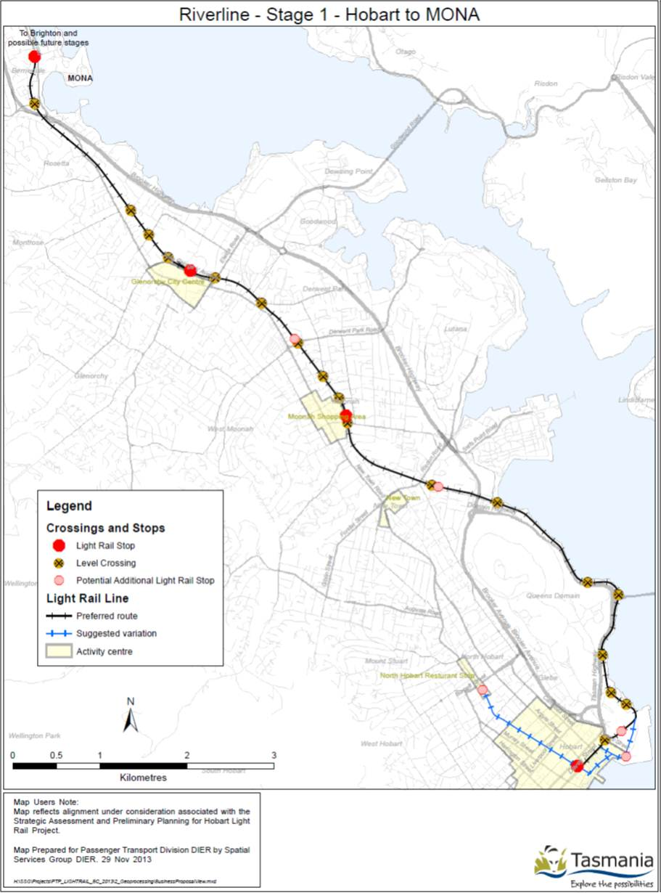

Sites of specific impact are highlighted in Table 7 below.

Table : Sites of specific project impact

|  |  |  |
| --- | --- | --- |
| Location | Likely HLR Requirement | Impact issues |
| Franklin Square (Station/Terminus) | Need to remove at least one lane of traffic and possibly close Elizabeth Street between Macquarie and Davey Streets. | The project would need to consider the passenger amenity and safety issues against the vehicle movement impacts.  Given Elizabeth Street is closed to private vehicles north of Macquarie and Collins Streets, our hypothesis is that closure is the best option. |
| Davey Street | Most likely need to close two lanes (parking and traffic) on the northern side of the road.  In order to maintain HLR on-time reliability light rail vehicles will need absolute priority along Davey Street in both directions. | The HLR should operate on the northern side of Davey Street for several reasons:   * Minimise delay to trams using one intersection to cross both Evans and Davey Streets * Light rail vehicles closest to the traffic stream in Davey Street will be travelling in the same direction as the traffic stream (not against it) * Light rail vehicles turning left from Franklin Sq. will not delay traffic in Davey St * Minimises impact on vehicles accessing Hunter St, Franklin Wharf and Constitution Dock |
| Davey Street | In order to maintain HLR on-time reliability light rail vehicles will need absolute priority along Davey Street in both directions. | Without absolute priority through every intersection on Davey Street (in the eastbound direction) the light rail vehicles will be 1.5 minutes late to every passing loop around 50% of the time. Some will be not late; others will be up to 4.5 minutes late.  This 1.5 minute delay will affect all three inbound vehicles the outbound vehicle crosses paths with and will increase the headway between vehicles by 10%.  The 10% increase in headway will result in 10% more boardings on some vehicles and 10% less on others. This uneven loading will affect boarding times and compound the late running.  The overall result could quickly degrade the service headway and end-to-end travel times. |
| Macquarie Point (potential stop) | The HLR should serve the Macquarie Point development. | If no stop is planned for Macquarie Point the HLR should operate on the most direct alignment of the existing freight line. If the Macquarie Point developers provide space and funding for an additional stop in Macquarie Point then the HLR should operate on the eastern boundary of the site. Both options will need discussion and agreement with the Macquarie Point Development Corporation. |
| New Town (potential stop) | A station a New Town is easy to provide but wouldn’t have a significant pedestrian catchment. | The viability of a stop at New Town is dependent on the amount of development that will occur around the stop site. There could also be a need for car parking to be provided (albeit for a small catchment around New Town), which could significantly increase construction cost and may reduce benefits (such as the ability to intensify land use around the stop). |
| Moonah (Stop/Interchange) | The station would need ancillary infrastructure such as limited car parking and bus interchange facilities. | There seems to be enough space for this ancillary infrastructure. However the bus interchange modelled assumes a cross-platform transfer which will require very specific bus access movements. The car park could impact negatively on the surrounding activity centre. |
| Derwent Park (Potential Stop) | The station would need ancillary infrastructure such as car parking and bus interchange facilities. | There seems to be enough space for this ancillary infrastructure. However the bus interchange modelled assumes a cross-platform transfer which will require very specific bus access movements. This could be the preferred location for park & ride car parking (as there would be less impact on the surrounding activity centre).  The viability of this is contingent on demand and can only be justified is significant development appears possible. The one advantage of this stop is that it would allow withdrawal of some main road bus services, as this stop will be a limited substitute for these services. |
| Glenorchy (Stop/Interchange) | The station would need ancillary infrastructure such as car parking and bus interchange facilities. | There seems to be enough space for this ancillary infrastructure. However the bus interchange modelled assumes a cross-platform transfer which will require very specific bus access movements. |
| MONA (Terminus stop) | The station would need ancillary infrastructure such as car parking and bus interchange facilities. | There seems to be enough space for this ancillary infrastructure. This would be the most suitable location for park & ride car parking (as the surrounding activity is limited to a local hotel and MONA). |

In addition there are 15 locations where the HLR would cross roads and pedestrian paths which would require signal priority. It should be noted that there is no single international standard practice for the safety treatment of light rail crossings (pedestrian and vehicular). Some have unprotected at-grade crossings for pedestrians and vehicles, while others have partially protected (traffic signals) and fully protected (boom gates) crossings. The light rail crossing locations are shown in Table 8 below.

Table : Locations of HLR road crossings

|  |  |  |
| --- | --- | --- |
| Location | Likely HLR Requirement | Impact issues |
| Evans Street (Davey Street intersection) | Would require an additional phase to the traffic signals providing absolute right of way to HLR vehicles. These would stop all traffic, enabling the HLR vehicles to enter the intersection without delay in either direction. | Could have a significant impact on intersection capacity with 8 closures of the intersection each hour, totalling approximately 4 minutes less time for other traffic to use the intersection |
| McVilly Drive | Would require traffic lights at a minimum (similar to Bridport St South Melbourne). | Minimal impact |
| Domain Slipyard (access road) | Would require road to be rebuilt and new signs installed. | Minimal impact |
| Derwent Mercantile Collegiate Rowing Club (access road) | Would require traffic lights at a minimum (similar to Bridport St South Melbourne). Also needs to cater for safe movement of the inter-city cycleway users across the road. | Could have an impact on the safety of Domain Hwy southbound lanes. |
| Queens Walk | Likely to require boom gates due to the complex intersection. Also needs pedestrian facilities. | May impact on intersection. |
| Bay Road | Likely to require boom gates due to proximity of Bell St roundabout. Also needs pedestrian facilities. | May impact on intersection. |
| Albert Road | Would require traffic lights at a minimum (similar to Bridport St South Melbourne). Also needs pedestrian facilities. | May impact on intersection. |
| Hopkins Street | Would require traffic lights at a minimum (similar to Bridport St South Melbourne). Also needs pedestrian facilities. | Minimal impact |
| Sunderland Street | Likely to require boom gates due to the Birdwood Ave intersection. Also needs pedestrian facilities. | May impact on intersection. |
| Derwent Park Road | Likely to require boom gates and pedestrian facilities due to the traffic volumes on Derwent Park Road. | Minimal impact |
| Lampton Avenue | Likely to require boom gates due to the Howard Rd intersection. Also needs pedestrian facilities. | May impact on intersection. |
| Elwick Road | Likely to require boom gates and pedestrian facilities due to the traffic volumes on Elwick Road and proximity of the roundabout. | May impact on intersection. |
| Wrights Avenue (McKay Timber access road) | Would require road to be rebuilt and new signs installed. Also needs pedestrian facilities. | Preferable to close Wrights Ave and provide access to McKay Timber from McKay Ave or Grove Rd. Impact depends on responsibility for construction if the crossing is retained. |
| Grove Road | Would require traffic lights at a minimum (similar to Bridport St South Melbourne). Also needs pedestrian facilities. | Minimal impact |
| Riverway Road | Would require traffic lights at a minimum (similar to Bridport St South Melbourne). Also needs pedestrian facilities. | Minimal impact |
| Berridale Road | Would require traffic lights at a minimum (similar to Bridport St South Melbourne). Also needs pedestrian facilities. | Minimal impact |
| Inter-city cycleway pedestrian access points (various locations) | Would typically require a ‘switchback’ crossing so that pedestrians face each direction along the track before crossing the tracks. | The crossings would not typically need to be signalised, however the speed of HLR vehicles may make signals, bells and gates necessary in some instances. |

###### Planning assessments likely to be required

1. Assessments of specific impacts are likely to be required for any aspect of the HLR project that may impact on the surrounding properties and community. At an early stage in project definition a risk assessment of each specific site affected by the HLR should be undertaken. This risk assessment should focus on issues related to service relocation, technical feasibility, safety and security, service reliability and ability to meet the project objectives using the site.

Some of the potential assessments and issues are discussed in Table 9 below.

Table : Assessments of HLR impacts likely to be required

|  |  |  |
| --- | --- | --- |
| Topic | Issues | Discussion |
| Noise | Residents around the railway may incorrectly expect the light rail to sound like the current freight service. The light rail will operate much more often and may intensify the impact of noise.  Noise during construction and maintenance could also be an issue (particularly if night work is required).  Noise could also be an issue in the CBD (where there are more people) and on tight curves (where there is greater chance of the wheels slipping). | A noise and vibration assessment will be required in the planning phase.  There are numerous examples of light rail in close proximity to houses and in CBD streets. There are also a range of technologies to supress noise from light rail (including rubber-shoed track, curve radius standards and track sub-base designs). |
| Vibration | Vibrations could be a result of the construction process or the HLR operations | Current Australian light rail construction and operations examples provide useful insight into vibration issues. The degree to which it may be an issue for HLR will depend on the geological structure of the railway corridor and its surrounds. |
| Heritage | There are few known heritage issues in the existing railway corridor (as it has been used as a railway for over 100 years). There are heritage places adjacent to the corridor, but they are unlikely to be affected.  There are heritage buildings in the CBD adjacent to the proposed alignment which may require careful design or construction techniques to be employed. | Based on the existing corridor and small amount of on-street running in Davey Street (and perhaps Evans Street) a heritage assessment will be required to ensure the HLR is designed in a way that minimises heritage impacts. |
| Visual Amenity | Visual amenity along the railway will be affected in a very minor way with the addition of stanchions and catenary wires along the corridor. Stops and associated infrastructure may have a greater impact on the amenity of the area. | The stops can quite easily be designed to be unobtrusive (given the 300mm platform height and minimal need for many other on platform facilities). |
| Congestion | It is probable that the HLR could increase congestion, particularly on streets that cross the alignment at grade and on Davey Street if a lane is required to be removed. | It is suggested that site specific assessment of likely congestion be conducted. These assessments should take into account the likely mode shift and diversion of trips to other network links (such as drivers may avoid Albert Road in favour of Risdon Road) |
| Rail Safety | Rail Safety accreditations will be required prior to operation. Close liaison with the Office of the National Rail Safety Regulator (ONRSR) through the design phase will be important.  This process is likely to involve several  (non-mandatory) safety assessment stages to confirm that the alignment and concept will meet the safety requirements.  The single track and passing-loop arrangements, contra flow operations in Davey Street together with the treatment of road and intersection crossings, will be important considerations for railway safety. | Rail safety should continue to be a key aspect of future development stages for HLR. |

###### Approvals likely to be required

1. There are several approvals that would (or may) be required for the HLR project. These include:

* Planning Approval
* Various Rail Safety approvals and licensing (infrastructure, fleet, drivers)
* Heritage Approval

These are discussed below.

* + - 1. Planning approval

1. Given the railway already exists, the risks associated with planning approvals in this corridor are relatively low;, however it should be noted that the use of the Corridor is intensifying in terms of frequency which may constitute a ‘change in use’ and require approval. Consideration also needs to be given to the approval processes required for rail infrastructure (such as stops and car parking) which may occur outside the existing rail corridor.
2. The development may require approval under three separate Planning Schemes if a permit is required under s57 or s58 the Land Use Planning and Approvals Act 1993 (LUPAA); this will need to be confirmed through a planning review. Depending on the timing of the development, approval may be required under the existing Planning Schemes, or the proposed Interim Planning Schemes.
3. An assessment of the planning approvals options is required to determine the most effective planning approval process. This assessment should include analysis of overall timeframes for approval, the level of information required and public consultation. The two options are the standard planning approvals under s57 or s58 of LUPAA and the Projects of Regional Significance process also under the LUPAA.
4. Relevant Planning Schemes are as follows:

* Hobart Planning Scheme 1982 or Hobart Draft Interim Planning Scheme
* Glenorchy Planning Scheme 1992 or Glenorchy Draft Interim Planning Scheme
* Sullivans Cove Planning Scheme 1997

It should be noted that heritage approvals may be required under the Planning Schemes as well as by the Tasmanian Heritage Council.

* + - 1. Projects of regional significance

1. Division 2A of Part 4 of LUPAA provides for a project of regional significance to be dealt with through a streamlined planning approval process. It is expected that the HLR would meet the eligibility criteria in Section 60C of the Act as it is a project of regional significance. It is noted that the process for “projects of regional significance” is untried and untested to date as no developments have undergone this assessment process.
2. The Tasmanian Planning Commission is developing a road and railway assets code which provides guidance for developments within 50 metres of existing or future railways. This code protects the existing railway corridor and any planned railway corridor (planned rail corridors need to be designated by the Minister) from external impacts of encroaching development.

If the HLR project proceeds consideration could be given to getting the planned rail corridor (on Davey and Elizabeth Streets) designated by the Minister.

* + - 1. Contaminated sites

1. The Macquarie Point redevelopment site (which is part of the rail corridor) has levels of contamination and will require remediation depending on future site usage and management. The area surrounding the former gas works near Davey Street is also understood to include deep contamination.

An assessment of the level and depth of contamination may be required for the HLR depending on the design and construction requirements for the system. If the development is classified as a level 1 activity it can be assessed under LUPAA.

* + - 1. Historic Heritage approval

1. Approval will be required for any development within a heritage place listed in the Tasmanian Heritage Register. A heritage review of listed places both within the Tasmanian Heritage Register and also within Planning Schemes, including the Interim Planning Schemes will need to be undertaken to determine the level of impact on historic cultural heritage.
2. At this stage of the HLR planning it is unknown if any such places will be affected, although there are many registered places in proximity to the corridor which could be affected directly or indirectly through potential plans for intensification of land use and development. For example 48 Station Street, Moonah is a heritage site and plans to use this site for a car park or increased density around the station would trigger the need for heritage approval.
3. Specific details of the project should not be changed simply to avoid heritage approvals. Rather the approvals required should be understood as the project details are confirmed and suitable action should then be taken. Potential actions could include:

* Changing the project scope to avoid (or reduce) the impact on the heritage place
* Design the project such that the impact on the heritage place is sympathetic to the heritage place
* Collect and archive the history of the heritage place (including oral history) and remove the heritage place if absolutely necessary (including consideration of relocating the heritage place)

1. Some places are more likely to have heritage issue than others. For example the Hobart CBD has numerous heritage places adjacent to the corridor along Davey Street, and there are many ways that the HLR may impact on those sites (such as building fixings for catenary wires). As the HLR project is progressed in terms of detail, it should be developed with a focus on how to best achieve the project objectives.

It should also be noted that the **Sullivans Cove Planning Scheme 1997** outlines places of archaeological sensitivity within the Macquarie Point redevelopment site and on Davey Street. The HLR will need to consider the level of impact in these designated areas.

* + - 1. Other permits required

Permits may be required for other potential impacts including related to the issues discussed in Table 10 below.

Table : Other potential legislative requirements

|  |  |  |
| --- | --- | --- |
| Topic | Legislation | Discussion |
| Aboriginal Heritage | *Aboriginal Relics Act 1975,*  *Draft Aboriginal Heritage Protection Bill 2012* (yet to be passed) | Given the shoreline location of a segment of the corridor, there is a significant chance that deep earthworks could disturb Aboriginal relics. |
| Changes to road infrastructure | *Traffic Act 1925* | Changes to road infrastructure would be negotiated with the relevant state and local bodies. |
| Noise | *Environmental Management & Pollution Control Act 1994,*  Environment Protection Policy (Noise) | Given the existing freight operations the impact in terms of noise is considered to be minimal at this stage. However it should be noted that frequency of movements will intensify significantly. |
| Flora and Fauna | *Threatened Species Act 1995, Environmental Protection and Biodiversity Conservation Act (Cmwth) 1999* | Given the existing rail operations are in an urban area, the chance for impact on flora and fauna is considered to be minimal at this stage. |
| Land Acquisition | *Land Acquisition Act 1993* | Land acquisition may be required for rail infrastructure adjacent to the existing corridor such as stations, car-parking and bus interchanges.  It is not expected that any land acquisition (for the purpose of infill development) is required for the project in its current form. It would be prudent for Government to begin ‘land banking’ any sites in proximity to the stops as they come up for sale. The State Government does not engage in this activity at present, and a mechanism for it to do so may need to be established. It is recommended that responsibility for this type of acquisitions should be given to one specific agency. |
| Services relocation | *Telecommunications Act 1997*  *Electricity Supply Industry Act 1995*  *Gas Pipelines Act 2000*  *Water and Sewerage Industry Act 2008* | It is recommended that consideration be given to a new Act (common in Europe) that removes the burden of service relocation risk from the infrastructure proponent and makes service relocation the responsibility of the relevant service provider. |

* + - 1. Rail safety approvals

1. The **Rail Safety National Law** is the applicable rail safety legislation in Tasmania. The Office of the National Rail Safety Regulator (ONRSR) is responsible for administering the law.
2. Accreditation of rail transport operators is required. To achieve accreditation the operator must demonstrate to the Regulator that they have the competence and capacity to manage the safety risks associated with their railway operations.

The accredited rail infrastructure manager and/or rail operator must maintain interface agreements with parties that come into regular contact with the rail corridor (such as the owners of private roads that cross the track). They must also prepare and maintain a range of safety plans, programs and procedures and have these endorsed by the ONRSR.

## Public transport service requirements

This chapter of the report identifies the service requirements likely to be necessary to integrate the HLR project with the wider public transport network. It also covers some technical issues regarding fleet procurement, traction (power supply), depots and maintenance.

###### Service requirements

1. Service requirements discussed below include:

* Frequency
* Span
* Interchange and transfers
* Fares policy

The HLR corridor and feeder services proposed are shown in Figure 3 below.

Figure : HLR Stage 1 and Feeder Bus Services

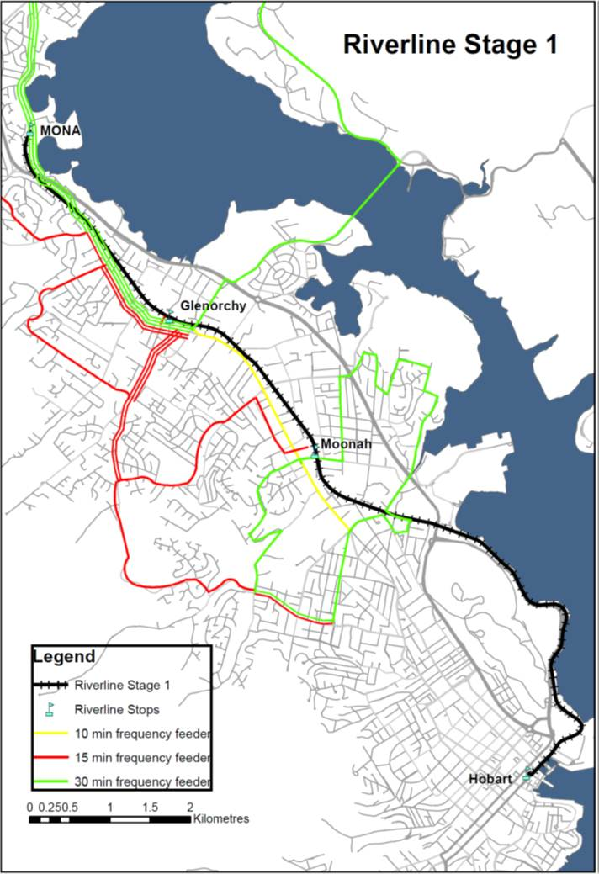

* + - 1. Existing Services

The existing bus services in the Main Road corridor provide a frequently stopping service between Glenorchy and Hobart CBD every 10 minutes between 7am and 7pm on weekdays. There are limited stops (‘semi‑express’) bus services travelling via the Brooker Highway which operate approximately every 10 minutes in the peak and 30 minutes between peaks. The HLR project will provide service every 15 minutes. The HLR project is based on reducing the number of limited stop bus movements between Glenorchy and Hobart CBD by altering such bus services to ‘feed’ passengers to the light rail stops. In addition, a number of high penetration- low demand bus services are proposed to be removed and reallocated to provide ‘feeder’ bus services to light rail stops.

* + - 1. Feeder Services

1. The feeder bus services would operate every 15 or 30 minutes over the same service span as the light rail (similar to that currently provided by the bus network). As the feeder bus service frequency drops from every 15 minutes to 30 minutes (during early evenings and weekends) careful timetable design is necessary so that passengers’ overall journey times do not suffer from excessive transfer times.
2. Additional student bus services are required to augment demand for public transport in peaks. If the HLR project is to accommodate some of this transport task, these bus services will also need to become part of the bus network. The supervision and direction of students onto student bus services will require careful coordination between bus operators and schools in order for timely connections to be made to the HLR. Contingencies may also be required for instances when the HLR capacity is exceeded.
3. For the HLR to operate with maximum effectiveness, it is critical that each service adheres to the departure timetable. This means that HLR services will need to depart regardless of whether all feeder bus services have arrived on time. Given this, it is recommended that the bus timetables include a small additional allowance (or ‘buffer’) in order to maximise the likelihood that each bus will arrive before the scheduled light rail departure (as is standard international practice). Without such a time buffer, the connection between the modes is likely to fail from time to time. An unavoidable side-effect of this contingency is that there will also be times that the bus arrives too early for the associated HLR service (as a result, passengers have to wait much longer).

These service operating issues can create significant pressure on all bus and light rail drivers to adhere to the timetable, which may be technically possible, but is challenging in practice. The proposed HLR assumptions, which feature additional travel time and additional passing-loops can assist to mitigate reliability risks. An additional buffer time for feeder bus services is another important way to mitigate the risks related to reliability of transfers.

* + - 1. Span

Given the HLR is proposed to cease operation after 8pm, there will be a degree of confusion for passengers who will have to catch bus services after that time. The problem could be overcome by matching the HLR operating span to that of most bus services (until approximately 10pm every night). This will provide a better overall product for customers (that is easy to understand). However, providing HLR services when demand is low, will reduce the associated benefit-cost ratio.

* + - 1. Interchange and Transfers

1. The HLR service assumptions are focussed on travel to Hobart (from the north as well as nearby areas primarily west of the line) in the morning and travel from Hobart in the afternoon. This could easily result in some difficulties with counter-peak connections between light rail services and feeder bus services.
2. The one minute transfer-time between services may exaggerate the level of patronage demand that has been modelled. It is noted that there is some contingency in travel times associated with feeder bus services and the average wait time between services in the model is closer to three minutes. Before the project proceeds this modelling should be revisited, with a focus on the impact of transfer times, travel time and reliability assumptions. In particular, the future feeder bus routes will be subject to the vagaries of operating in mixed traffic with an unknown number of stops (due to passenger boarding or congestion). While DIER is seeking to implement bus priority measures in some locations to alleviate this problem, sensitivity testing of the demand model needs to focus on the potential impact of these variables on total patronage.

The business case for the HLR refers to passengers completing their transfers across platforms in only one minute. The cross-platform transfer arrangement would be similar to that designed for the Randwick terminus of Sydney’s CBD & South East Light Rail project, as shown in Figure 4 below.

Figure : Sydney CBD & South East Light Rail – Randwick Terminus

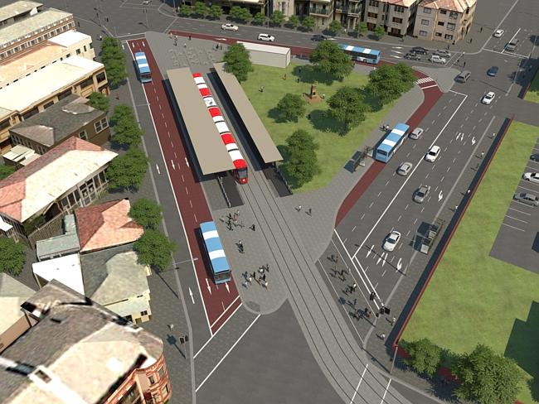

Source: Transport for New South Wales

This minimises the transfer penalty[1] incurred by passengers though the careful siting of passenger facilities and use of land. Another option would be to have the bus stop at the same platform as the light rail vehicle (once the LRV has departed). Assuming this infrastructure can be created at each stop, this would provide the most seamless transfer between the two modes.

* + - 1. Fares Policy

1. Fares policy is another service issue that needs to be explored as it can have a significant impact on patronage. The current fares system has been simplified, but may still be more complex than necessary. For example each GreenCard (the electronic ticketing medium) needs to be programmed as a short, medium or long distance default fare. This means that when choosing to make a different length of journey, passengers either need another card or they need to ask the driver to change the fare from the default on the card. In the context of HLR, this interaction with the driver (or a conductor) to manage the fare collection will be an additional (inefficient) operational cost. It is also a disincentive to customers and will have a negative impact on patronage.
2. Alternatives to resolve this issue include placement of ticketing devices on each light rail platform, or inside each vehicle. On the platform is typically preferable on a small light rail system, as the movement of devices inside each vehicle creates added complexity in terms of calculating the fare, electrical interference with base station communications. These complexities caused significant delays in Melbourne and resulted in a material change to fares policy (removing trams from zone 2) which impacted on revenue.

On board GreenCard validation also takes longer (in terms of passenger loading and unloading) and is less safe for passengers (if they are trying to validate the ticket while the vehicle is moving).

###### Technical requirements

1. Technical requirements discussed below include:

* Fleet
* Traction (power supply)
* Depots
* Maintenance

1. The fleet required to operate the HLR will be very small. Options for fleet purchase include second-hand vehicles, off-the-shelf design, bespoke design and a middle-ground that uses off-the-shelf basic components and then adds design variation to the cosmetic external features. In the context of a very small fleet procurement and limited project budget, minimising costs is important. Nevertheless, in the context of what is trying to be achieved a “new and sleek” design may be warranted.
2. Fleet options need to be carefully considered if the project proceeds, because the fleet procurement options can have a significant impact on capital and operational costs. For example, in the testing phase of Gold Coast Light Rail two vehicles have already been involved in crashes significant enough to damage external panels. Under some fleet procurement scenarios these panels could be quite expensive.
3. The HLR traction is expected to be electric (not diesel). The power supply in Melbourne is 600V (DC), while in the Gold Coast light rail it is 750V (DC). HLR should consider the traction options at the same time as considering fleet options.
4. A single depot will be required for a small number of vehicles. In our experience it will not be difficult to find a depot site along the existing track alignment.
5. Maintenance facilities will be required at the depot. The maintenance regime can significantly affect the operational cost of the light railway. The options should be considered in the fleet decisions.

## Supportive policy

This chapter of the report discusses the policy changes that can support HLR. These policies support HLR by increasing potential patronage, bringing forward funding or generating new funding streams.

###### Policy areas

1. A wide range of policy areas were reviewed as part of this project. The following were considered to have the highest potential for helping to solve the problems identified and supporting HLR:

* Implement an Urban Growth Boundary (UGB) to be retained and enforced over a long period of time
* Encourage infill development
* Encourage intensification of employment hubs
* Public housing policies
* Continuing cooperation between the State Government and Local Government
* Greater cooperation between the State Government, the Hobart City Council and UTAS
* Streamline the development approval process in the corridor
* Tasmanian State Government – development and implementation of service standards for public transport

These options are discussed below.

* + - 1. Implement an urban growth boundary

1. An urban growth boundary (UGB) is normally intended to limit housing development in green-field sites. The UGB would restrict the ability of councils to release new green-field land for housing developments in areas which are destined to become highly car dependent. This will also direct and encourage future housing development towards existing urban areas which achieves more efficient utilisation of existing infrastructure (and increases the demand for public transport on routes that are already provided).
2. The Southern Regional Land Use Strategy recommends a Greater Hobart Residential Strategy to manage residential growth by establishing a 20 year UGB. Amendments to the Regional Land Use Strategy, including the UGB, were approved by the Minister in October 2013. Councils will be responsible for adhering to the Urban Growth Boundary through the development of their Interim Planning Schemes.

There is a significant issue in the expectations regarding what happens after 20 years. The UGB will have little impact if the expectation is that it will expand further over time, as it becomes a temporary boundary and the impact on property economics (to spur on in-fill development and higher urban density) is reduced. Cities with successful UGBs (including many in Europe and Portland, U.S.) closely monitor land consumption within (and outside) the boundary. They also take great pride in only ever making very minor strategic changes to the UGB. This has a significant impact on the property market and encourages significant investment in infill areas.

* + - 1. Encourage infill development

1. A UGB is complemented by policies to encourage infill development as a substitute for green-field development. The overall effect would be a reduction in car dependency in Hobart, which will decrease the cost of transportation and therefore improve the Tasmanian economy. It will also improve the resilience of the Tasmanian economy should oil prices continue to rise.
2. Over time, it will increase Hobart’s productivity by reducing travel distances between residential areas and services/employment hub(s). It will also improve social equity and quality of life by encouraging the development of sustainable communities that are accessible to important health and education services.
3. The Southern Regional Land Use Strategy outlines a Greater Hobart Residential Strategy to manage residential growth by establishing a 20 year urban growth boundary and proceeding on the basis of a 50/50 ratio of green-field to infill (‘brown-field’) development. The Strategy recommends an Infill Development Program to identify key redevelopment opportunities, without relying upon small scale subdivision and unit development to promote these changes. Councils will be responsible for adhering to the infill targets through the development of their Interim Planning Schemes.
4. DIER, STCA, DED and some metropolitan Councils are currently working together to identify barriers and opportunities (including intervention mechanisms) to encourage greater levels of infill development in Hobart. There has also been a shift toward providing affordable housing and public housing in the CBD, close to Activity Centres and close to high frequency public transport corridors.

Overall these policies can be strengthened through restrictions on out-of-centre development and specific programs that help to reduce development risks associated with infill sites. Government is well placed to assume risks that developers will not (such as contamination costs associated with dockland sites) and then recoup the investment with land sales for higher intensity uses.

* + - 1. Encourage intensification of employment hubs

1. Developing policies that facilitate, encourage and prioritise the development of important services, such as education and health services, along the corridor. This could include:

* Improving communication between key stakeholders such as service providers, councils and service users.
* Providing incentives for the private sector to develop facilities along the corridor, such as rezoning land to allow for appropriate development or streamlining the development application process.
* Councils actively combining land allotments to allow for development of sufficient scale.
* Providing policy incentives to encourage concentration of employment in hubs in the Hobart CBD and also along the corridor. For example, land zoning policies could be relaxed to allow more intensive commercial development.

As an initial step, Councils are developing new Interim Planning Schemes which provide for mixed use and inner residential zones adjacent to key public transport corridors. Currently, mechanisms to encourage greater levels of infill development being explored include bonus floor/density space ratio, identification of priority areas for infill development and establishment of planning guidelines.

* + - 1. Public housing policies

1. Policies can be developed to ensure future public housing developments are located in areas with high quality public transportation. These areas tend to have good links to Hobart CBD where important services are located. These policies would be designed to ensure that future public housing residents (elderly, people from lower socio-economic backgrounds) are located in areas with good access to important services, education and employment opportunities. This will improve social equity and reduce travel costs for those people.
2. The Tasmanian Government has adopted standards and guidelines for the development of public housing. These reflect the need to develop housing in infill areas and along transport corridors.

The Tasmanian Government has committed to construction of social housing in inner infill areas, including the proposed Trinity Hill housing project in North Hobart which includes 46 independent living units.

* + - 1. Greater cooperation between the State Government and Local Government

1. Greater Hobart consists of several independent Local Government areas and lacks a unified governance body with legislative authority over land use and transport decisions (policy or statutory). This is a particular issue as each local municipality has their own objectives and priorities. Together with a historic lack of clear State Government direction regarding transport and urban planning policy, this has contributed to a sprawling polycentric city that lacks coherent or integrated metropolitan planning.
2. The Southern Tasmanian Regional Land Use Strategy 2010 -2035 was jointly developed by the Southern Tasmanian councils and the Tasmanian Government. The parties will continue to work together to implement the Strategy, including working to ensure that Planning Schemes reflect the Strategy.
3. Greater communication between the local councils and the State Government will ensure greater alignment between the objectives of the State Government and local Governments, particularly in relation to land use planning. This will ensure the smooth implementation of the Southern Tasmania Regional Land Use Strategy 2010-2035 (and other initiatives as they arise) which will curb urban sprawl, encourage denser developments and decrease car dependence.

In addition, the Draft H.30 Hobart Capital City Plan 2011-2040 has been developed jointly by State and Local Government. The State Government will continue to support the Strategy through the work being undertaken in relation to passenger transport planning, including the development of Transit Corridor Plans.

* + - 1. Continuing cooperation between the State Government, the Hobart City Council and UTAS

1. Continuing cooperation between these three parties will support UTAS' development of teaching, research and residential facilities in the CBD, which will invigorate the CBD, increase its scale and diversity, attract investment and improve the economic performance of the region.
2. The Tasmanian Government, Hobart City Council (HCC) and UTAS will continue to work together to support the development of UTAS' teaching, research and residential facilities in the CBD. This has included cooperation aimed at improving passenger transport options (including active transport and public transport links) for students and staff of the University.
   * + 1. Developing and implementing public transport service standards
3. Developing and implementing universal service standards will provide a framework for the provision of more efficient (reliable, frequent and cost effective) public transport across all locations and providers. This includes ensuring that public transport services are procured by Government in a consistent manner with resources allocated equitably based on need and minimum service standards.
4. Developing and implementing State-wide service standards would improve the quality (speed, frequency, reliability) of public transport. In particular they would:

* Provide a better definition of what government wishes to procure in terms of services per hour, route coverage and network principles.
* Improve the efficiency of public transport services by placing priority on specific high capacity corridors.
* Define customer awareness and accurate expectations of services in their area.
* Focus public transport resources to provide services with high frequency over the largest possible span of hours.
* Encourage the design of more direct, faster and higher frequency routes.

The Tasmanian Government is currently developing service standards for public transport.

* + - 1. Streamline the development approval process in the corridor

1. Making it easier and quicker for developers to gain planning and development approvals for development along the corridor will increase the level of interest in pursuing infill development. So long as the developments are compliant with strategic intent for the corridor (such as appropriate density and design) these will improve the corridor. Streamlining the approval process for certain types of building projects would encourage development along the corridor which would:

* Increase public transport usage through placement of both residents, and destinations they need to travel to on a regular basis, around the northern public transport corridor
* Reduce overall car dependency and greenhouse gas emissions, by diverting some development away from car dependent fringes of Hobart.

## Conclusions

1. This report has considered the next steps required to progress planning for HLR. It included consideration of the project risks, legislative framework and policies required to support the case for HLR.
2. There are significant doubts as to whether the HLR would provide a worthwhile investment for the community in the short term, given the wide range of other options that can be implemented to solve the identified problems. The project benefits rely heavily on reliable travel time reductions (compared with the existing bus services) and an increasing demand for travel between Hobart and the northern suburbs.

Therefore, preliminary planning efforts should focus on increasing the density of residential development and trip attractors in the corridor and testing project assumptions to ensure the travel time reductions can be reliably achieved.

###### Next steps

The priority actions from here are to investigate and implement policy changes that support the existing public transport corridor from Hobart CBD to the northern suburbs. The policies should support public transport by giving higher-capacity public transport vehicles priority through intersections and on congested links. It should also intensify the density of population and activity (employment, retail and recreation) along the corridor so that it attracts a greater proportion of Hobart’s travel demand.

With regards to the HLR project, some clarifying steps could be taken to determine if alternative funding options might be applicable in the local context, and whether there are technical options that could provide greater service reliability at a lower cost to the currently favoured Optimal Operating Service Model.

## References

1. Please see the Riverline – Hobart Light Rail - Strategic Assessment
   1. Appendices

Appendix A Level crossing example 39

Appendix B Risk register 40

#### Level crossing example

1. The level crossing safety measures required for light rail are different to those required for heavy rail and should reflect the nature of the road being crossed, the traffic levels and surrounding land uses. A good example of a light rail level crossing treatment can be found on Bridport Street, South Melbourne.

The particular location caters for a total of 12 light rail vehicle movements per hour in the peak. The crossing has warning bells and a traffic signal for road movements and a signal for light rail movements. There are no pedestrian signals and no gates or physical barriers. Images from the site are provided in Figure 5 below.

Figure : Route 96 at Bridport Street, South Melbourne

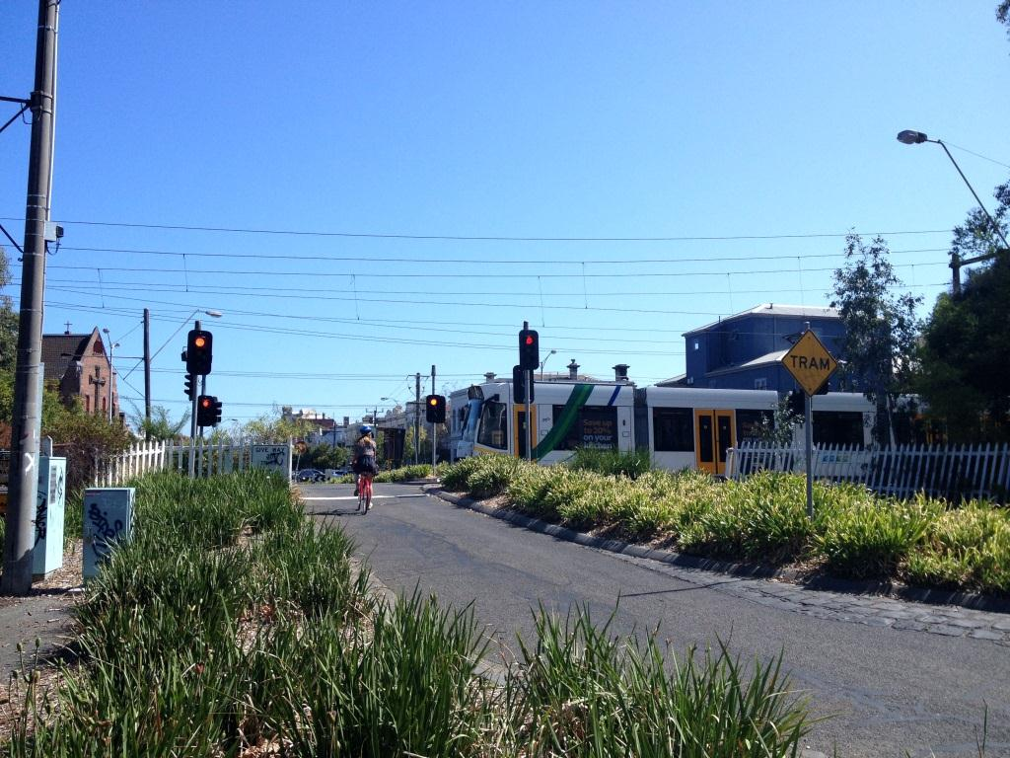

1. When this crossing was for a heavy railway it included boom gates and louder warning bells. The frequency of light rail services resulted in an increase in crossing closures and caused annoyance to local residents. The solution was to install traffic signals which reduce the amount of time the light rail closes the road and different (softer) bells which create less nuisance.

#### Risk register

1. On 11 December 2013, the PwC review team facilitated a one day risk workshop involving the various State and local government entities having policy, planning or regulatory responsibilities relevant to the proposed HLR. The workshop was conducted to confirm the existing and identify new risks (including causes, potential impacts and the associated likelihoods) attributable to the HLR project. It was focussed on high level risks commensurate with the current project status. The table below summarises the discussions that occurred at the workshop.

|  |  |  |  |  |  |  |  |  |  |  |  |  |  |
| --- | --- | --- | --- | --- | --- | --- | --- | --- | --- | --- | --- | --- | --- |
| No. | Risk Title | Strategic Assessment | IA Approval | Design & Construction | Operations | Risk Description (What could happen?) | Causes (How and why could it happen?) | Likelihood (How often could it happen?) | Consequences (So what if it does happen? ) | Current Mitigation Strategies (What are we doing about it?) | Consequence | Likelihood | Risk Rating |
| 1 | Federal government funding & support | Y | Y | Y | Y | Risk that the federal government does not fund a public transport project in Tasmania. | Change of government policy regarding infrastructure.  Change of government causes deferral or change of decision.  Lack of commitment at government levels to infrastructure development.  Lack of money at Commonwealth level.  Delay in submission of funding request.  BCR analysis does not meet criteria for funding.  Timeframes for funding decisions not met by multiple approval authorities.  Justification for project does not align to government priorities.  Unable to demonstrate path to achieving urban renewal targets. | Possible. Concern expressed during the workshop that federal government commitment to HLR is lacking, which increases the likelihood of no or inadequate funding. | Catastrophic impact on all aspects of the project. No funds to go means no project.  Need tripartite support - $ - legal and policy from Commonwealth, State and Local? If we don’t get it we wont have.  Fail IA - no funding (noting there are other sources).  IA process/project graded as "in pipeline" but not enough to move forward. | Satisfy ourselves as to project viability.  Capture & communicate wider benefits to Commonwealth, including urban renewal.  Increase engagement with government to build a joint approach.  Environmental benefits - capture and promote.  Identification of correct goals to demonstrate the necessity of the project.  Independent assessment and inputs to the IA and CoA submissions.  Have to find funding from 'local' and state sources (incl private).  Promote wider benefits - need to do more, but have "Brand Vision". | Catastrophic | Possible | **Very High** |
| 2 | State government funding & support | Y | Y | Y | Y | Risk that the Tasmanian government does not commit to funding a proportional amount of the development, construction and operation costs. | State government currently managing a budget deficit. HLR is not a budget priority, so government is unlikely to commit to proportional funding without a solid case for benefits at a reasonable cost.  Budget pressure may dilute the overall subsidy to public transport, forcing further cost cutting of existing and proposed urban transport systems. | Possible. Government budget pressure unlikely to be addressed in the near term. | DIER cannot secure funding for the project development phase. HLR project stalls or fails entirely. Infrastructure Australia does not support project unless state government commits funding.  Inadequate funds for sustained operation. | Development involves external experts, consultancy.  Land redevelopment by private developers is a consideration, but needs to be enabled.  Independent assessment and inputs to the IA and CoA submissions.  Promoting wider benefits - need to do more, but have "Brand Vision". | Major | Possible | **High** |
| 3 | Community and stakeholder acceptance & commitment | Y | Y | Y | Y | Risk that community and other stakeholders are not committed to the success of the project. | Stakeholders are not identified and engaged prior to the planning stages.  Additional stakeholder needs are identified during construction, potentially leading to changes in scope.  Poor coordination of stakeholder engagement processes.  Future development clashes with other community needs.  Can’t demonstrate strong argument for the HLR. | Possible - the stakeholder engagement processes are in place but there is a low level of awareness amongst community of the benefits from the HLR. | Major to catastrophic impacts across all phases of the project. Community support means voting support for government - community acceptance unlikely without compelling business case and opportunity for improved services and lifestyle.  Resident complaints about potential for disruptive noise, passengers activity, lighting, level crossing noise, vandalism.  Residents could picket the line and build negative perception. Could build to a crescendo if stakeholders not engaged well.  Project scope change due to lack of engagement and support, adding cost to execution.  Land owner consent not given, causing schedule delays in delivery. | Project is being planned, funded and delivered to appropriate standards and requirements for community consultation.  Design will need to demonstrate minimal impacts on other uses. | Catastrophic | Possible | **Very High** |
| 4 | Competing modes of transport | Y | Y | Y | Y | Risk that the HLR does not demonstrate or reach economic and operational viability targets due to the prevalence of competing modes of transport. | The urban bus routes are reasonably well developed and may be able to deliver a similar level of service as the HLR.  Ferry and heavy rail options have not been investigated.  Competition from cars/buses will always be an issue.  Trams are regarded as a good transport option (perception of community).  Dependency on tourist sites for demand. | Possible - project success depends on changing user behaviour. | All aspects of the project will be impacted. Failure to demonstrate a path to shifting patronage to HLR will result in the viability of the project being challenged, ultimately resulting in a lack of, or no, project funding. | TBA | Major | Possible | **High** |
| 5 | Local government support | Y | Y |  | Y | Risk that local councils along HLR corridor do not support the development of the HLR. | Councils may express a desire for the HLR product, without making a commitment (financial assistance, development reform, planning approvals).  Socio-demographic profile of the northern suburbs may limit the council's ability to stimulate interest or support. | Possible. Local government are not active participants in the project proposal at this stage. Could be a game changer. | Project does not get through the strategic assessment due to the lack of local support, because take up will fall short of operational targets.  HLR does not achieve operating efficiencies envisaged.  Inadequate funds for sustained operation. | Capture and communicating benefits to local government.  Active engagement of local government and key stakeholder groups along the HLR corridor.  Promote wider benefits - need to do more, but have "Brand Vision". | Major | Possible | **High** |
| 6 | Change of governments, departments or project sponsorship | Y | Y |  | Y | Risk that a change to the existing structure of project ownership and sponsorship results in a change of priorities for funding of public transport projects. | Elections – Project is highly sensitive to changes in political support such as Commonwealth change to urban rail federal funding policy following the last election. | Likely. Budget and political pressures at state and federal levels are being accentuated as a result of change in government. | Project fails to proceed through strategic assessment.  Project stops, stalls or tumbles in the ranking of IA priorities.  Change of scope for route, technology or funding arrangements that significantly changes operating profile.  Alterations to underlying assumptions about project scope and supporting elements (land renewal, bus services, etc). | Satisfy ourselves as to project viability.  Capture & communicate wider benefits to Commonwealth, including urban renewal.  Increase engagement with government to build a joint approach.  Environmental benefits - capture and promote.  Identification of correct goals to demonstrate the necessity of the project. | Major | Likely | **High** |
| 7 | Urban renewal targets | Y | Y |  | Y | Risk that the urban renewal targets along the rail corridor are not met or are not feasible. | Land or property available for renewal adjacent to rail corridor may not be sufficient.  Demand for renewal may not eventuate due to options for land use, development costs, patronage on HLR.  Policy changes result in a lack of suitable land parcels or constraints on development.  Too much land on Domain around corridor.  Lack of development options along the corridor. | Possible - there is sufficient awareness of the existing constraints and opportunities for renewal along the corridor and a perception that there's not enough demand. | IA funding (for the whole project or specific stages) may be dependent on urban renewal targets being met.  Stakeholders don’t get the land value uplift or renewal, and HLR doesn’t get the target patronage, leading to operating losses. |  | Minor | Possible | **Moderate** |
| 8 | Legal challenge to approvals | Y | Y |  |  | Risk that interest groups, project detractors or land owners along the proposed HLR corridor challenge the approvals process. | Interest groups unconvinced of the economic or environmental benefits of the project.  Land owners seeking compensation for potential impacts on land value.  Legal challenges during the Strategic Assessment around benefits and funding options (statutory processes challenged, indigenous communities). | Low likelihood as workshop experience with rail corridor approvals suggests it is not so difficult in Tasmania. | Minor impacts on strategic assessment and IA approval, mainly contributing to delays in strategic assessments.  Cost escalation or change to plans causes delay to IA approvals.  Delays in planning approvals and appeals.  Difference of opinion amongst stakeholders. | Use streamlined approval provisions in State and Commonwealth legislation if available.  Identify key stakeholder concerns early and seek to identify remedies. | Minor | Unlikely | **Moderate** |
| 9 | Integration with existing infrastructure | Y | Y | Y |  | Risk that the existing infrastructure is unsuitable for integration of the HLR technologies. | Failure to fully consider existing infrastructure in planning and design of proposed HLR. | Unlikely - Project is being planned, funded and delivered to appropriate standards and requirements. | May lead to inadequate facilities for stops, access, transfers.  Location of ticketing and enquiries hubs may be inadequate. | Independent review of proposed schematics and interface issues. | Minor | Unlikely | **Moderate** |
| 10 | Integration with other transport modes | Y | Y | Y |  | Risk that the integration of HLR timetables with other modes of transport is inadequate. | Design of light rail timetables does not completely address integration with other modes (predominantly buses), leading to the potential for some passengers to be stranded. For example if the feeder buses are delayed passengers may miss the light rail service and be much worse off.  Other potential causes include the locations of stops, car parking and bicycle facilities. | Possible. The design of the route and stops takes this risk into account, but there will be assumptions and compromise. | Operational viability of the HLR is jeopardised.  Passenger outrage or under-utilisation of HLR. | Integration with existing network:   * Facilities. * Ticketing/fares. * 3-5 minute transfer. * Transfer penalty. | Possible | Minor | **Moderate** |
| 11 | Support for recommended rail technology | Y | Y | Y |  | Risk that the recommended technologies for HLR are not approved or endorsed. | Proposed electrification and opposition to catenary wires across Sullivans Cove may re-open the debate about alternative traction technologies. | Unlikely - Project is being planned, funded and delivered to appropriate technical standards and requirements. The business case for the selected technology will take into account the most pragmatic, safest and cost effective technology for rail vehicles. | This will complicate design, leading to additional costs/feasibility. Project viability would be placed at risk. | Getting suitable LR vehicle technology options in the business case to meet access and operating space on road. | Major | Unlikely | **High** |
| 12 | Demand for services | Y | Y |  | Y | Risk that the demand for HLR services cannot be demonstrated or achieved. | Potential issues related to light rail:   * Removal of existing preferred bus services. * Lack of core demand. * Inadequate location of stops. * Parking (free) as impediment to mode shift.   Not enough people using the service, due to:   * Not enough light rail stops. * Catchment density and access arrangements. * Bus transfer times. * Feeder bus reliability.   Land use planning changes take decades.  Patronage is less than forecast.  There may be unexpected costs. | Possible, as the proposed route already provides access to other transport services. | Major impacts on the strategic assessment, IA approval and operations phases.  Increased focus on ferries reduces the degree of unified commitment to rail.  Some other areas of Hobart may want light rail, but the mode cannot be as viable in these locations. | Address the mode versus mode debate in the proposals and awareness campaigns.  Consider how light rail can be most effectively be supported by a range of other policies that stimulate long term demand in the corridor. | Major | Possible | **High** |
| 13 | Regulatory approval |  | Y | Y | Y | Risk that DIER fails to obtain approval for the planned operation of the HLR. | Poor risk processes.  Lack of alignment between project, construction and accreditation.  Unable to prove to regulator that rail safety issues have been properly managed.  Full DDA compliance cannot be achieved.  Funding model is not economically viable.  Infrastructure viability for operation (ie suitable/maintainable).  Poorly defined study area ie. Not taking into account all elements and impacts associated with the project.  Inability to demonstrate an adequate BCR.  Lack of broad support across all sections of the community.  Lack of political support at a informal level.  Not successful in gaining IA support.  Inadequate planning.  Changes to government funding processes.  Unforseen issues or errors in technical information.  Other developments having impacts - changing focus or parameters. | Possible, as the regulatory approvals are complex and multi-tiered.  DIER does not have established processes for managing these approval processes in a passenger rail context. | Catastrophic impact on the project overall, due to significant delays or rejections of the business case.  Timeline for statutory approvals assessment blows out due to reliance on external assessment bodies.  Won't meet timing requirements for IA approval.  Cannot start operation on time - don't deliver the benefits to users and government. | Existing approval process with set timelines.  Project of regional significance.  Accreditation (Get and Maintain).  Management Actions:   * Risk Identification Process. * Use of technical expertise to ensure regulatory approvals are identified and understood at an early stage, so far as is reasonably practical. * Capacity of project delivery team. * Safety Management System lessons from others.   Communications Plan.  Offer opportunity for private sector investment.  Develop a safety case for approval. | Possible | Catastrophic | **Very High** |
| 14 | Design to meet operating requirements |  | Y | Y | Y | Risk that the design of the rail infrastructure (track, signalling, vehicles, level crossings, etc) does not meet standards, requirements for safe and efficient operation. | Lack of information about materials/costing.  Does not meet operating parameter.  Off-the-shelf or bespoke vehicles and associated infrastructure.  Scope poorly defined (in terms of who is the customer and what needs are being met by the project design).  Inability to design the operations perfectly to ensure no delays at passing loops. | Unlikely, as the development of the scope, solution and submissions are collaborative efforts with users, other stakeholders and government. Independent consultants and experts are being engaged. | Design construction delays.  Light rail vehicles (trams) don’t get priority at CBD signals.  If vehicles get the lights they are on time, if not they delay inbound services.  Travel time savings/benefits/patronage will not be achieved.  Cost of retrofitting second track will be prohibitive.  Setting operating parameters - speed not accomplished. | Procurement & selection of designer with appropriate qualification and expertise.  Awareness campaigns with community.  Determine travel times on probability of delivery (understand margin of error).  Fixed budget or specific service outcome.  Independent reviewer of proposed designs.  Learn from others, especially mistakes (and include in project review). | Moderate | Unlikely | **Moderate** |
| 15 | Design to meet user needs |  | Y | Y | Y | Risk that the rail route and design do not meet the needs of users in the Hobart city centre and other significant user locations. | Failure to thoroughly investigate all user needs and to consider them in the design of the HLR route and infrastructure.  Light rail must terminate as close to Hobart city centre as possible requiring use of Davey and/or Macquarie St, which will prove challenging as these streets do not have transport capacity to add light rail without losing parking lanes, reducing/removing width for pedestrians and cyclists and /or traffic lanes (= unreasonable congestion in peaks). | Unlikely, as the development of the scope, solution and submissions are collaborative efforts with users, other stakeholders and government. | Moderate impacts during the approval and D&C phases.  User groups contest the proposed design.  IA does not approve the project because the user need is unclear or not addressed in the design. | Collaborative planning and development. | Moderate | Unlikely | **Moderate** |
| 16 | Deliver to budget and/or schedule |  |  | Y |  | Risk that the delivery phase of the project design and construction (D&C) fails due to cost or schedule over-runs. | Industrial Action.  No or inadequate design or construction resources available for this project.  Contamination issues and Macquarie point.  Lack of expertise, qualifications with internal resources.  Inadequate procurement and Quality Control in the design and construction phases.  No internal design and construction resources.  Environment - unexpected discoveries. | Possible. The project is likely to be competing for D&C resources against other major developments in the mainland states. | Major impact on the D&C phase. Delays to project start and new funds need to be sought.  Costs blow out significantly due to one or many complex issues such as.   * Design and construct contract conditions. * Variations. * Deadlines (too short time frame = quality loss). * Scope creep and project delay. * Design does not meet product promise. | In-house/agency technical expertise.  consultancy - design - buying from interstate to offset lack of local knowledge.  Procurement of contractors & construction businesses familiar with light rail.  Selection criteria for design include bespoke and off-the-shelf options. | Major | Possible | **High** |
| 17 | Funding for sustained operation |  |  |  | Y | Risk that operating funding is inadequate for continued operation of HLR at target levels of performance. | Lack of demand due to availability of alternative transport options.  Population density does not match the passenger transport capacity for HLR. | Possible - absence of contemporary rail option in Hobart creates difficulty in accurately modelling demand on basis of actual mode choices. | Leads to a larger operating deficit for state and local governments to cover.  Creates an ongoing budget burden, resulting in cost saving initiatives such as less maintenance, fewer services – potentially a downward spiral of reducing service on HLR. | As above. Develop case for wide public policy agenda.  Understand level of support by the new State government. | Moderate | Unlikely | **Moderate** |
| 18 | Health & Safety Incidents |  |  |  | Y | Risk that people or property may be harmed during the construction and operating phases of the HLR project. | Fatality during construction (work site accident).  Inadequate design of safety systems for the operation of HLR.  Hazardous interactions/events with overhead wires. | Possible, as the introduction of new rail into urban areas will create some safety challenges. | Operation of the HLR will be subject to work OHS regulatory review, intervention and penalties for breaches. | Design to safe operating standards. | Major | Possible | **High** |
| 19 | Network congestion |  |  |  | Y | Risk of congestion in the HLR network. | Level crossing interaction - vehicles. High use intersecting roads will need to be closed at frequent, brief intervals. | Congestion could occur each peak hour | Car traffic could be delayed, may shift people to public transport, but otherwise may have negative productivity impacts. | Design to avoid or alleviate congestion in hot spots. | Minor | Unlikely | **Moderate** |
| 20 | Network safety |  |  |  | Y | Risk of safety incidents on the rail network causing damage to rail assets and operations. | Level crossing collision.  Poor integration with other transport modes.  Bus/train/car/cycling.  Car/truck/bus tries to get through crossing before LRV.  Pedestrian/cyclist on tracks unaware of LRV approaching.  Inadequate maintenance.  Derailment into waterway. | Could be minor safety incidents on a daily basis in the operational phase. | People are injured or killed, leading to prosecution and penalties.  Line could be closed.  New safety works could be required.  Public outrage.  Changes to operation.  No significant mitigation/barriers. | Refer to design.  Public awareness campaign. | Major | Possible | **High** |

1. Transfer penalty is the term given to the annoyance and reduced value incurred by a passenger who is forced to transfer between public transport services in order to complete their journey. The penalty is not monetary or financial although estimates of the value (in time or dollars) of such inconveniences have been researched.