

|  |  |  |
| --- | --- | --- |
|  | **Project:** Freight Logistics Coordination Team Major Consultancy Support to Work Program  Tasmanian Shipping and Ports | Reference: 234986  **Prepared for:** Department of Infrastructure, Energy and Resources  Revision: 0  9 September 2013 |

Document Control Record

Document prepared by:

Aurecon Australia Pty Ltd

ABN 54 005 139 873

Aurecon Centre  
Level 8, 850 Collins Street  
Docklands VIC 3008

PO Box 23061  
Docklands VIC 8012

Australia

|  |  |
| --- | --- |
| **T F E W** | +61 3 9975 3000 +61 3 9975 3444 melbourne@aurecongroup.com aurecongroup.com |

A person using Aurecon documents or data accepts the risk of:

1. **Using the documents or data in electronic form without requesting and checking them for accuracy against the original hard copy version.**
2. **Using the documents or data for any purpose not agreed to in writing by** Aurecon**.**

|  |  |  |  |  |  |  |
| --- | --- | --- | --- | --- | --- | --- |
| **Document control** | | | | | | |
| **Report Title** | | **Tasmanian Shipping and Ports** | | | | |
| **Document ID** | |  | **Project Number** | | **234986** | |
| **File Path** | | **P:\IND\234986 DIER - Freight Logistics\report\Final Supply Chains Report Part II 20130829 pmc version** under construction.docx | | | | |
| **Client** | | **Department of Infrastructure, Energy and Resources** | **Client Contact** | | **Department of Infrastructure Energy and Resources** | |
| **Rev** | **Date** | **Revision Details/Status** | **Prepared by** | **Author** | **Verifier** | **Approver** |
| **0** | **24 May 2013** | **Initial Draft** |  | **MS/NDS/NP** |  | **PC** |
| **1** | **01/08/2013** | **Draft for FLCT review** |  | **MS/NDS/NP/PC** | **SM** | **PC** |
| **2** | **12/09/2013** | **Internal Review** |  | **MS/NDS/NP/PC** | **KK** | **PC** |
|  |  |  |  |  |  |  |
| **Current Revision** | | 0 | | | | |

|  |  |  |  |
| --- | --- | --- | --- |
| **Approval** | | | |
| **Author Signature** |  | **Approver Signature** |  |
| **Name** |  | **Name** | **Peter Carney** |
| **Title** |  | **Title** | **Supply Chain Manager** |

**Disclaimer**

This report has been prepared solely for the benefit of the Freight Logistics Coordination Team (FLCT) and in accordance with instructions given by or on behalf of the FLCT and in the circumstances which existed at the time of preparation. It is not possible to make a proper assessment of the report without a clear understanding of the terms of engagement under which the report has been prepared, including the scope of the instructions and the directions given to and the assumptions made by those who prepared the report. The report may not address issues which would need to be addressed if the particular intention, environment, circumstances, time, requirements and brief are different from those for which this report has been prepared. This report may also make assumptions about matters which a third party may not be aware. It should not be used or relied upon or used for any other project or in a different set of circumstances and requirements without an independent check being carried out as to its suitability, relevance or accuracy. Aurecon accepts no responsibility or liability for the consequences of the report or the information contained therein being used or relied upon for a purpose other than the purposes for which it was commissioned at the time of the commissioning or for any unauthorised use by its client or any third party.

The information in this report has been collected through detailed interviews with industry, peak organisations and infrastructure providers. The information collected includes both business-related data and the confidential views of participants. Confidentiality of discussions and the aggregation of data and views were key components supporting stakeholder participation.

# Contents

1 Contents 2

2 Executive Summary 4

2.1 Background 4

2.2 The Nature of Tasmania’s Shipping and Ports 4

2.3 Findings 5

2.3.1 The Cost of Bass Strait Shipping Services 5

2.3.2 International Liner Service Calls at Tasmania 6

2.3.3 Terminal Operation and Utilisation 7

2.3.4 Port Capacity and Future Planning 7

3 Study Objectives and Methodology 8

4 Shipping 9

4.1 Bass Strait Shipping Service Providers 9

4.1.1 TT-Line 10

4.1.2 SeaRoad Shipping 11

4.1.3 Toll-ANL 12

4.2 Features of Bass Strait Shipping Services 12

4.2.1 Overnight Services 12

4.2.2 Freight Profiles 13

4.2.3 Terminal Utilisation 13

4.2.4 International Transhipment 13

4.3 Issues Affecting the Cost of Shipping across Bass Strait 14

4.4 Overseas Short Sea RORO Shipping Service Rates 15

4.4.1 Comparison of Services and Rates Across the Cook Strait 15

4.4.2 Comparison of Services and Rates Across the North Sea 16

4.4.3 Consideration of Services Between Spain and Majorca/Las Palmas 17

4.5 International Liner Service Calls at Tasmania 19

4.6 Shipping Economics 22

4.7 A Comparison of Service Features of International Liner Services and Bass Strait Services 24

4.8 Indicative Freight Rates for Liner Services to and From Australia 24

5 Ports 26

5.1 Terminal Features 26

5.2 A Comparison of Tasmania’s Northern Ports 29

5.3 Commentary Tasmania’s Northern Ports 30

5.4 Freight Specialisation of Tasmania’s Northern Ports 31

5.5 Port Productivity 34

5.6 Port Expansion 37

5.6.1 Port of Melbourne 37

5.6.2 Port of Burnie 38

5.6.3 Port of Devonport 40

5.6.4 Port of Bell Bay 43

6 Findings 47

7 Appendices 48

7.1 List of Tables and Figures 49

7.2 Commodity Classifications 51

7.3 References 53

7.4 Companies Contacted 55

# 

# Executive Summary

## Background

The Freight Logistics Coordination Team (FLCT) was established as part of a one-off $20 million Australian Government funding package to assist Tasmanian exporters following the cessation of international container shipping services to Tasmania in 2011.

The FLCT is an independent expert advisory body comprising 19 senior representatives from major shippers and producers, infrastructure providers, freight logistics companies and peak industry bodies. The FLCT has a clear focus on outcomes that deliver improved freight efficiency for Tasmanian businesses, and support business growth.

As part of the FLCT’s work, Aurecon was engaged to undertake a major study on supply chain quality, cost and benchmarking. The objectives of this study are to undertake a detailed analysis of:

* transport and logistics supply chains across key commodity groups and benchmark them in terms of quality and cost; and
* the cost of shipping as a modal component of the supply chain.

Consistent with these objectives, the outcomes of the study are presented in two reports:

1. *Tasmanian Supply Chains*

In this report Aurecon examined the supply chains of all major non-bulk commodities produced within Tasmania, and provided quantitative information and expert qualitative observations on the costs, quality and efficiency of supply chains at both an individual and aggregated level. The study has involved detailed interviews with a wide range of freight users and stakeholders, supported by site visits, analysis of freight and cost data and our own industry knowledge.

1. *Tasmanian Shipping and Ports*

In this report Aurecon examined the cost, capacity and the relative efficiencies of Bass Strait shipping services and Tasmania’s three northern ports. It also investigated the underlying cost considerations to vessel owners which form the basis of freight rates and considers the potential for the resumption of direct call international shipping services to Tasmania’s north coast.

## The Nature of Tasmania’s Shipping and Ports

Tasmania relies on moving freight in and out of the state by sea through its sea ports. Sea freight constitutes 99% of all freight movements to and from the island by volume. Tasmania’s three northern ports carry the majority of freight, with Burnie the highest volume port for container freight. Shipping freight services across Bass Strait service both the domestic and international markets as feeder services via transhipment through the Port of Melbourne. A key feature of the service offered by all Bass Strait shipping operators is the provision of an overnight outbound service which integrates with road transport allowing day time deliveries to mainland destinations. Many businesses have designed their supply chains around this aspect of the shipping services.

This Report, Tasmanian Shipping and Ports, examines the features, benefits and relative efficiencies of Bass Strait shipping services and Tasmania’s three northern ports. It also investigates the underlying cost considerations to vessel owners which form the basis of freight rates and considers the potential for the resumption of direct call international shipping services. Key findings in each of these areas are set out below.

## Findings

### The Cost of Bass Strait Shipping Services

For freight users, the price of shipping across Bass Strait is a significant cost of doing business. As discussed in Aurecon’s report ‘Tasmanian Supply Chains’, the Bass Strait shipping cost component is proportionally the largest single cost in a typical Tasmanian freight user’s transport supply chain. This report also identifies that there are price variances within the market, largely based on volume but also on service (time sensitivity of fresh produce).

The price of shipping across Bass Strait is often raised in comparison to the cost of direct international shipping to Asia or in comparison with similar short sea services elsewhere in the world.

This study found that Roll on/Roll off (RORO) vessels used by Bass Strait shipping operators are well suited to the variety of freight that it serves (i.e. containers, trucks, break bulk and over-dimensional). This type of vessel also provides the flexibility for fast loading and unloading of time sensitive freight.

RORO vessels are used elsewhere in the world where trade is similar. Short sea trades also use conventional or container vessels. These typically serve trades where freight is not ‘time sensitive’ – generally bulk freight or freight in containers that are not required to be delivered to the market quickly.

For vessel owners, it is estimated that 65% of costs are fixed or exist regardless of activity and 35% are variable or related to volume and activity. A significant characteristic of shipping operations are high capital costs. Operating costs are also largely fixed. These costs include crewing, maintenance, insurance etc. Similar to aviation, the shipping industry is highly regulated. Key factors supporting an economic return on this investment are the use and utilisation of the vessel and maximising ‘economies of scale’ (i.e. assuming sufficient demand, the larger the vessel, the more freight it will carry for the same fixed crewing and maintenance cost).

A comparison of costs of liner services to Asia from the mainland and Bass Strait shipping to the mainland is not appropriate. This is because the liner service is fundamentally different and has different market drivers. Compared to Bass Strait services, International Liners carry significantly greater volumes, have a higher degree of uniformity in the presentation of freight, have longer delivery windows and lower service frequency. In addition, the Australia to Asia freight rate is substantially less than from Asia to Australia due to the imbalance of containerised freight on this trade route. Shipping lines offer discounted rates to shippers who want empty containers repositioned north.

The study undertook two benchmarking studies of short sea RORO shipping services similar to Bass Strait. While it is difficult to find comparable services and operating and regulatory environments; broadly comparable nominal rates on these benchmark services indicate that Bass Strait prices appear to be higher by approximately 24%.

This price difference should however be put into context. It is in part influenced by costs which are higher in Australia, mainly due to Australian labour costs and fuel. This report found that these input costs for Australian shipping to be 23% higher than European costs.

For Bass Strait shipping operators, the cost of providing shipping services is impacted by:

* Labour costs. Being a coastal trade, Bass Strait shipping falls under Australia’s cabotage laws meaning only Australian flagged and crewed vessels can operate this trade. The impact on the cost of freight is that the wages and costs for Australian crews are three to six times higher than rates of international flagged vessels.
* Bunker fuel prices. Australian fuel costs are substantially higher than prices in the main bunkering ports in the Asian region.

For RORO vessels in general, the cost of shipping services is more expensive than container shipping due to:

* The nature of the trade. Short-sea trade vessels are more heavily utilised and subject to more wear and tear compared to longer distance international liners. Across Bass Strait, freight is loaded and discharged twice in every 24-hour period. This continuous loading and unloading and mandatory rest periods require higher crew numbers when compared to international liners. In comparison, longer distance vessels would only load and discharge freight once every seven days or longer.
* Freight configuration. The variety of configurations in the way freight is presented causes significant operational issues and inefficiencies with receival, handling and storage at terminals; and stowage on board RORO vessels. This impacts the ability to maximise the lift and management at the destination terminal.

### International Liner Service Calls at Tasmania

A direct international container service offers the least complex and lower cost supply chain for Tasmanian importers and exporters. The withdrawal of direct international services in 2011 and current proposals to service Tasmania only if subsidised suggest that the economics of direct call container services are marginal at present.

There is interdependence between frequency of service and demand for freight. If there is sufficient freight ships will call, the more freight the more frequent the calls. Conversely, as with the AAA service, if there is little freight, services will cease of be infrequent.

A basic analysis of available export volumes (based on FY 2011/12 transhipment data from the Port of Melbourne) and allocating these volumes to a service level and port, shows that the volume of containers would have been around 600 TEU per call for a weekly service (assuming that cargoes could be assembled in one place). This is below the volume GPS Logistics Pty Ltd suggests is likely to attract a direct call vessel which was 700 to 1,000 TEU. Our analysis suggests that there is sufficient volume to attract a container vessel to call monthly, but only if volumes were aggregated in one place.

In addition to cargo volumes, there are other issues which may militate against a return to a direct call vessel. The Tasmanian imbalance between import and export flows is one of these. This would result in significant one way freight for an International Liner service. While this could be supplemented with importing empty containers it is unlikely to be profitable and is counter to the normal liner trade servicing Australia from Asia which is predominantly loaded containers moving south.

A further issue is the provision of infrastructure. The trend towards larger vessels will require ever more efficient infrastructure and continual upgrading of facilities. Whether it makes good economic sense for Tasmania to keep pace with shipping infrastructure requirements that larger vessels may require is not clear.

### Terminal Operation and Utilisation

The study found that Tasmanian RORO shipping operations are efficient in their stevedoring operations, and achieve similar “lift” rates to container terminals elsewhere.

Terminals are also efficient in throughput terms as well. The terminals’ willingness to accept freight for shipment on the same day, combined with no requirements for customs clearance on domestic freight results in the utilisation of terminals (on a throughput per hectare basis being high) and comparing favourably with other mainland port terminals.

### Port Capacity and Future Planning

With incremental investment in port infrastructure and some productivity improvement there is sufficient capacity at Burnie and Devonport to cater for the growth in volume, anticipated by the Port of Melbourne until 2025.

The growth rates proposed by the Port of Melbourne seem optimistic compared to recent actual growth rates and so capacity at these two berths may take much longer to be reached. There are additional RORO assets at Bell Bay (currently not operational) that could further add to Tasmania’s RORO port capacity, if required.

Investment in the development of Bell Bay into a 400,000 TEU international container terminal is best made cautiously, in view of the relatively small volumes which would be exported and the likely high cost of such a development.

A comparison of the features of ports shows the key differentiating features between Bell Bay and Burnie are that Bell Bay are the superior port in terms of water depth and that Burnie is best in terms of ocean access. Devonport is not a candidate to be a container port because of land constraints.

The arguments for specialisation of activity at a given port are strongest where they relate to serving their hinterland activities and minimising road freight. In the immediate term the benefits of specialisation do not seem large.

# Study Objectives and Methodology

**Objectives:**

Aurecon’s objectives in this report were to:

* review Bass Strait shipping and associated costs and compare these to similar international services;
* conduct a broad review of Tasmania’s northern ports and compare port productivity to container ports elsewhere; and
* comment on the topics of port specialisation and port expansion in Tasmania, based on a desktop analysis.

**Methodology:**

Interviews were conducted with infrastructure and freight providers, freight forwarders and vessel brokers to understand the nature of Bass Strait shipping.

The task was undertaken by experienced shipping and port consultants, and their findings draw on the interviews conducted, their observations on the operations visited and their own industry knowledge.

Key reports and publicly available data and commentary were also reviewed.

# Shipping

Bass Strait shipping services both domestic and international markets, as a feeder service via transhipment through the Port of Melbourne (PoM). The majority of Tasmania’s freight is destined for domestic markets.

This chapter examines Bass Strait shipping services and examines their features, benefits and inefficiencies to users. It also discusses aspects of International Liner shipping services that are relevant to Tasmanian imports and exports.

Bass Strait freight rates are also compared against similar international short sea trade ferry services.

## Bass Strait Shipping Service Providers

Three shipping operators – Toll-ANL, SeaRoad Shipping and TT-Line – provide an overnight RORO freight service across Bass Strait between the PoM and Tasmania’s northern ports of Burnie and Devonport.

Figure 1 shows Aurecon’s estimate of container market share by volume of TEU for the major shippers in FY 2011/12. Toll is the largest shipping provider with just over half the market share, followed by SeaRoad Shipping and TT-Line. Agility no longer operates their shipping service.

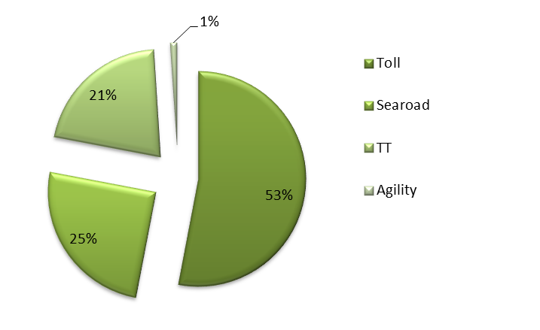

Figure 1: Freight Providers Market Share (Source: Aurecon analysis)

The RORO vessels used by the operators are well suited for the movement of time sensitive freight. Freight is unloaded within a few hours of arrival, making it possible for goods to leave Tasmania in the evening and reach their mainland destination the next day. The service provided by TT-Line is often referred to as an ‘express’ service due to its quicker travel time, departing Devonport at 7.30pm and arriving in Melbourne at 6am.

Each provider operates independently using their own terminals and infrastructure. An overview of the services of the three shipping lines is provided below.

### TT-Line

|  |  |
| --- | --- |
| **Observation** | **Comment** |
| **Vessels and Design** | Two RORO vessels: Spirit of Tasmania I, Spirit of Tasmania II passenger.  Designed for the carriage of passengers (primarily) and freight traffic.  234 car equivalent spaces and about 175 TEU of trailer lanes.  Flexibility in terms of their vehicle deck configurations for the carriage of road freight traffic for the carriage of road trailers. Prefers not to carry containers and other break-bulk freight.  Stern and bow operation enables a drive through service, the vessel is also fitted with stabilisers. |
| **Port and Services** | Operates between Devonport East, Tasmania and Station Pier, Victoria.  7 days per week service.  Operate at a higher speed with a shorter voyage or transit time serving time sensitive freight especially chilled and frozen freight.  Offers “double” trips (an additional daytime service) during peak times. At these times the ferries have to be turned around in 3 hours at the ports requiring efficient unloading and re-loading at the terminal. |
| **Business** | Freight business contributes around 40% of the company’s revenue.  Crew of around 75 persons. Vessels relatively new at around 15 years old.  Market share of 21% moving around 95,000 TEU per annum. |

Table 1: TT-Line

### SeaRoad Shipping

|  |  |
| --- | --- |
| **Observation** | **Comment** |
| **Vessels and Design** | Two RORO vessels; MV SeaRoad Tamar, MV SeaRoad Mersey.  Designed for carriage of mixed freight.  The vessels use a system of “cassettes” onto which containers and other break-bulk freight are loaded. The cassettes are towed onto and off the vessel using special tractors that are able to lift these cassettes hydraulically and position them on to the vessel.  The vessels have 33 cassettes in their main decks and carry road trailers on the upper deck. |
| **Port and Services** | Operates between Devonport East, Tasmania and Webb Dock East No 1, Port of Melbourne.  6 days per week service and a weekly service that calls at King Island (SeaRoad Mersey).  Carry break-bulk, general and refrigerated containerized freight (stowed on the vessel) and road trailers of various types and lengths. Containers and other freight can be stored with a minimum of space being wasted.  Inbound trade is largely general freight, fertilisers, dangerous goods and road and mining equipment.  Outbound freight is largely agricultural products, live cattle and sheep. |
| **Business** | The company also offers a range of associated logistics and freight forwarding services.  Vessels are more than 20 years old and the company is considering options to replace.  Market share of 25% moving around 105,000 TEU per annum. |

Table 2: SeaRoad Shipping

### Toll-ANL

|  |  |
| --- | --- |
| **Observation** | **Comment** |
| **Vessels and Design** | Two RORO vessels: MV Tasmanian Achiever, MV Victorian Reliance.  Use a system of “Mafi” trailers onto which they load containers and which are then loaded onto the vessels. This system offers them an ability to place more containers onto the vessel and also pre-loads and secures them onto the Mafi trailers before the vessel arrives in port.  They can carry a variety of break-bulk freight and road trailers including chilled and refrigerated containers and trailers. |
| **Port and Services** | Operates between Port of Burnie, Tasmania and Webb Dock East No 2, Port of Melbourne.  6 days per week service.  The vessels are flexible in their ability to carry various configurations of freight e.g. break-bulk, general purpose containers, refrigerated containers, road trailers etc., and also carry over dimensional freight (ODs).  The design reduces the time required for loading and unloading of the vessel. |
| **Business** | Toll also offers a range of associated logistics and freight forwarding services.  The Tasmanian Achiever and Victorian Reliance were built in 1999, making them 14 years old.  Market share of approximately 54% moving 240,000 TEU per annum. |

Table 3: Toll-ANL

## Features of Bass Strait Shipping Services

### Overnight Services

The most important feature of Bass Strait services is that each operator provides an overnight outbound service which integrates with road transport, allowing day time deliveries to mainland destinations. Many businesses have designed their supply chains around this aspect of the shipping services.

Freight users and forwarders deliver their containers or trailers to the outbound terminals in the afternoon on any weekday and the freight is able to be collected from PoM the next morning and moved to the end destination or intermediate e.g. warehouse by late morning the day after leaving Tasmania.

This is an important feature for food and agricultural products and particularly fresh and refrigerated seafood and market produce, which is a growing segment of the Tasmanian economy.

A refrigerated container of seafood from Tasmania can be packed at the farm or facility in north or central Tasmania into a ‘reefer’ container around 2:00 pm and delivered to the ferry terminal in Devonport by 6:00pm. The container would be available for pick up in Melbourne by 6:30am the next morning and could be delivered to a market in Sydney by the evening of the same day. This is a 24-hour transit time from farm to market and is probably better than mainland producers achieve.

### Freight Profiles

Freight is presented at Tasmanian ports in a variety of ways:

* Unitised freight is largely in:
  + - containers that are general purpose, food grade and ‘reefers’; and
    - dangerous goods requiring special handling and stowage in the terminal and on the vessel.
* Non unitised over dimensional freight.
* Trucks can be open tops, flat racks, trailers, taut-liners and light commercial vehicles etc.
* Private cars, caravans and vans are moved.

This variety of configurations cause significant operational issues and inefficiencies into the operations with receival, handling and storage at the terminals and stowage on board and affects the ability to maximize the lift on any given voyage and management at the destination terminal.

Shipping operators advise they accept all types of freight and rarely reject freight, though TT-line strongly prefers trailers over containers. This is a feature of the service of all operators. Toll-ANL has the greatest capacity for break bulk and mixed freight.

### Terminal Utilisation

The ability of the shipping operators to accept freight for shipment on the same day and no requirement for customs clearances on domestic freight means the utilisation of the terminals is high and compares favourably with other mainland port terminals bringing a benefit to operators and exporters in lower terminal costs and charges (see discussion section 5.5).

Export freight on International Liner services leaving Tasmania have to be delivered to the terminal within strict windows about three days before the vessel arrives.

### International Transhipment

SeaRoad Shipping and Toll-ANL handle freight that is to or from international destinations that is transhipped through Melbourne. Both companies offer services that handle this transhipment freight through their terminals in PoM.

To support the export containers achieving the strict “windows” for accepting containers at the international terminals for shipment on the International Liner services, both SeaRoad Shipping and Toll-ANL use their own terminals as a storage point for Tasmanian freight.

No additional charges are imposed on Tasmanian exporters for this storage and handling of containers for export some for six or more days.

## Issues Affecting the Cost of Shipping across Bass Strait

For freight users, the rates for shipping across Bass Strait are a significant cost of doing business.

For freight providers the costs of shipping across Bass Strait are impacted by:

| **Observation** | **Comment** |
| --- | --- |
| **Cabotage** | Bass Strait Shipping is a coastal trade and so falls under the cabotage laws of Australia meaning only Australian flagged and crewed vessels can operate in this trade. The impact on the cost of freight is that the wages and costs for Australian crews are 3 to 6 times higher than rates of international flagged vessels.  This lack of competitiveness has contributed to a steep decline in the number of vessels registered and operating under the Australian flag.  Whether the changes to the Navigation Act 2012 and associated legislation will arrest the decline in the numbers of Australian vessels is yet to be seen, but so far there does not seem to be any noticeable change in the industry. |
| **Fuel** | Bunker fuel prices on the coast of Australia are substantially higher than prices in the main bunkering ports in the Asian region such as Singapore. Australian vessel owners have to purchase duty paid bunkers while foreign vessel owners purchase duty free bunkers. A Diesel Fuel rebate scheme is available to Australian vessel owners (and others) whereby some of this extra bunker fuel cost is mitigated. |
| **Operations Aspects** | RORO services and International Liner services have distinctly different operating cost structures as discussed below:  Short-sea trade vessels are far more heavily utilised and subject to wear and tear compared to long distance International Liners. RORO vessels load and discharge freight twice in every 24-hour period; long distance vessels would do so only once every 7 days or even longer (on average). In addition there are other associated effects on costs such as:   * RORO vessels in the Bass Strait trade are manned with slightly higher crew numbers to manage the continuous loading and unloading and the mandatory periods for rest than with International Liner vessels. * The wide variety of freight and configurations to be managed on the Bass Strait trade impose inefficiencies in shipping operations. |

Table 4: Bass Strait Shipping Cost Impacts

## Overseas Short Sea RORO Shipping Service Rates

The FLCT requested two benchmarking studies of short sea RORO Shipping services similar to Bass Strait services in order to understand the relative rates and service features compared to Bass Strait. These were a comparison of services across the Cook Strait in New Zealand and a second comparable international service.

### Comparison of Services and Rates Across the Cook Strait

|  |  |
| --- | --- |
| **Observation** | **Comment** |
| **Cook Strait Services – Wellington and Picton, New Zealand** | This service has been in place for many decades and it is owned by the New Zealand government trading under the name “Inter-islander”.  The Cook Strait service is very passenger oriented as it is a vital link between the North and South islands of New Zealand. In addition to carrying passengers, container freight is carried on trailers and road trailers. Around 60% of freight is general freight, 20% food and agricultural products and rest courier livestock and some bulk products.  This ferry service is not a good comparison for Bass Strait services as the nature of the supply chain for commercial freight users is quite different to that between Tasmania and mainland Australia. It is provided below as an indication of rates on another ferry service in our geographical area that is subject to some aspects of cabotage. |

Table 5: Comparison of Services and Rates Across the Cook Strait

Table 6 below shows a comparison of Cook Strait and Bass Strait shipping rates.

| Route | Service | Configuration | Price (linear mtr excl tax, THC) | Price $AUD* | Distance |
| --- | --- | --- | --- | --- | --- |
| Wellington to Picton | 3 hours | Trailer (dry) | $NZD100 | $82.70 | 51 nm |
| Melbourne to Devonport (TT-Line) | Overnight  10.5 to 11 hours | Trailer (dry) | $AUD130 | $130 | 220 nm |
| Melbourne to Devonport | Overnight  10.5 to 11 hours | Reefer Trailer – premium freight | $AUD170 | $170 | 220 nm |
| $NZD1 = $AUD0.83 | | | | | |

Table 6: RORO Ferry Services – Australia and New Zealand

### Comparison of Services and Rates Across the North Sea

For the second international benchmark, Aurecon sought to identify services that of approximately the same voyage distance as Bass Strait services which is 220 nautical miles (nm) or about 400km. This distance lends itself to overnight services. While the sea distance between ports has a bearing on freight costs, it is not a linear relationships and is not the most important factor. Overnight service is a service feature that affects the nature of the supply chain for commercial freight users; with freight rates more linked to the type of service.

| **Observation** | **Comment** |
| --- | --- |
| **Immingham (UK) and Rotterdam (Netherlands) and Immingham and Cuxhaven (Germany).** | The North-Sea and Baltic have numerous RORO ferry services which have a wide combination of service types from mainly freight, to passenger and freight, to mainly passenger services (and consequently the type of RORO vessel used also varies very widely). Aurecon selected the DFDS operated RORO freight oriented service to benchmark. DFDS are a large Danish group and they operate a large number of services of varying types in the North Sea and Baltic. |
| **Similarities of the DFDS Service with Bass Strait Services** | The sea distance from Immingham to Rotterdam is 205 nm which is very close to the voyage distance across Bass Strait; however the distance from Immingham to Cuxhaven is further at about 330 nm.  DFDS are freight oriented. They accept road trailers with accompanying drivers or road trailers without the accompanying drivers.  The service to Rotterdam is an overnight service. The Cuxhaven service takes about 24 hours.  DFDS accept containers on trailers, or containers independently which are loaded onto Mafi type trailers, road trailers of various sizes and refrigerated containers and trailers.  DFDS offer a 6 day a week service. |
| **Differences Between the DFDS Service with Bass Strait** | These services operate between two countries hence cabotage rules do not apply.  Commonly vessels in these trades employ east European crews whose wages are less than Australian but more than Asian wages.  The population of the UK and Europe is larger than Australia.  There is substantial competition in the provision of services because shippers have more choice of routes and ports than across Bass Strait.  Rotterdam (and northern Europe in some ports) is known to be a port with the cheapest bunker fuel prices which benefits the DFDS operator. |

Table 7: Comparison of Services and Rates Across the North Sea

Table 8 shows a sample of Immingham RORO ferry service freight rates.

|  |  |  |  |  |  |
| --- | --- | --- | --- | --- | --- |
| Route | Service | Configuration | Price € | Price $AUD* | Distance |
| DFDS Immingham to Rotterdam | Overnight, 12 hour transit | Trailer (dry) | € 428.75 | $714 | 205 nm |
|  |  | 20ft GP** | € 361.37 | $612 |  |
|  |  | 40ft GP | € 441.00 | $735 |  |
| DFDS Immingham to Cuxhaven | Daily 24 hour transit (5 days a week) | Trailer (dry) | € 632.00 | $1,053 | 329 nm |
|  |  | 20ft GP | € 588.00 | $980 |  |
|  |  | 40ft GP | € 632.00 | $1,053 |  |
| *\* €1= $AUD1.66 this not the current exchange rate, but a typical long term rate*  *\*\* General Purpose* | | | | | |

Table 8: Sample RORO Immingham Ferry Service Rates

The above freight rates are inclusive of BAF (fuel surcharge) and only ocean freight. Rates do not include terminal charges and charges for power used for refrigerated containers.

### Consideration of Services Between Spain and Majorca/Las Palmas

We were also asked to consider a service between the Spanish Mediterranean coast and the island of Majorca or the islands of Las Palmas. We did not consider this a good comparison for the following reasons:

|  |  |
| --- | --- |
| **Observation** | **Comment** |
| **Spanish Mediterranean Coast and the Island of Majorca or the Islands of Las Palmas** | The distance from Valencia to Mallorca is 138 nm which is considered too short and not very comparable to Bass Strait services.  The company operating this service uses very fast vessels with a voyage time of around 6 hours. They are also very passenger oriented unlike the DFDS services. These services were considered to be less comparable than those discussed above and are therefore not included in this study. |

Table 9: Consideration of Services Between Spain and Majorca/Las Palmas

Comparing nominal Bass Strait shipping to the Immingham and Cook Strait services we can generate the following chart.

Prices range typically from $800 to $1,200 per Twenty Foot Equivalent Unit (TEU). A ‘rack rate’ of $1,050 to $1,150 was indicated by major freight providers for Bass Strait for an ad hoc customer per TEU. An average of nominal rates from Europe was $800. It is acknowledged that large freight users can negotiate substantial discounts from these prices. Adjusting for port handling charges, currency effects and averaging rates, nominal Bass Strait freight prices appear to be higher than an average nominal ‘rack rate’ from Immingham to European ports by broadly 24%.

This price difference should be put in context; it is in part influenced by costs which are higher in Australia mainly due to Australian labour costs and bunkers, as discussed in section 4.3. We found these input costs for Australian shipping to be 23% higher than European costs.

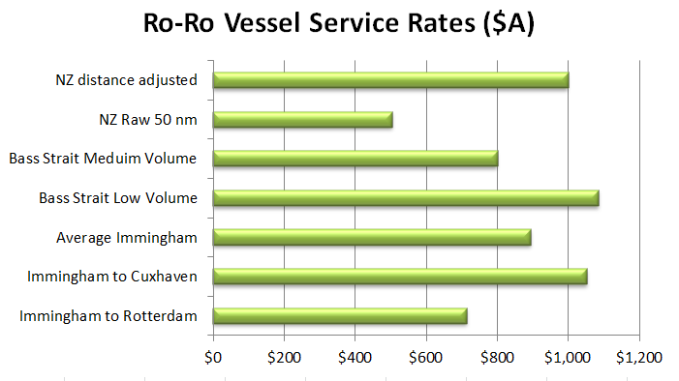

**Figure 2: Bass Strait and International RORO Rate Comparison**

## International Liner Service Calls at Tasmania

Direct calls of International Liner services in Tasmania are unlikely to resume because the volume of freight in one place is insufficient to attract operators.

There is a trade-off between frequency of service and volume of freight - if there is sufficient freight ships will call. If there isn’t services cease (e.g. AAA service). On the demand side for freight a similar function applies if there is a sufficiently frequent direct call service to Tasmanian ports, freight will be attracted to it. If it is seldom, freight will be transhipped through Melbourne where timelier container services can be found. The latter is a more expensive supply chain.

The withdrawal of international services in 2011 and current proposals to service Tasmania only if subsidised suggest that the economics of direct call container services are currently marginal.

To provide some insight to the FLCT Aurecon conducted a basic analysis considering available export volumes and comparing these to the volumes required by liner service operators, such as AAA, as indicated in the paper “International Container Shipping Service Viability for Tasmania”.[1]

Aurecon analysed the current transhipping volumes through Melbourne and allocated these volumes to a service level and port. Our assessment includes the following assumptions.

|  |  |
| --- | --- |
| **Assumptions** | Volumes based on FY 2011/12 transhipment data from Port of Melbourne.  One third of annual exports and imports (12,000 TEU) to be transhipped even though there is a direct call vessel, as this was the percentage transhipped when a direct call vessel was operating in FY 2010/11.  Excluded Norske Skog export volumes (3,000 TEU) and Nyrstar export volumes (10,000 TEU). These are handled domestically and it is assumed this arrangement will continue.  Included an estimate of Bell Bay Aluminium (7,000 TEU) volumes direct shipped currently.  Added 25% for re-positioned empty containers to the total.  Service level allocation rule: Volumes which needed to be shipped weekly would not be able to be shipped monthly. However volumes which were shipped monthly could be shipped weekly.  Location allocation rule: Unless a reason to favour either port, volume allocated 50/50 between Burnie and Bell Bay. An example of this would be aluminium which was allocated for shipment through Bell Bay. |

We calculated the following annual volumes in TEU could be available for a direct call service:

|  |  |  |  |  |  |  |
| --- | --- | --- | --- | --- | --- | --- |
| Service Level | Burnie | Bell Bay | Total | Less transhipped through Melbourne | Total for Direct call | Total Direct call plus empties re-positioned |
| Weekly | 11,688 | 12,695 | 24,383 | 8,046 | 16,337 | 20,421 |
| More than weekly | 3,033 | 9,533 | 12,566 | 4,147 | 8,419 | 10,524 |
| Total | 14,721 | 22,228 | 36,949 | 12,193 | 24,756 | 30,945 |

Table 10: Annual Volumes Available for a Direct Call Service

The above annual volumes can be expressed as volumes per call. These are shown in the table below:

|  |  |  |  |
| --- | --- | --- | --- |
| Service | Burnie | Bell Bay | Total (consolidated at one port) |
| Weekly service | 234 | 353 | 586 |
| Fortnightly | 96 | 302 | 399 |
| Monthly | 209 | 655 | 864 |

Table 11: Annual Volumes Expressed as Volumes per Call

The above simple analysis shows that the volume of containers available to ship on a direct call vessel in FY 2011/12 would have been 30,945 TEU/yr or about 600 TEU per call for an international container ship calling weekly. It assumes the cargoes could be assembled in one place.

This is below the volume suggested in the abovementioned paper is likely to attract a direct call vessel, which was 700-1000 TEU. From this it would suggest that there is sufficient volume to attract a vessel to call monthly. If volumes could not be aggregated in one place then the prospect of attracting a direct call vessel would be substantially less.

Other issues which mitigate against a return to direct call vessels are:

|  |  |
| --- | --- |
| **Observation** | **Comment** |
| **International Container Imbalance** | The imbalance between import and export would result in significant one way freight for the liner service and while this could be supplemented with importing empty containers it is unlikely to be profitable and is counter to the normal liner trade serving Australia from Asia which are predominantly loaded containers moving south. |
| **Trend to Larger International Liner Vessels** | The adoption of larger vessels in the International Liner shipping trades with Australia feeding into the large hubs such as Singapore continues to reduce the cost of shipping. The economies of scale of the larger vessels enjoy make it difficult for smaller direct call vessels to compete. In response direct call vessels are tending to larger sizes.  To be efficient larger vessels seek to make fewer calls, load larger cargoes and load quickly. To attract direct call vessels increasingly larger cargo parcels and improving port infrastructure will be required. In a slow growing economy such as Tasmania the likelihood of a direct call reduces in the face of this trend. |
| **Frequencies** | International transhipments through PoM are able to connect to daily liner services through PoM internationally. Assuming direct call vessels visit, given the need for significant cargo exchanges, services to and from Tasmania would likely to be less frequent than weekly. The demand for direct shipping, however, is cost and service based. Despite the lower cost if the frequency of service is too low, exporters will prefer to tranship through Melbourne. |
| **Infrastructure** | Should direct call vessels commence, the trend to larger vessels will require ever more efficient infrastructure and continual upgrading of facilities. Whether it makes good economic sense for Tasmania to keep pace with shipping infrastructure requirements that larger vessels may require is not clear. |

Table 12: Direct Ship Calling Barriers

In summary, the limiting factor for a resumption of direct call vessels is scale. Only if all of Tasmania’s export freight could be loaded and shipped from the one location or if Tasmanian volumes grew strongly might a resumption of direct call shipping be possible. In the absence of these possibilities the resumption of a service is unlikely.

## Shipping Economics

In this section we consider some shipping economics factors. Our view is that the application of RORO vessels to Bass Strait trade is no accident. These vessels are well suited to the mixed trade which is Bass Straight freight and around the world RORO vessels are used where the trade is similar.

| **Observation** | **Comment** |
| --- | --- |
| **RORO Vessels** | The scale and type of vessel is normally determined by:   * Volume demand. * The draft and berths available at the ports concerned. * The nature of the supply chain e.g. containerised, reefers, trucks, break bulk, over dimensional.   Where there exists a mix of all this variable freight the use of RORO vessels is common irrespective of the length of the voyage. RORO vessels are almost always used in the short sea trades in the North Sea, Baltic, Mediterranean and Japan as they have the following advantages:   * Fast loading and discharge. * Handling products/containers are reduced by using mafi trailers/or similar. * Immediate delivery to vessel /re-delivery to trucks by roll-off road trailers. |
| **Alternative Vessels** | Two service providers across Bass Strait that used conventional type vessels were unsuccessful. There were several factors that affected those operators but the fact that the vessels were not suited to the needs of the vast majority of freight interests was a major contributor to their demise.  The short sea trades also use conventional or container vessels. But they serve trades where the freight is not “time sensitive”. This freight is generally bulk freight or freight in containers that are not required to be “delivered to market” quickly. The size of vessel is determined by the volumes and the port facilities available. Here again the ratio of time in port to total time on the voyage is important. This type of vessel in the short sea trades is common all around northern Europe, around the UK, Japan and the Mediterranean. |
| **Costs** | A significant characteristic of shipping operations are the high capital costs particularly the cost of a vessel varies widely by size, type, carry capacity, speed and the methods of operation.  Operating costs of vessels are also largely fixed, including crewing, maintenance, registration, insurances etc.  The shipping industry is highly regulated with complex technical requirements, crew certification and compliances, similar to aviation.  A RORO vessel costs more than a conventional vessel of the same capacity as they are more sophisticated in their construction and management. Larger vessels have higher capital costs, but smaller crewing and maintenance costs. Vessels on long international voyages will have a different breakdown due to the high amount of fuel consumed on the voyage and the short time in port. |
| **Economic Returns** | A vessel operator’s objective is to make a reasonable economic return on investment. This is achieved by maximising:   * The use and utilisation of the vessel. * “Economies of scale” by employing the largest size vessel the trade can support and ports can physically accept. Assuming the route has the sufficient demand, the larger the vessel, the more freight it will carry for the same fixed crewing and maintenance cost. However this is countered by the need for the vessel to remain in port longer to load and discharge. So the speed at which a vessel can load and discharge in port is intrinsically linked to profitably. |
| **Cost Breakdown** | The cost of a voyage to vessel-owners, which forms the basis of their freight rate, indicates the largest component is the capital and financing cost of the vessel. Then crewing, maintenance and fuel costs (which are the largest variable cost). Our estimates of costs are as follows:  Fixed costs  Capital and financing costs (interest etc.) 35 ~45%  Crewing, wages, Administration, on-costs etc. 15%  Repairs, surveys, dry-docks and maintenance 15%  Variable  Fuel costs for voyage 30%  Port costs – berthing, pilotage etc. 5%  The above estimates are that **65% are fixed** or exist regardless of activity and **35% variable** or related to volume and activity. |

Table 13: An Explanation of Shipping Economics and its Influence on Vessel Type

## A Comparison of Service Features of International Liner Services and Bass Strait Services

Table 14 compares the service features of International Liner services (in the Australian trades) and Bass Strait RORO services. They are quite different and reinforce the rationale behind the choice of vessel for Bass Strait shipping.

| **Service Feature** | **International Liner** | **Bass Strait RORO Services** |
| --- | --- | --- |
| Volumes carried on vessel | 2,000 to 4,000 TEU | 200-500 TEU |
| Uniformity of freight presentation | Containers only. 20ft and 40 tt containers; a few flat racks etc. | Mixed freight. 20ft and 40ft containers, road trailers, cars, caravans, break-bulk |
| Delivery windows | Strict limits – 3 days | Flexible up to 1 hr prior departure |
| Service frequency | At best weekly from Tasmania | Daily and overnight |

Table 14: International Liner and Bass Strait Service Features

## Indicative Freight Rates for Liner Services to and From Australia

We provide some indicative freight rates for liner services to and from the mainland in this section. We do this to highlight that comparison of cost between liner services to Asia from the mainland and Bass Strait shipping to the mainland is not appropriate. The liner service is a different service (as detailed above) and has different market drivers, most notably an imbalance of freight to this region.

|  |  |
| --- | --- |
| **Observation** | **Comment** |
| **Freight Rates** | The freight rate is a total of base ocean freight plus numerous surcharges and additional charges. Rates are terminal to terminal and are similar to the basis of charging for moving of freight across Bass Strait.  The Australia to Asia freight rate is substantially less than from Asia to Australia because of the imbalance in the flow of containerized freight in this trade route as Australia is an importer of finished and consumer goods, and an exporter of bulk commodities and agricultural products. Shipping lines offer discounted rates to shippers who want containers repositioned north.  The rates for refrigerated containers are usually greater than USD$500 per container, more than for a general-purpose container. |
| **Implications** | The implication of the above is that Tasmanian exporters who export their products to Asia will obtain very favourable international liner freight rates. However, this would not be a fair comparison on which to judge Bass Strait shipping rates. |

Table13 provides a comparison of indicative freight rates for International Liner services across a sample of routes to and from Australia and shows there is significant variability in shipping rates depending on route and type of container shipped. As discussed, rates from Australia to Asia are considerably lower than those from Asia into Australia due to the trade imbalance in this region. This means that direct international rates from Australia are likely to be lower as shipping lines back-haul, further distorting and comparison with Bass Strait freight rates.

| Shipping Line | Type of container | Route | Total freight $USD | Total freight $AUD* | Products |
| --- | --- | --- | --- | --- | --- |
| Line H | 20ft GP | Melb to Shanghai | $1,112 | $1,079 | General, food etc |
| Line H | 40ft GP | Melb to Shanghai | $1,338 | $1,298 | General & Food etc |
| Line A | 20ft GP | Melb to Shanghai | $999 | $969 | Non perishable food, paper |
| Line A | 40ft GP | Melb to Shanghai | $1,179 | $1,143 | Non perishable food, paper |
| Line H | 20ft GP | Shanghai to Melb | $2,321 | $2,251 | Machinery |
| Line H | 40ft GP | Shanghai to Melb | $4,216 | $4,089 | Machinery |
| Line H | 20ft Reefer | Melb to Singapore | $2,757 | $2,674 | Frozen Veg |
| Line H | 40ft Reefer | Melb to Singapore | $4,533 | $4,379 | Frozen Veg |
| Line C | 40ft Reefer | Melb to Singapore | $4,149 | $4,025 | Chilled food |
| *\* $USD1 = $AUD0.97* | | | | | |

Table13: Sample International Liner Shipping Rates

## 

# Ports

Each of the Bass Strait shipping operators uses their own terminals in Tasmania and in Melbourne. This chapter further discusses the port and terminal operations of each of the operators and identifies constraints that can influence the operation of the freight market.

## Terminal Features

| **Observation** | **Comment** |
| --- | --- |
| **TT-Line** | Operates between the Port of Devonport and Station Pier in Melbourne. |
| **Melbourne – Station Pier** | TT-Line leases the wharf from the Port of Melbourne and pay for the cost of maintaining the wharf and terminal.  Cruise vessels calling at Melbourne also use this terminal. When this happens, there is considerable disruption to the loading and unloading of freight vehicles from the TT-Line ferries as these cruise vessels and their passengers take priority over the unloading of freight from TT-Line which can cause disruption during peak times and is inefficient.  During off-season or non-peak periods, Aurecon are advised that the area at the terminal at Melbourne is about adequate. However, during peak periods, there is inadequate space for marshalling of vehicular traffic.  There is an adjoining area where freight trucks and trailers are marshalled prior to driving on to TT-Line’s ferries. Additional structures have been built on the wharf that allows trucks and cars to be driven onto and off the ferries keeping to one direction. This means, if the vehicles enter the ferries from the stern at one port they exit the vessel from the bow at the other port. This allows for quick unloading of vehicles and the reloading of the next set of vehicles. |
| **Devonport** | The freight terminal at Devonport is adjacent to, but separate from, the passenger terminal. The layout and arrangement for vehicular traffic is good and they have a good system of receiving incoming trucks and trailers while delivering outgoing trailers and other vehicles.  The terminal has the adjoining structures for vehicle access and egress similar to Melbourne, which enables the vehicular traffic to be driven on and off the vessel in one direction. This complements the system in Melbourne and makes for a very efficient seaboard vehicular operation.  While the terminal operation is very efficient, it requires considerable load planning and sequencing of trailers, containers, cars, caravans and other types of non-standardised freight that are a feature of the trade.  TT-Line terminal space at Devonport is adequate for present and future needs. |

|  |  |
| --- | --- |
| **Observation** | **Comment** |
| **SeaRoad Shipping** | SeaRoad Shipping operates between the Port of Devonport and Webb Dock East No 2 at the Port of Melbourne. |
| **Melbourne Webb Dock** | Webb Dock terminal is well laid out for the receival of containers, trailers and other break-bulk freight. During normal periods, the terminal area is adequate; however during peak periods, the available terminal area is inadequate for the volume of traffic.  The terminal has powered sockets for the refrigerated containers and has areas set aside for the storage and handling of dangerous goods.  Consolidation of containers onto cassettes and unloading from cassettes are done in the terminal yard. The usual routine is that incoming freight are unloaded from the vessel within the first 2 or 3 hours after the vessel arrives. Loading of outgoing freight takes place from about 1 pm.  Incoming freight on trailers can be cleared from the terminal within an hour of arrival.  Freight on trailers and other break bulk freight are accepted for shipment on the same day up to about 3:30pm and seems to be a feature of the trade.  Webb Dock terminal is adequate during normal periods but inadequate for the volume of traffic during peak period. |
| **Devonport** | SeaRoad Shipping has an efficient logistics operation at their terminal. They have leased additional space next to their main terminal in which staging of freight occurs. This terminal area is about 4 to 5 hectares.  The terminal has container forklifts besides cassettes and tractors by which freight is consolidated and/ or sorted and stored.  The stern / ramp end of their vessels berth very close to the bow end of the Spirit of Tasmania but there is no interference with unloading and loading logistics to their vessels. The vessel’s ramps land on a link-span to cater for the tide.  The vessels use an automated vacuum based mooring system so they do not need to use mooring lines to tie up the vessel which enables a quick berthing and departure. These automated mooring systems involve significant capital investment but reduce berthing and un-berthing time and helps keep port costs down.  There is a bonded warehouse and storage facility adjacent to their terminal. This is an efficient operation in that bonded freight (not yet customs cleared) are taken by tractor or trailers from the vessel to the bonded facility. This service is convenient for Tasmanian importers and links with SeaRoad Shipping’s tranship service in Melbourne, where they collect import containers from the International Liner services and move the same to Devonport for collection by importers.  The space available at the Devonport terminal is adequate for present and future needs. |

|  |  |
| --- | --- |
| **Observation** | **Comment** |
| **Toll-ANL** | Toll-ANL operates between the Port of Burnie and Webb Dock East No 1 at the Port of Melbourne. |
| **Melbourne Webb Dock** | Webb Dock terminal area is well laid out for the receival and delivery of containers, trailers and trucks. There is adequate space in the terminal for normal traffic volumes but the terminal becomes congested during peak periods.  Toll-ANL have an adjoining terminal / facility used by their freight forwarding division (Edwards) and this is an advantage to their service as consolidation work can be carried out in that yard before moving across to the Bass Strait Shipping terminal. The yard has powered areas for the storage of refrigerated containers and other areas set aside for dangerous goods.  Webb Dock terminal is adequate for present traffic volumes. |
| **Burnie** | Freight arrives at the terminal until about 3:00pm for shipping that day. In some cases freight may arrive up to one hour before sailing.  The company has invested in several high tech container forklifts and reach stackers, which have increased efficiency and safety. The vessels ramp is lowered onto a link-span arrangement, which caters for the rise and fall of the tide. This is similar to arrangements at the other terminals.  The Burnie terminal layout has its limitations due to legacy issues at the port. However, the company has been making changes to layout to increase efficiency of terminal operations such as introducing one-way traffic flows with designated areas for incoming containers by road and rail. These have improved terminal operations and maintain the vessels on schedule.  The space available at the Burnie terminal is not adequate for present and future needs and together with TasPorts and TasRail, Toll-ANL are working on a project to increase efficiency and to allow more terminal space for the throughput of containers and other freight. Significant changes are being considered in the port layout including changing the rail interface area at the port and changing the location of buildings in the terminal  The terminal has powered outlets for refrigerated containers and the company has developed an innovative Mafi-type trailer for refrigerated container freight which has involved additional capital expenditure but has brought logistics savings to the customers. |

## A Comparison of Tasmania’s Northern Ports

Table 15 provides an overview of the main features of the three northern Tasmanian ports and terminals used by Bass Strait Shipping service providers at present and in the past.

|  |  |  |  |
| --- | --- | --- | --- |
| Feature | Devonport | Burnie | Bell Bay |
| **Operator** | TT-Line and SeaRoad Shipping | Toll-ANL | Not used at present |
| **Position of Port** | Up Mersey river; short distance from sea. Port straddles the Mersey River (west bulk goods and east containers and passengers) | On the north coast | Up Tamar river; fair distance |
| **Distance From Sea** | About 1.5 nm from entrance | On the north coast | About 9.0nm from entrance |
| **Navigational Issues** | Turning basin 300m in river; vessel length limited to 205 m due to narrow river | Not an issue | Turning basin in river and sharp turns in the river make navigation difficult; length limited to 250 m |
| **Depth of Channel** | 9.2m | 10m | +12m |
| **Dredged depth at berth (LAT)** | 6.7m TT-Line (berth 1E)  8.6m SeaRoad Shipping (berth 2E) | 10.5m (berth 4) | 12m (berth 5) |
| **Available Terminal Space** | TT-Line – 2 Ha (adequate)  SeaRoad Shipping -7 Ha (adequate) | 6 Ha (approaching capacity) | 7 Ha. Not used for Bass Strait services at present |
| **Terminal Development Potential** | Minimal No need for further development at present | Potential to expand terminal space, Presently in discussions on expansion plans with TasPorts and TasRail | Not utilized but adequate. Limited ability to expand to hinterland due to significant ridge at rear of narrow terminal |
| **Other Features** | Navigation to and from port in relatively short time. Tidal currents are not an issue | Navigation to and from port very quick due to coastal port | Navigation to and from port takes relatively long time due to river transit. Also bar at mouth which is tidal with strong currents. Fog an issue for several days each year |
| **\* Freight Throughput** | 3.35 M tonnes + 200,695 TEU | 3.74 M tonnes + 242,284 TEU | 2.33 M tonnes + 5,885 TEU |
| **Access to Population & Industrial Area** | Limited population; but industries in hinterland | Limited population; but industries in hinterland | Close to Launceston and main population centres of North Tasmania |
| **Road & Rail Links to Port** | Good road link; no rail link on dock on eastern side. Rail link on western side | Good road link. Good rail link on dock with plans to upgrade | Good road link; but Limited and poor quality rail on dock |
| *Source: TasPort’s 2011/2012 Annual Review publication* | | | |

Table 15: Comparison of Port Features

## Commentary Tasmania’s Northern Ports

We make a range of comments on each of the northern ports.

|  |  |
| --- | --- |
| **Observation** | **Comment** |
| **Port locations** | Ports that have long river transits are not attractive to an International Liner shipping service because of the importance of maintaining schedules. Delays and issues with river navigation, draft limitations, bends, turning areas, traffic congestion, and fatigue on the crew etc., make river transits less desirable.  As in many ports around the world, the container terminals have moved (or have been built) close to the mouth of the river. Also there is a move away from urban areas where real estate values are very high. |
| **Port Location Comparison** | Bell Bay is not well positioned compared to Devonport and Burnie and has some shallow outcrops in the river and strong currents at the rivers entrance. The mouth of river is affected by fog on certain days. The Tamar River is narrow and has some sharp bends, which causes some navigational difficulties.  These could be limiting factors in large vessels calling at Bell Bay in the future. |
| **Bell Bay Draft Limitation** | While there is a deeper draft available in the river it is the draft over the shallow outcrops near the entrance that limits a vessels arrival and departure so vessels have to wait for the high tide to enter or leave the river, which is not attractive to shipping lines. |
| **Bell Bay Expansion Capacity** | While the container terminal at Bell Bay has adequate space for the current imports and exports volumes there is a limit on the how much that terminal can be expanded for future use due to the steep escarpment (ridge) very close to the present terminal.  In addition, the rail connection to and from the container berth is very basic and not conducive to achieving terminal operations standards that are common at world-class container ports. |
| **Devonport Limitations** | Devonport is also positioned up a river but the distance from the mouth is considerably shorter as compared to Bell Bay. However, there is a limitation on the length of vessel that can utilize the port due to the turning basin area.  The draft available is 9.0m, which is not suitable for the larger vessels expected in the future. There is siltation at the mouth of the river, which needs dredging to maintain the depth for vessels.  Devonport is not served by a rail link into the port and hence at present this would be a major disadvantage to developing the port as a major container port. However, it may be possible to install a good rail connection to the berths in the future. |
| **Burnie** | Burnie is a coastal port and does not have the disadvantages of river ports.  A sizeable part of the port of Burnie has been built on reclaimed land with ample opportunity to carry out further reclamation in or around the port if there is a need to expand the port.  The available draft of 11.5m is sufficient for bulk vessels up to Handy or Handymax size but it not sufficient for larger bulk vessels if the bulk trades through the port expand.  The port is served by a good rail line that reaches to the berths and there is a project underway to improve the rail-road- berth interface in the port to improve port operational efficiency.  The hinterland of Burnie has some important industries that deal with bulk freighters so this aspect of the port’s capabilities must not be overlooked when considering future port development. |

## Freight Specialisation of Tasmania’s Northern Ports

Aurecon was asked to comment on freight specialisation by port. We make the following observations and comments.

This high level discussion is based on economic principles as Aurecon do not have sufficient information to enable us to make an in-depth consideration to arrive at a definitive conclusion considering future port development.

|  |  |
| --- | --- |
| **Observation** | **Comment** |
| **Specialisation or Consolidation** | There is a question on the number of ports that are needed to serve northern Tasmania and be economically viable for owners, operators and users. There may be a case for consolidation and specialisation of ports, so that one port is developed as a major container port, while another is developed as a major bulk port and another is developed as a major RORO port for freight and passengers. |
| **Discussion** | Decisions about port specialisation obviously take into account port efficiency but should also take into account the wider economic effects. It is the whole system or supply chain cost that ought to be weighed on decisions about specialisation.  Matters to consider include whether or not ships will call, what type and size, how far freight must travel to reach a port. Given the enormous costs of developing ports, they are 100 year decisions, it is important to avoid developing infrastructure that won’t be fully used. Similarly it is important to develop infrastructure in time so that the economies are not constrained by its lack.  A good strategy therefore would be one where investments can be phased such that they do not run ahead of the market.  Ports serve the trade of their hinterlands of the area and not the other way around. Hence while some ports have developed into handling one particular type of freight, these developments have been driven by the needs of the hinterland of the port. We suggest that there must be a clear benefit to all if a port is to specialise in one type of freight.  However, avoiding duplication of costly infrastructure is a valid motive so to the extent that the hinterland trade isn’t disadvantaged, there are benefits in centralizing types of freight in one port. |
| **Consolidation Scenarios** | We consider some issues around different kinds of consolidation. |
| **Container Freight Consolidation** | There is a proposal that a major container port should be developed at Bell Bay. It’s important to be clear what that means. We assume it means a modern terminal that would serve cellular container vessels using portainer cranes for lifting on and off a vessel. We also assume the proposal is to service the mainland trade.  Cellular container vessels which use load on/load off methods would be at best, weekly or fortnightly, this service level would be at odds with more than 50% of Tasmanian freight users who want an overnight service.  Should such a service commence it would draw some freight from the existing RORO services and freight rates for these services would probably increase.  Tasmanian ports are currently very efficient we do not see how centralizing all container traffic at one port (Bell Bay or elsewhere) will bring benefits unless there are very substantial efficiencies and cost savings to be had.  If the purpose of a single container port is primarily for export cargoes, at this stage the remaining volumes look too thin to support the large investment in infrastructure, which would be required. |
| **Bulk Freight Consolidation** | Centralizing all bulk freight exports from Tasmania in one northern port could bring benefits or savings, if:   * Infrastructure could be shared such as common vessel loaders to load all types of bulk freight. * One berth and channel at a suitably deep draft for all bulk vessels could be maintained in place of several. * Investment is made once to achieve compliance with environmental laws. * The origin of the bulk freight is not disproportionately far from the port. The benefits of aggregation at one port would be lost to the cost of transportation to that one port if too far away.   There are other factors that need to be considered such as the complexities of the mix of the bulk freight. The equipment needs to be compatible with the products such as:   * Material handling and vessel loading conveyor system to avoid contamination. * Separation and dust control measures need to be considered in stockpile areas. |
| **RORO and Passengers Consolidation** | Centralising RORO freight and passenger services in one port does not seem to have similar benefits as for bulk freight because by the nature of the trade and the operations.  Each Bass Strait RORO service provider requires their own terminal in which to receive, store and deliver freight so if services were centralized in one port, two separate terminals would be required within the one port and there are unlikely to be other savings in the supply chain to offset the additional terminal costs.  There could be savings made in port maintenance or dredging but this forms a small proportion of the total cost of the supply chain across Bass Strait and this would be the case only if one other port is totally shut down.  A potential disadvantage to having both RORO service providers in one port is that the capacity of the rail system into that port may need to be increased to cater for the flow of freight from two terminals and there would be increased road traffic and congestion in and around the vicinity of the port with adverse impacts on the reliability of the supply chain and the local community.  On the other hand an advantage of having two terminals at the one port would improve competition, particularly for those shippers who want to use rail for their land transport component of their freight tasks, as currently the choices these shippers face are limited. |
| **Liner Service Volumes** | The total containers for international destinations (export and import), presently transhipped through Melbourne, is approximately 48,000 TEU’s or 11% of Tasmania’s freight.  If the underlying premise to developing a single major container port in northern Tasmania is to attract International Liner services, on the current volumes it would seem there are insufficient volumes across all ports to attract an International Liner service and enable it to earn sustainable returns. |

## Port Productivity

| **Observation** | **Comment** |
| --- | --- |
| **Terminal Operations** | Australian mainland container terminals adopt conventional modes of operation which utilise portainer (gantry) cranes for vessel to shore loading and unloading, serviced by straddle carriers (SC) or rubber tired gantry cranes (RTGC).  Containers are stored in closely aligned single rows stacked 3 to 4 high for a SC operation whereas they could be stacked 6 high and 6 wide for an RTGC operation.  Increasingly in Australia and around the world, marine container terminals are being upgraded or designed for higher productivity using semi-automated rail mounted gantry cranes capable of efficiently sorting containers in stacks up to 6 high and 10 wide. |
| **Performance Measures** | Typical indicators to measure performance of container terminals include TEU per hectare per year and TEU per metre of wharf per year.  Acceptable levels of performance at conventional container terminals range from 25,000 to 35,000 TEU per hectare per year and 1,200 to 1,700 TEU per metre of wharf per year.  With semi-automated rail mounted gantry cranes facilities delivering performance in the order of 45,000 to 50,000 TEU per hectare per year and 2,000 TEU per metre wharf per year. |
| **Tasmanian Port Terminals** | Reach stackers and forklifts are commonly used to handle containers at inland intermodal terminals in Australia and it is this type of yard equipment is currently used by Toll-ANL and SeaRoad Shipping to load and unload containers on Mafi trailers and cassettes respectively.  This method is also used for smaller marine container ports around the world supported by portainer (gantry) cranes or mobile harbour cranes (MHC) for vessel to shore moves. Reach-stackers typically stack containers up to 3 high and 3 wide and are effective for operations up to around 250,000 TEU per year.  The performance rate being calculated at 15,000 TEU per hectare per year.  Another mode of operation involves forklifts and chassis for handling containers in the yard. This system was once used almost exclusively in the USA but is rapidly being phased-out. Containers are stored on chassis and are therefore restricted to a single height “stack” on wheels. This is a very inefficient use of valuable port property.  The performance rate being calculated at TEU per hectare per year. |

| Port (Berth) | Operator | Type | TEU/Year | Area (Ha) | Berth (m) | TEU/Ha Yard | TEU/m Berth |
| --- | --- | --- | --- | --- | --- | --- | --- |
| Burnie (Berth4) | Toll-ANL | RORO | 242,284 | 6 | 180 | 40,380 | 1,345 |
| Devonport (Berth 2) | SeaRoad Shipping | RORO | 105,000 | 7 | 180 | 15,000 | 583 |
| Devonport (Berth 1) | TT-Line | RORO | 95,000 | 2 | 115 | 47,500 | 825 |
| Melbourne  (Swanson) | Patrick (East)  DP World (West) | Container | 2,579,097 | 74 | 1,830 | 34,850 | 1,410 |
| Sydney  (Brotherson) | DP World (South) Patrick (North) | Container | 2,036,142 | 82 | 1,990 | 24,830 | 1,025 |
| Adelaide (Berths 6&7) | Flinders Ports | Container | 323,832 | 24 | 620 | 13,495 | 520 |

The characteristics and performance indicators for the various ports are tabled below:

Table 16: Characteristics and Performance Indicators of Burnie And Devonport Ports

| **Observation** | **Comment** |
| --- | --- |
| **Analysis** | Throughput at the Port of Burnie is 240,000 TEU per year, it is assumed that a single RORO vessel transports around 120,000 TEU per year. The vessel operates from the port 6 days per week or 306 times a year allowing 1 week for annual maintenance.  This equates to 390 TEU’s per vessel per day. Assuming 20ft (1TEU) and 40ft (2TEU) containers are apportioned 50/50 on-board, this translates to 260 moves (lifts) per vessel or 65 moves per hour given a vessel takes around 4 hours to load |
| **TEU per metre of wharf** | The performance for the RORO service of Toll-ANL and TT-Line compare favourably with those expected at a modern container terminal, including the PoM, Australia’s most productive container port.  Using the indicator of TEU per metre of wharf could be argued to be inappropriate for measuring performance of RORO operations. In particular when Toll-ANL and SeaRoad Shipping load and unload freight from the stern ramp of their vessels. However, it does highlight that compared to vessel to shore operation at container ports, RORO operations require considerably less length of continuous berth which is particularly cost effective when combined with the use of stand-alone moorings (Dolphins). |
| **Crane lifts per hour** | Another measure of performance of a container terminal is crane lifts per hour whilst loading and unloading a container vessel. In 2012, the PoM international container terminal performed at an average of 52 lifts per hour which is high compared to others such as 35 lifts per hour at the Port of Botany, Sydney. These figures are taken from the Bureau of Infrastructure, Transport and Regional Economics, Statistical report, Waterline 51.  Loosely correlated, this indicator is compared against the average moves per hour for Toll-ANL to load a RORO vessel.  65 moves per hour compares favourably with the Port of Melbourne’s average of 52 lifts per hour.  From the performance table SeaRoad Shipping’s performance is less efficient compared to that of Toll-ANL and TT-Line. However, performance can be influenced by many factors including the type and proportion of freight. For example, TT-Line handles wheeled TEU’s almost exclusively in the form of taut-liner trailers and containers on wheeled chassis. Goods on TT-Line tend to be time-sensitive and as such, are driven almost immediately from the terminal to market or stored for only a few hours. The time that containers are stored in the yard (dwell time) makes a tremendous difference to the through-put of the yard. Modern container terminals strive to reduce dwell time to 5 days or less. Reduction of dwell time by even 1 day can result in significant increases in throughput. |
| **Dwell Times** | Approximately 35% of overall TEU throughput in Tasmania are transported as trailers or wheeled chassis. International containers contribute only 11% of the overall TEU throughput and impose the longest dwell times of 3 to 6 days. Therefore, other than a relatively small proportion, Tasmania’s ports enjoy dwell times of less than 1 day which contributes enormously to the high productivity and turnover of TEU’s through the yard. |
| **Summary** | Overall, the RORO operation servicing Tasmania is productive and performing efficiently despite yard constraints and other challenges described elsewhere. |

## Port Expansion

This section of the report considers the existing operation and capacity of Tasmania’s northern ports and based on the PoM’s growth forecasts, future port capacity requirements.

### Port of Melbourne

The Port of Melbourne Corporation (PoMC) latest Port Development Strategy (PDS) 2035 Vision (August 2009) forecasts that Tasmanian container throughput will reach 793,000 TEU (4% CAGR) and 1,150,000 (3.8% CAGR) by 2025 and 2035 respectively. Section 7 of the PDS, describes its “Future Berth and Land Needs” for its Webb dock Bass Strait RORO terminals as follows:

|  |  |  |
| --- | --- | --- |
| Year | Berths | Terminal Area (Ha) |
| Existing | 2 | 14 |
| 2025 | 4 | 20 |
| 2035 | 5 | 30 |

Table 17: Port of Melbourne Future Expansion

The existing, adjoining terminals at Webb dock are operated by SeaRoad Shipping and Toll-ANL, each with a single berth and yard measuring around 7 hectares.

We believe Toll-ANL is operating its RORO terminal, near capacity at the Port of Burnie, handling 240,000 TEU per year in a storage area of around 6 hectares using 2 vessels and a single berth and wharf, 180 metres in length. Therefore, theoretically, RORO operations in Tasmania should be capable of achieving 40,000 TEU’s per hectare per year using a single berth.

Based on these parameters and PoMC’s forecasts and assuming larger RORO vessels are used in future, berth and land needs in Tasmania could be forecast as follows:

|  |  |  |
| --- | --- | --- |
| Year | Berths | Terminal Area (Ha) |
| Existing | 2 | 13 |
| 2025 | 3 | 20 |
| 2035 | 4 | 29 |

Table 18: Tasmania Future Expansion

In keeping with the PoMC parameters, the existing berth and terminal area figures in the table above only refer to the operations of Toll-ANL and SeaRoad Shipping at the Ports of Burnie and Devonport respectively.

### Port of Burnie

The RORO terminal at Port of Burnie is currently undergoing expansion plans through joint collaboration between TasPorts, TasRail and Toll-ANL.

The project includes an upgrade of the rail yard to develop an intermodal terminal. The re-routing of rail track will also enable direct access to the RORO terminal. At present, trains need to shunt along a section of beach and restaurant precinct before returning to enter at the rear of the RORO terminal. The intermodal terminal will release additional area for the storage and handling of containers. Otherwise, it is difficult to appreciate where additional terminal area can be released at Burnie to service the RORO operation up to 2025 and beyond.

Conceivably berth 5 could provide an additional berth for RORO operations. The triangulated area of land adjoining berth 5 is used for concentrate storage at present. Assuming this land is allocated for RORO operations, it measures around 4 hectares which is well short of the forecast 7 and 16 hectares required by 2025 and 2035 respectively. The addition of berth 5 together with productivity improvements may satisfy requirements up to 2025 but at least 1 more berth would be needed up to 2035.

From a desktop perspective, it would appear that additional land could be developed adjoining the existing RORO terminal by reclamation in an easterly direction towards the breakwater. This would be a costly if not prohibitively expensive solution given that the reclamation area is dredged to -10 metre. However, it would provide greater flexibility for expansion and also facilitate the extension of berth 4 and the construction of 1 or 2 additional berths.

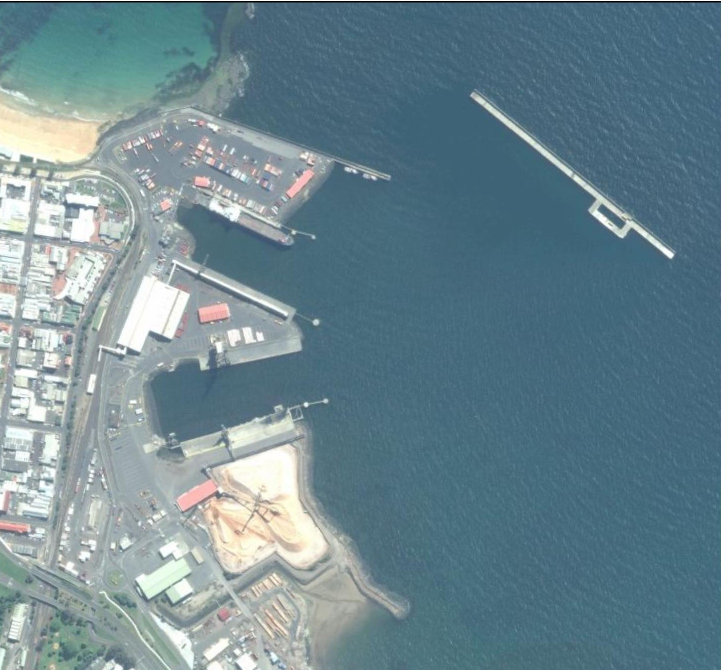

Berth 4

Berth 5

Berth 7

Berth 6

Figure 2: Port of Burnie Aerial Photo (Source: Bing Maps)

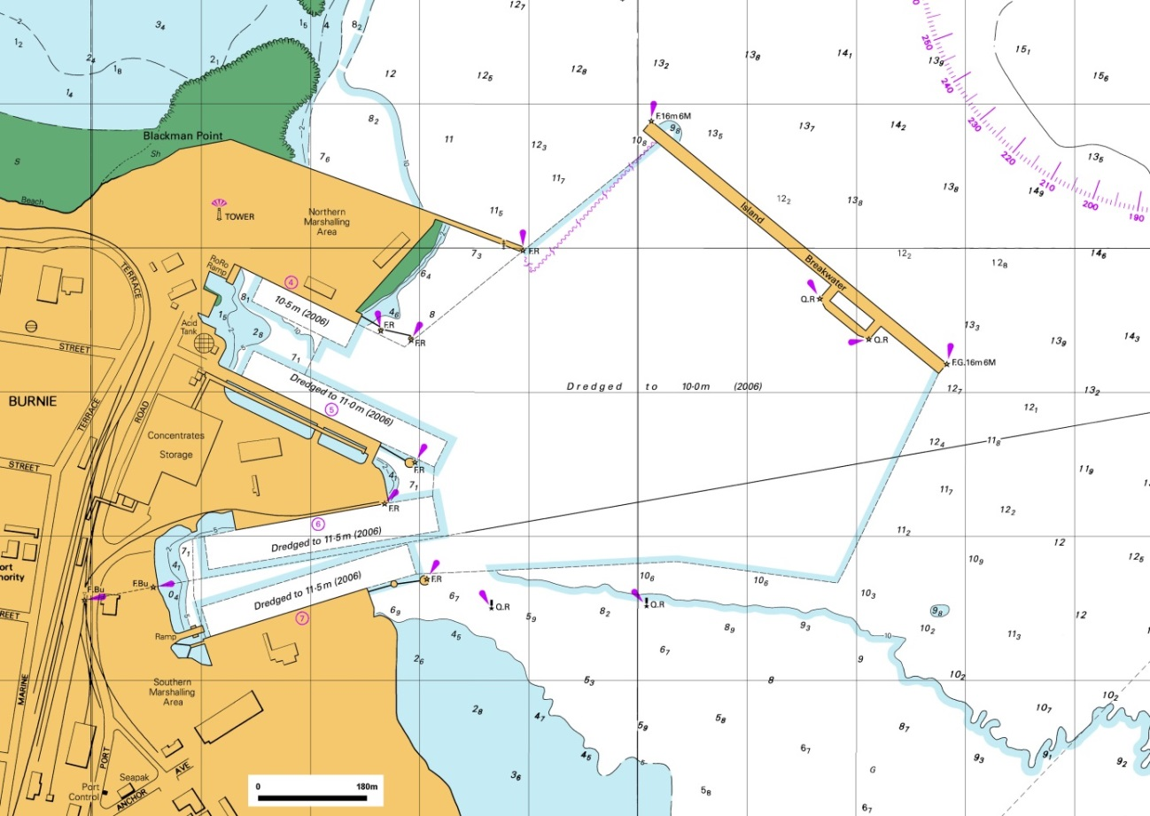

Figure 3: Port of Burnie Maritime Chart

### Port of Devonport

Currently, productivity by SeaRoad Shipping at the Port of Devonport (15,000 TEU per hectare per year) is relatively low compared to Toll-ANL’s (40,000 TEU per hectare per year) at the Port of Burnie.

So there is probably an opportunity for productivity improvements before land area becomes an issue for SeaRoad Shipping at Devonport. Theoretically, the current area of 7 hectares could support throughput to a capacity of 280,000 TEU per year (almost three times current volumes).

Urban encroachment severely restricts the ability to expand inland. Reclamation opportunities are also limited given that the river is narrow and the turning basin is already tight for the vessels currently using berths 1 and 2 and the downstream berths on the west bank. There is land to the south of the existing terminal that appears to have low-level occupation and some potential opportunity for expansion. However the area is narrow and would only add about 1 or 2 hectares. It would further elongate the terminal making for longer travel distance and more inefficient operations on the terminal.

The Port of Devonport is also disadvantaged by not having connection to the railway.

The current configuration of berths 1E and 2E results in the bow of TT-Line’s Spirit of Tasmania overlaps or extends beyond the stern of the SeaRoad Shipping vessels when both are in port. This does not seem to pose a problem for now but may dictate changes to the wharf and docking arrangements in future, should SeaRoad Shipping increase the size and width of their vessels.

There is limited constraint to developing an additional berth at Devonport (berth 3E) but it would seem redundant if land could not be expanded commensurately.

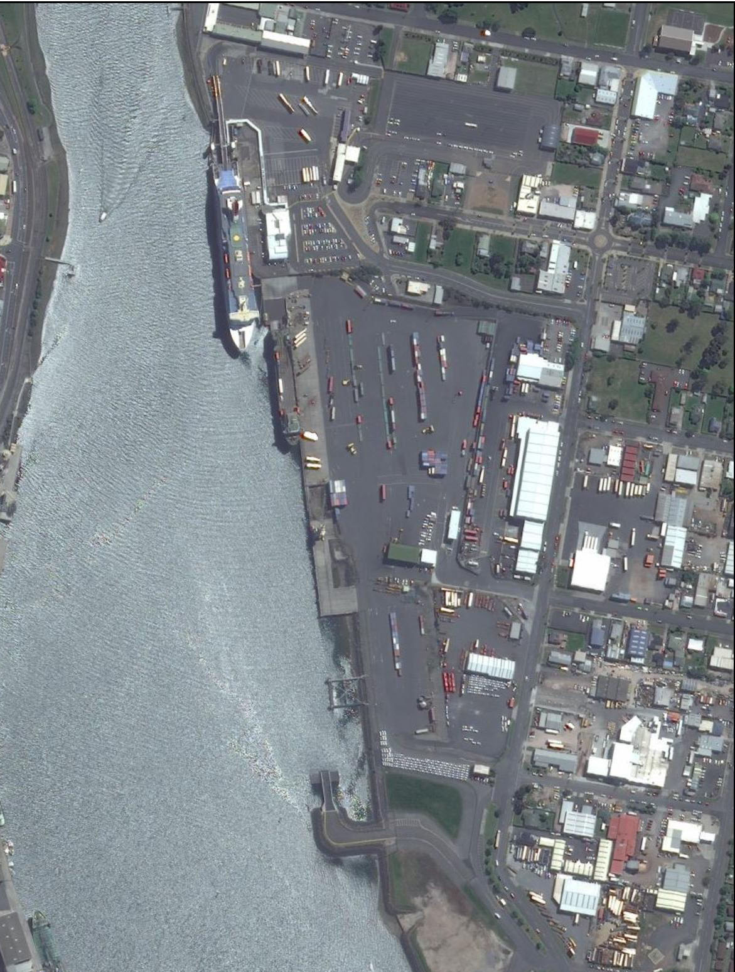

Berth 3E

Berth 2E

Berth 1E

Figure 4: Port of Devonport Aerial Photo (Source: Bing Maps)

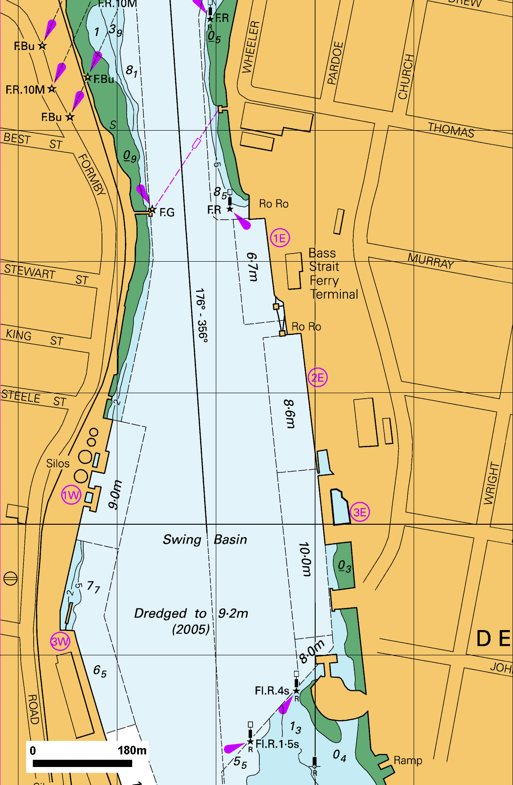

Figure 5: Port of Devonport Maritime Chart

### Port of Bell Bay

The Port of Bell Bay currently has virtually no container throughput despite having handled 47,690 TEU’s in 2010/11.

The Tasmanian Government’s 2011 Submission to Infrastructure Australia supports development of a major container terminal at Bell Bay under a project named the Bell Bay Intermodal Expansion at an estimated cost of $150 million.

According to the submission, the expansion would be developed in two stages with capacity to handle up to 200,000 and 400,000 TEU’s per year by 2020 and 2025 respectively.

There have been studies and reports produced around the viability of a dedicated container terminal to service Tasmania’s relatively small international container market estimated at around 11% of overall throughput or currently 48,000 TEU’s per year.

These reports include:

1. Containerised freight Specialisation at the Port of Bell Bay: A cost benefit analysis by MMC Link dated September 2012.
2. International Container Shipping Service viability for Tasmania by GPS Logistics for DIER dated February 2013.
3. Report for TasPorts Bell Bay Intermodal Expansion by GHD for TasPorts dated December 2010 (produced specifically to assess the development of a container port at Bell Bay). The report contained a concept drawing that describes key features of the proposed development including the following:

* Extend 200 metre of existing wharf (berth 5) and construct 470 metres of new wharf to achieve an overall length of 670 metres.
* Demolish the existing multipurpose and woodchip wharf (berth 6).
* Reclaim 8.3 hectares of land and develop an overall terminal area of 17 hectares.
* Provide 1 additional portainer crane in addition to the 1 existing.

Observations and comments in relation to the proposed development include the following:

| **Observation** | **Comment** |
| --- | --- |
| Typically an efficient container terminal yard layout should be rectangular in shape with an upland width of around 500 metres, parallel to the berth face. | A steep incline or ridge to the rear of the proposed Bell Bay facility prevents expansion inland or the ability to square-up the terminal. Hence, the proposed yard layout is an irregular and elongated shape that increases travel distance and reduces efficiency. |
| The efficiency of a yard is dependent on the ability to layout rows of containers in a dense and uniform arrangement. | The irregular shape of the yard would introduce “dead pockets” of space where rows of containers are truncated resulting an inefficient layout and wasted opportunity for operations. |
| A proposed wood chip berth is shown located closest to the proposed new container stacking area, with the container berth(s) located further away from the storage yard. | This berth layout is undesirable and further increases the travel distances in an already inefficient yard. |
| A single berth should measure around 350 metres to accommodate a modern container vessel. Therefore an overall length of 670 metres would normally accommodate two large container vessels. | The location of the woodchip-loader essentially limits the facility to a single berth. |
| Provision of 1 portainer crane in addition to the existing, single Panamax size gantry crane is grossly inadequate to service modern container vessels. | Typically, a single and dual berth facility would require 4 and 7 portainer cranes respectively to achieve internationally acceptable vessel-to-shore loading rates. |
| The proposed layout indicates that existing wood chip swing-conveyor remains in operation over the access road to the new container terminal. The drawing does not indicate if the conveyor needs to be raised higher. | Containers could be stacked 3 to 6 high depending on the mode of operation. The container handling equipment is higher again so there would be serious disruption to operations if the conveyor obstructs travel routes. |
| Modern container terminals require heavy duty pavements of depth from 750 mm to 1 metre to withstand the punishing wheel loads and repetitions associated with container handling equipment. | Assumedly the estimated cost includes provision for the removal and reinstatement of heavy duty across the entire terminal. The pavement profiles would also have to be graded both longitudinally and transversely to suit the type of equipment and alignment of the proposed container stacks. |
| The existing water depth along the proposed berths ranges from 10 to 12 metres. The size of container vessels has increased dramatically over the past 10 years when Panamax size vessels carried 3,000 TEU’s with a draft of around 11 metres. Recent developments at Port Botany, Sydney and PoM have included dredging to -16.5 metres and -14.6 metres respectively to cater for container vessels capable of carrying up to 8,000 TEU’s. The largest container vessels to visit Australia to date carry around 6,000 TEU’s with a draft of 14 metres. Conceivably by 2025, these are the size of container vessels that will commonly service Australia from Asia. | It is unlikely that there will be sufficient container volumes to attract a carrier with a dedicated international service that is tailored to the existing navigation constraints and water depth at Bell Bay port. Therefore, to attract a carrier, dredging may be required to deepen the berth to more than 14 metres which could prove prohibitively expensive, especially if rock is encountered. |
| The Tasmanian Government’s November 2011 submission to Infrastructure Australia describes expansion of Bell Bay in two stages to cater for 200,000 and 400,000 TEU per year by 2020 and 2025 respectively. There is no mention of the mode for operating the container terminal. A two stage development may justify a reach stacker and mobile harbour crane operation initially transitioning to a more rigid and expensive straddle carrier (SC) and portainer crane operation in future. | Given that the proposed terminal area is 17 hectares, this translates to around 12,000 and 24,000 TEU per hectare per year for a reach stacker and SC operation respectively, which falls comfortably within the performance thresholds discussed in Section 5.5. This relative “comfort” would also compensate for the inherent inefficiency associated with the shape of the yard and distance from the wharf. |
| The concept plan refers to one existing and one proposed portainer crane. As a minimum a modern container berth would require four super-post-panama portainer cranes working simultaneously to satisfy a carrier and turnaround a 6,000 TEU container vessel in an internationally acceptable timeframe. | The rail gauge for such cranes is 30 to 35 metres which would exceed the width of the proposed wharf. The estimated cost to provide say 4 portainer cranes, 16 SC’s, 2 reach-stackers, 4 tractor-trailers and other container handling equipment required to cater for a 400,000 TEU facility could be in the order of $80 million. |
| The estimated cost of the development is $150 million which seems low for a modern container terminal given the amount of reclamation, wharf construction, demolition, refurbishment of the yard and ancillary buildings required. | Based on broad assumptions and 40% contingency together with knowledge and experience in the construction of marine infrastructure and container terminals, Aurecon estimates that the cost could be more than double the existing estimate which excludes provision for container handling equipment mentioned above. |

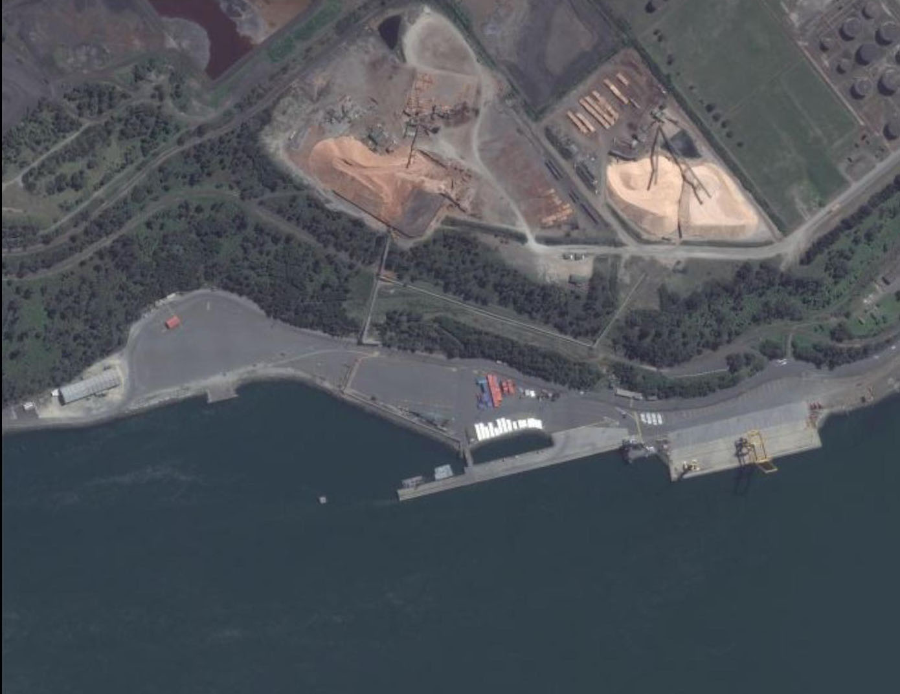

Berth 5

Berth 6

Figure 6: Port of Bell Bay Aerial Photo (Source: Bing Maps)

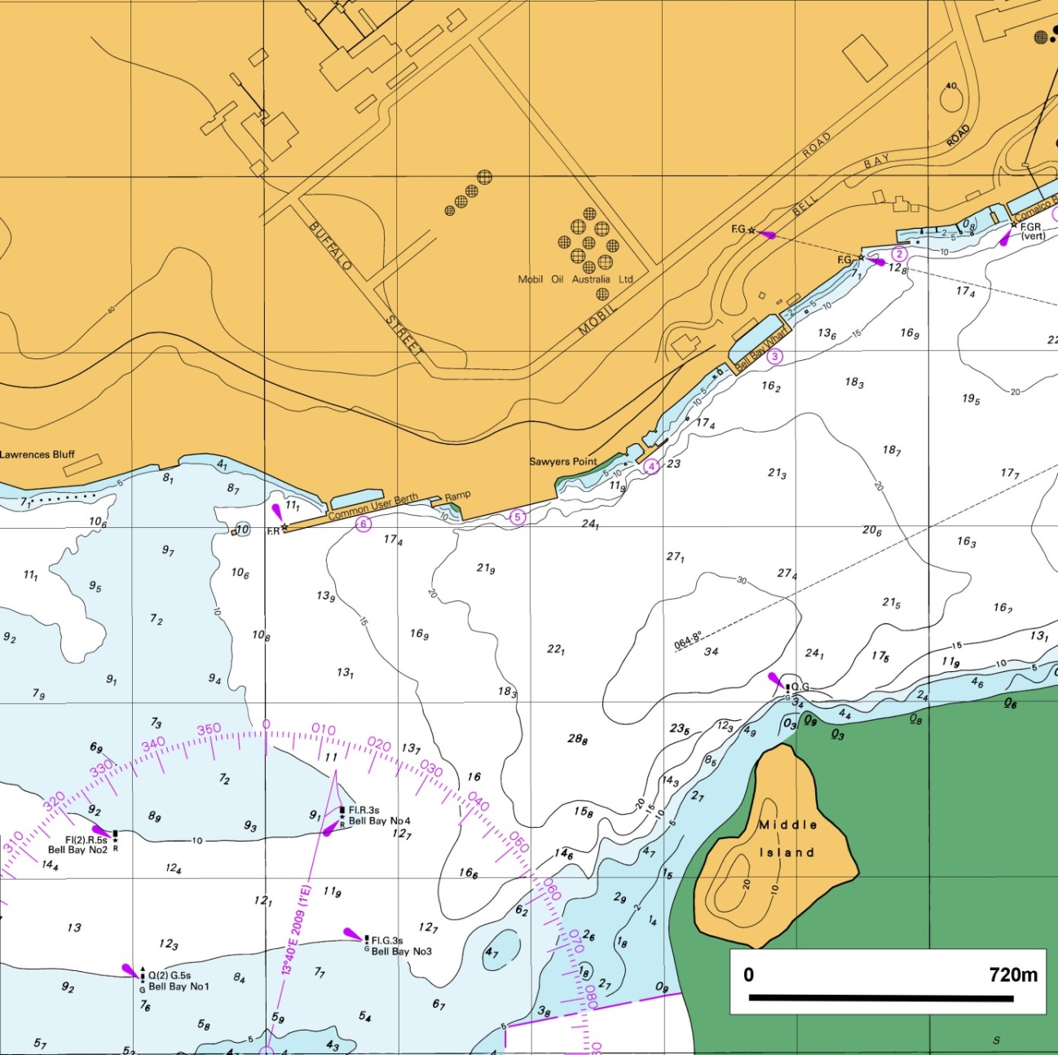

Figure 7: Port of Bell Bay Maritime chart

# Findings

RORO shipping is a good fit for Bass Strait trade in that is provides an efficient and effective overnight service for a variety of freight including containers, trucks, break bulk and over-dimensional.

RORO shipping operations are efficient in their stevedoring operations, and achieve similar “lift” rates to container terminals.

Bass Strait shipping is more expensive than similar services overseas, but Bass Strait costs are also greater.

With incremental investment in port infrastructure and some productivity improvement there is sufficient capacity at Burnie and Devonport to cater for the growth in volume anticipated by the Port of Melbourne until 2025. It should be noted however that the growth rates proposed by the Port of Melbourne seem optimistic compared to recent actual growth rates and so capacity at these two berths may take longer to be reached.

In addition of RORO assets at Burnie and Devonport there are RORO assets at Bell Bay (currently not operational) that could further add to Tasmania’s port capacity.

Investment in the development of Bell Bay into a 400,000 TEU international container terminal is best made cautiously, in view of the relatively small volumes which would be exported and the likely high cost of such a development.

A comparison of the features of ports shows that they key differentiating features between Bell Bay and Burnie are that Bell Bay is the superior port in terms of water depth and that Burnie is best in terms of ocean access. Devonport is not a candidate to be a container port because of land constraints.

The arguments for specialisation of activity at a given port are strongest where they relate to serving their hinterland activities and minimising road freight. In the immediate term the benefits of specialisation do not seem large.

# Appendices

|  |
| --- |
| Appendix A List of Tables and Figures |

Table 1: TT-Line 10

Table 2: SeaRoad Shipping 11

Table 3: Toll-ANL 12

Table 4: Bass Strait Shipping Cost Impacts 14

Table 5: Comparison of services and rates across the Cook Strait 15

Table 6: RORO Ferry Services – Australia and New Zealand 15

Table 7: Comparison of services and rates across the North Sea 16

Table 8: Sample RORO Immingham Ferry Service Rates 17

Table 9: Consideration of services between Spain and Majorca/Las Palmas 17

Table 10: Annual Volumes Available for a Direct Call Service 20

Table 11: Annual Volumes Expressed as Volumes per Call 20

Table 12: Direct Ship Calling Barriers 21

Table 13: An Explanation of Shipping Economics and its Influence on Vessel Type 23

Table 14: International Liner and Bass Strait Service Features 24

Table 15: Comparison of Port Features 29

Table 16: Characteristics and Performance Indicators Of Burnie And Devonport Ports 35

Table 17: Port of Melbourne Future Expansion 37

Table 18: Tasmania Future Expansion 38

Figure 1: Freight Providers Market Share (Source: Aurecon analysis) 9

Figure 2: Port of Burnie Aerial Photo 39

Figure 3: Port of Burnie Maritime Chart 40

Figure 4: Port of Devonport Aerial Photo 41

Figure 5: Port of Devonport Maritime Chart 42

Figure 6: Port of Bell Bay Aerial Photo 45

Figure 7: Port of Bell Bay Maritime chart 46

|  |
| --- |
| Appendix B Commodity Classifications |

Port of Melbourne commodity classifications have been used in this report. Commodities map to commodity groups as shown.

| Commodity Group | Commodities | Commodities | Commodities |
| --- | --- | --- | --- |
| Agriculture | Animal Foods, NEI | Fruit, Fresh | Milk, Processed |
| Barley | Hay, Chaff & Fodder | Oats |
| Beef - Packaged | Hides, Skins & Furs | Oil Seeds, Nuts, Kernels |
| Butter And Cheese | Lamb - Packaged | Stockfeed |
| Cereals - Other | Livestock | Vegetables, Fresh & Frozen |
| Dairy Products - Other | Malt | Vegetables, Processed |
| Fish, Fresh & Frozen | Meals & Flours | Wheat |
| Fish, Processed | Meat, NEI | Wine |
| Flour | Milk Products | Wool |
| Fruit Preserved | Milk, Dried |  |
| Automotive | Agricultural Machinery | Transport Equipment, NEI |  |
| Second Hand Motor Veh. | Vehicle Parts |  |
| Industrial | Aluminium | Leather Manufactures | Scrap Metal - Other |
| Chemical Elements And Comp, NEI | Lubricating Oils | Soda Ash |
| Chemical Products, NEI | Machinery - Non Elec. NEI | Steel Scrap |
| Copper & Brass | Medical & Pharm. Prods | Sugar, Raw |
| Distillate Fuels | N-Met Minerals & Manuf. NEI | Textile/Fibre Waste |
| Dyeing & Coloring Materials | Non-Ferrous Metals, NEI | Timber - Other |
| Explosives | Petrochemicals | Timber, Sawn |
| Ferrous Metals, NEI | Petroleum & Products, NEI | Tin |
| Fertilizers Manufactured | Pig Iron | Wood & Cork Manuf. |
| Fibres - Other | Pitch, Asphalt | Zinc |
| Iron & Steel - Shapes | Plastics, Raw |  |
| Lead | Residual Oil |  |
| Mining | Cement | Crude Fert & Minerals, NEI | Ores & Conc. - Other |
| Clay | Gypsum |  |
| Pulp & Paper | Newsprint Paper | Paperboard & Manuf. |  |
| Paper, Other | Pulp And Waste Paper |  |
| Retail | Beer | Fabrics | Molasses |
| Builders Hardware | Fermented Beverages - Other | Non-Alcoholic Beverages |
| Cereal Products | Floor Coverings | Pet Foods |
| Clothing, Etc | Food Preparations, NEI | Plastic Ware |
| Cocoa And Beans | Furniture | Sugar Preparations |
| Coffee, NEI | Glass And Glassware | Textiles, NEI |
| Confectionery | Honey | Toys And Sporting Goods |
| Domestic Appliances | Metal Manufactures | Travel Goods |
| Electrical Machinery | Misc. Food Preparations | Yarns |
| Other | Aircraft | Gas, Manuf. (LPG) | Tallow |
| Animal Oils - Other | Gas, Natural | Tobacco Manufactures |
| Armed Forces Goods | Mail | Tobacco, Raw |
| Briquettes | Oils, Fats, Wax | Vegetable Oils |
| Crude Animal Materials | Personal Effects | Water Craft |
| Crude Veg. Materials | Precision Goods |  |
| Essential Oils | Rubber, Other |  |

|  |
| --- |
| Appendix C References |

* Department of Infrastructure, Energy and Resources; Tasmanian State Government
  + Tasmanian Freight Survey 2008/09
  + Major Industrial Sites Tasmania: 2011
  + Tasmania International Exports: 2011/12
  + 2012 Transport Submission to Infrastructure Australia
  + Western Tasmania Industry Infrastructure Study (May 2012), Sinclair Knight Merz Pty Ltd

International Container Shipping Service Viability For Tasmania (19 February 2013), GPS Logistics (Tas) Pty Ltd

* Tasmanian Ports Corporation Pty Ltd (TasPorts)
  + Annual Report 2011/12
  + Annual Report 2008/09
* Meyrick Consulting Group Pty Ltd
  + International and Domestic Shipping and Ports Study (1st May 2007)
* Sinclair Knight Merz Pty Ltd
  + Historic Freight Rate Data And Review Of Tasmania Freight Equalisation Scheme And Tasmania Wheat Freight Scheme (30 April 2008)
* Department of Infrastructure, Transport, Regional Development and Local Government; Australian Government
  + Australian Sea Freight 2009–10 (September 2011)
  + Statistical Report Australian Sea Freight 2010–11 (October 2012)
  + Tasmanian Freight Schemes Parameter Review (October 2011)
  + Freight Rates in Australia 1964–65 to 2007–08 (Information Sheet 28; October 2008)
  + Road Freight Estimates And Forecasts In Australia: Interstate, Capital Cities And Rest Of State (Report 121; September 2010)
  + A Regional Economy: a case study of Tasmania (Report 116; October 2008)
  + Truck Productivity: sources, trends and future prospects (Report 123; March 2011)
  + Tasmania Corridor Strategy (2007)
  + Tasmanian Freight Equalisation Scheme Ministerial Directions 2008 (November 2009)
* Tasmanian Railway Pty Ltd (TasRail)
  + Annual Report 2012
* Tasmanian Freight Logistics Council (TFLC)
  + Tasmanian Freight Logistics Council Annual Report 2011/12
* Tasmania Audit Office; Tasmania State Government
  + TasPorts: Benefits of Amalgamation; Report of the Auditor-General, No. 2 of 2012/13
* MMC Link Pty Ltd
  + Containerised Freight Specialisation at the Port of Bell Bay: A Cost-Benefit Analysis (September 2012)
* Davey & Maynard Pty Ltd & Eio Pty Ltd
  + Assessment of Circular Head and West Coast Freight Demand (30 January 2007)
* PricewaterhouseCoopers New Zealand
  + Upper North Island Port And Port-Related Infrastructure Supply And Demand Study (November 2012); Economic Development, Auckland Council
* Parliamentary Standing Committee On Public Works, Parliament Of Tasmania
  + Brighton Transport Hub Project (2008)
* InterTradeIreland
  + Freight Transport Report for the Island of Ireland (March 2008)
* Deloitte Access Economics Pty Ltd
  + Economic impacts of the proposed Shipping Reform Package (February 2012)
* TransEco Pty Ltd
  + Road Freight Cost Outlook Quarterly Report (May 2011)
* Australian National Audit Office; Australia Government
  + Tasmanian Freight Equalisation Scheme (November 2011)
* TT-Line Company Pty Ltd
  + Annual Report 2011/12

|  |
| --- |
| Appendix D Companies Contacted |

|  |  |
| --- | --- |
| Location | Organisation |
| Burnie | Lion Nathan Pty Ltd |
| Caterpillar Elphinstone Pty Ltd |
| Impact Fertilisers Pty Ltd |
| Devonport | Harvest Moon |
| SeaRoad Holdings Pty Ltd |
| Webster Ltd |
| Tasports Pty Ltd |
| Petuna Pty Ltd |
| Fonterra (Australia) Pty Ltd |
| Cement Australia |
| Incitec Pivot Ltd |
| Glaxosmithkline Australia Pty Ltd |
| TT-Line Company Pty Ltd |
| Fudge 'N' Good Coffee |
| Hobart | Tasmanian Chamber Of Commerce And Industry Ltd |
| Port Of Melbourne Corporation |
| Norske Skog (Australasia) Pty Ltd |
| Tasmanian Minerals Council Ltd |
| Forestry Tasmania |
| Nyrstar Australia Pty Ltd |
| Fruit Growers Tasmania Inc |
| Tassal Group Limited |
| Ta Ann |
| OOCL (Australia) Pty Ltd |
| Air Trade Pty Ltd |
| Tasmanian Freight Logistics Council Ltd |
| Houston - Lettuce |
| Boral Plasterboard |
| S.A. & K.A. Cuthbertson Pty Ltd |
| Ingham Chicken Growers Association Inc. |
| Bunnings Pty Ltd |
| Launceston | Tasmanian Transport Association |
| The Tasmanian Farmers And Graziers Association |
| Tasrail Pty Ltd |
| Bell Bay Aluminium |
| Veolia Environmental Services (Australia) Pty Ltd |
| Boags Brewery - Lion |
| Austral Bricks (Tas) Pty Ltd |
| JB Swift |
| Tas Alkaloid |
| Temco |
| Tasmanian Irrigation Pty Ltd |
| Toll Pty Limited |
| Neville Smith |
| Tasmania Agility |
| Tasmanian Exporters Group |
| Statewide Independent Wholesalers Limited |
| Bluescope Pty Ltd |
| Furneaux Freight Pty Ltd |
| Simms Metals |
| Lpi Australia |
| Ecka Granules Australia Pty Ltd |
| Smithton | Cadbury Schweppes Pty Ltd |
| Tas Dairy |
| McCains |
| Ulverstone | Botanical Resources Australia Pty Ltd |
| MMG Tasmania |
| Vincent Industries Inc. |

|  |
| --- |
| **Aurecon Australia Pty Ltd**  ABN 54 005 139 873  Aurecon Centre Level 8, 850 Collins Street Docklands VIC 3008  PO Box 23061 Docklands VIC 8012  Australia  **T** +61 3 9975 3000  **F** +61 3 9975 3444  **E** melbourne@aurecongroup.com  **W** aurecongroup.com  Aurecon offices are located in: Angola, Australia, Botswana, China, Ethiopia, Hong Kong, Indonesia,  Lesotho, Libya, Malawi, Mozambique,  Namibia, New Zealand, Nigeria,  Philippines, Singapore, South Africa,  Swaziland, Tanzania, Thailand, Uganda,  United Arab Emirates, Vietnam. |

1. Prepared by GPS Logistics (Tas) Pty Ltd